MINISTRY OF EDUCATION
RUHANGO DISTRICT
BIOLOGY EXAM OF THE THIRD TERM 2021 FOR SENIOR THREE
DURATION: 3 HOURS
INSTRUCTIONS:
This paper consists of three sections A, B and C Answer ALL questions in section A.(55 marks) Answer THREE questions in section B.(30marks) Answer only one question in sectionC. (15marks)
SECTIONA: ANSWER ALL QUESTIONS (55MARKS)
- The diagram below represents types of cells.
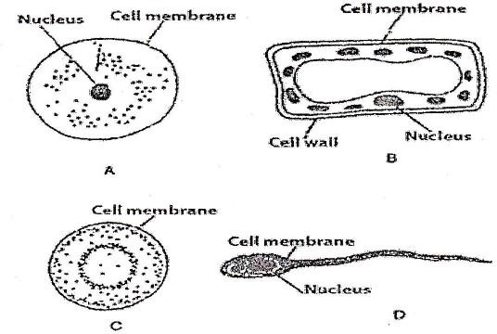
Which of these represents animal cells? Explain your answer. (3marks)

- Using √ and X, indicate the parts of the cell found in a plant and animal cell.
The first one has been done for you.(5marks)
Part | Plantcell | Animalcell
Nucleus | √ | √
Cellmembrane
Cytoplasm
Cellwall
Largevacuole
Chloroplasts

- Study the diagram below and answer the questions that follow.
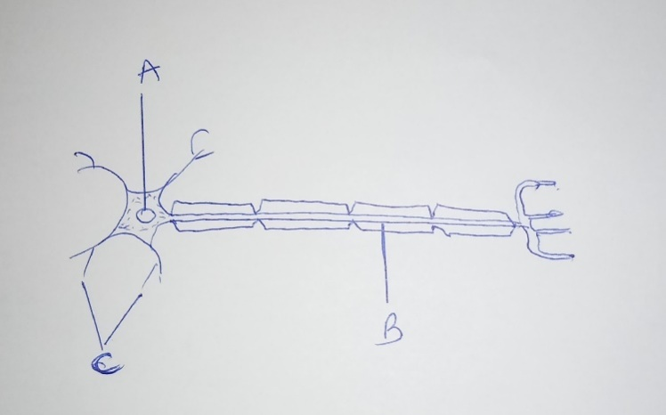
a. Name the parts labeled A, B and C. 3marks
b. Differentiate three types of neurons. 3marks

- Plants need mineral salts.
  - Through which part do mineral salts get in to the plant?(1mark)
  - Explain why water is important in this process.(1mark)
- Copy and complete the table below (4marks)

Mineral ions | Why needed in a plant | Effect if missing in soil
Nitrate
Phosphate

- Blood contains plasma, platelets, red cells and white cells. Each has one ormore important functions. Copy the table below and match each with its function.(4marks)
Red cells Fight bacteria
Platelets Carry dissolved hormones
Plasma Carry dissolved urea
White cells Transport oxygen around the body.
Helps blood to clot

- For each of the following digestive substance ,name the site of its production.(4marks)
Digestive substance | Site of production
Bile
Amylase
Lipase
Protease
- Red blood cells contain haemoglobin. Explain how this enables red bloodcells to pick up oxygen from the alveoli and release it to the cells in otherpartsofthebody. (4marks)
- The thickest muscular wall in the heart is that of the left ventricle. Why is this wall so thick? (2marks)
- Give Two functions of the human skeleton.(2marks)
- (a)What is a synovial joint?
    - What function does each of the following have in a joint?
      - A tendon
      - A ligament
      - Synovial fluid
      - A cartilage (5marks)
- The following results were obtained by a student who crossed the F1 generation of pure parents for Round seeds( R ) and wrinkled seeds(r).

Dominant trait | Recessive trait | Number of F2 offspring
Round seeds | Wrinkled seeds | 7524

a . Define the following terms (2marks)
i) Dominant
ii)Recessive
b. Calculate the number of Round and Wrinkled seeds. Show your working. (4marks)
- The table below shows the diploid number of chromosomes in the cell of some organisms.
Organisms | Diploid number
Human | 46
Pea | 14
Mouse | 40
Maize | 20

  - Define the terms:
Diploid(1mark)
Haploid (1mark)
  - What is the haploid number of chromosomes in a mouse? (1mark)
  - How many chromosomes would you find in a leaf cell of a pea?(1mark)

SECTIONB:Attempt any THREE questions in this section.(30marks)

14. What are the differences between vegetative and sexual reproduction in plants?(5marks)
b) What advantage does each type have over the other? (5marks)
15. The diagram below shows the position of the endocrine glands in humans.
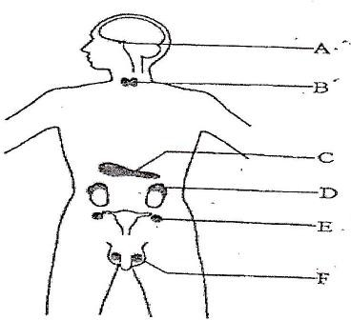
  - Name glands A-F. (6marks)
  - Name some of the hormones produced by gland A. (2marks)
  - What are the functions of the insulin hormone? (2marks)
- a) What draws water all the way form roots to the leaves of a plant? (2marks)
  - What is transported along the xylem tissues? (2marks)
  - What is transported along the phloem tissues? (3marks)
  - Describe how cells become turgid but do not burst. (3marks)
- a ) Describe the different types of carbohydrates giving examples of each type. (6marks)
b) You are provided with a solution which is suspected to contain reducing sugar. Describe the possible tests you can carry out to confirm that it is areducingsugar. (4 marks)

SECTIONC:This section is compulsory.(15marks)
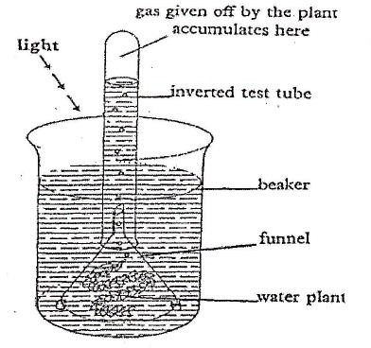
- A group of students carried out the experiment below to investigate whether oxygen is given by plants during a biological process.

- Name the biological process being investigated.(2marks)
- What conditions are necessary for that process you have named above? (5marks)
- Describe in detail how the process works until its final products are formed. (8marks)
Good Luck!!!!!!!!!!!!!!!!!!!!!!!!!!!!

RUHANGO DISTRICT 2021
MARKING SCHEME OF ORDINARY LEVEL BIOLOGY
Section A: Answer all questions
1. A, C and D because they don’t have a cell wall, a large central vacuole and chloroplasts. (3 marks)
2. (5 marks)
Part | Plant cell | Animal cell
Nucleus | √ | √
Cell membrane | √ | √
Cytoplasm | √ | √
Cell wall | √ | √
Large vacuole | √ | X
Chloroplasts | √ | X
3.a. (A) Nucleus. (1 mark)
(B) Axon or dendron. (1 mark)
(C) Dendrites. (1 mark)
b) Sensory neuron: transmit impulses from receptors to the C N S
Motor neuron: transmit impulses from C N S to the Effector.
Relay neuron : Connects impulses on both sensory and motor neurons.
4. (a) Through the roots (1 mark)
(b) Because mineral salts are in the solution with water and the entry of water by osmosis is done together with entry of mineral salts by diffusion. (2 mark)
5.
Mineral ions | Why needed in a plant | Effect if missing in soil
Nitrate | They are used in the synthesis of amino acids and proteins. | Decolouration of plant
Phosphate | Enter in composition of ATP and nucleic acid. | Small plants with poorly developed  roots and small purple leaves
(4 marks)
6. (4 marks)
Blood elements | Functions
Red blood cells | Transport oxygen in all parts of the body
Platelets | Helps blood to clot
Plasma | Transports dissolved hormones and urea
White blood cells | Fight against bacteria
Digestive substance | Site of secretion
Bile | Liver
Amylase | Salivary glands and pancreas
Lipase | Pancreas
Protease | Stomach, pancreas and small intestines

7.

(4 marks)

8. In the lungs (in the alveoli), haemoglobin combines with oxygen and becomes oxyhaemoglobin.
𝐻𝑏 + 𝑂2 → 𝐻𝑏𝑂2 (𝑂𝑥𝑦ℎ𝑎𝑒𝑚𝑜𝑔𝑙𝑜𝑏𝑖𝑛) (4 marks)
In the tissues, oxyhaemoglobin dissociates and releases oxygen to the cells to be used to produce energy.
𝐻𝑏𝑂2 → 𝐻𝑏 + 𝑂2 (ℎ𝑎𝑒𝑚𝑜𝑔𝑙𝑜𝑏𝑖𝑛)

9. Because the ventricles must contract with the great force to push the blood towards distant organs. The left ventricle pumps blood at great distance (to different tissues of the body) compared to the right ventricle which pumps blood to the lungs which are very close to the heart.
(2 marks)
10. Protect certain organs like the brain, heart and lungs.
Helps n the formation of red blood cells.
Helps in movement.
Store minerals such as calcium and phosphorus (3 marks)
11. a) A synovial joint is a junction between 2 tissues containing a liquid which facilitates lubrication. (1 marks)
b) (4 marks)
Parts of joint | Function
Tendon | Joins muscle to a bone
Ligament | Favours union between 2 bones
Synovial fluid | Reduces friction between two bones in a joint
Cartilage | Provides a smooth surface for joint  movement; absorbs mechanical shocks.

12. a) (i) Dominant : Refers to allele which can express it self in the phenotype even the absence (1 mark)of another.
ii) Recessive: Refers to allele which can only express it self in the phenotype only in the presence of a similar one. (1mark)

Parents: Round seeds x Wrinkled seeds: R; Wrinkled seeds: r

Genotypes of parents: RR and rr Gametes: Rand R; r and r Genetic diagram: ( 1 mark)
Gametes | R | R
r | Rr | Rr
r | Rr | Rr
Phenotype: 100 % Round seeds;
Genotype: 100 % Rr
ii) Rr x Rr: Genetic diagram. (1mark)
Gametes | R | r
R | RR | Rr
r | Rr | rr
Phenotype: 75 % Round seeds; 25 % Wrinkled seeds Genotype: 25 % RR; 50% Rr; 25 % rr
(b) CalculatIion: Round seeds: 75 x 7524/100 = 5643 or ¾ x 7524= 5643 ( 1 mark)

Wrinkled seeds: 25 x 7524/100 = 1881 or 1/4 x 7524= 1881 ( 1 mark )
13. (a) (i) Diploid refers to a condition where two sets of homologous chromosomes exist inside the organism's nucleus. (1 mark)
(ii) Haploid is a condition in which an organism has one set of the homologous chromosomes. (1 mark)
- 20 (1 mark)
- 14 (1 mark)
SECTION B: Attempt any THREE questions in this section. (30 marks)
14. (a) Differences between vegetative and sexual reproduction. (5 marks)

Vegetative reproduction | Sexual reproduction
Involves one parent | Involves two parents
There is no fusion of gametes | There is fusion of gametes
Produces many offspring | Produces fewer offspring
It takes a short time | It takes a long time
Involves mitosis | Involves meiosis

b) Advantages of sexual reproduction (5 marks)
It introduces genetic variation in the offspring.
The offspring are well protected
Advantages of vegetative reproduction
It does not require the search for mates.
Many off springs are produced quickly.
It requires less energy.

15. (a) A Pituitary gland B - Thyroid gland C – Pancreas D - Adrenal gland E – Ovary
F – Testis (6 marks)
(b)- ADH, Oxytocin, Thyroid stimulating hormone, Growth hormone (2 marks)
(c)It lower the levels of blood glucose back to normal; it converts glucose into glycogen. (2 marks)
16. (a) Transpiration, evaporation. (2 marks)
b) Water and mineral salts (2 marks)
c) Organic substances of food (elaborated sap) (3 marks)
d) Water enters inside the plant cell until a certain limit. The cell wall prevents the plant cell from bursting. (3 marks)
17. (a) There are three types of carbohydrates (6 marks)
Monosaccharides: These are the smallest of carbohydrates and are the building blocks for other carbohydrates. They are sweet, can crystallise and are highly soluble in water. They include; glucose, galactose and fructose as the common hexoses.

Disaccharides: These are formed by combining two monosaccharides in a condensation reaction which involves loss of water. They are also sweet, can crystallise and are highly soluble in water. There are main disaccharides which include the following;
Maltose: Formed by combining two glucose molecules. Lactose: Formed by combining glucose and galactose Sucrose: Formed by combining glucose and fructose

Polysaccharides: These are much bigger than the disaccharides. They are insoluble in water and are not sweet. They are bulky and are main storage organs in plants and animals.
They include: (4 marks)
Starch: which is formed from α-glucose. It is found in plants. Cellulose: composed of β-glucose. Found in animals and fungi. Glycogen: composed of α-glucose. Found in animals and fungi.

Test for reducing sugars:

Apparatus: Test tubes, heat source, Benedict's solution, solution containing reducing sugars.

Procedure:
Place 2cm³ of a solution containing reducing sugars in a test tube. Add 2cm³ of Benedict's solution and heat for 1 minute.

Observation: The colour of the solution turns from blue to green to yellow and finally brown.
Conclusion: Reducing sugars are present.

SECTION C: This section is compulsory. (15 marks)
(i) The biological process is Photosynthesis. (2marks)
- Carbon dioxide, Sunlight, Chlorophyll, Water, Optimum temperature (5 marks)
- Sunlight strikes chlorophyll molecules causing electrons to get excited thus producing energy rich compounds in the form of ATP and NADPH in the light dependent reactions of photosynthesis. Oxygen is also produced as a waste product. The light independent reactions follows and occurs in the stroma of chloroplasts. (8 marks)
It involves three stages:

  - Carbon fixation: Here, Carbon dioxide from the atmosphere combines with RUBP (Ribulose biphosphate) to form an unstable six compound. The six carbon compound then divides into two forming PGA (Phosphoglyceric acid).
  - Reduction: PGA is then reduced by ATP and NADPH to form PGAL (Phosphoglceraldehyde) also called glyceraldehyde-3-phosphate.
  - Regeneration of RuBP: PGAL then combines to form more RUBP Product. Some PGAL also combines with itself to form a hexose sugar that gives rise to glucose and other products such as starch, proteins and lipids.

