**MINISTRY OF EDUCATION SCHOOL YEAR:2020/2021**

**SOUTHERN PROVINCE TERM III**

**RUHANGO DISTRICT DATE:……/6/2021**

**PROMOTION: S 6 DURATION: 3hours**

**BIOLOGY EXAMINATION FOR MCB, PCB AND BCG**

**INSTRUCTIONS:**

1. **Do not open this paper until you are told to do so.**
2. **Use only blue or black pen**
3. **This paper has two sections A & B.**
4. **Answer all questions in section A**
5. **Attempt only three questions in section B**
6. **Maximum:100 marks**

**SECTION A: Answer to all questions 70marks**

1. In the making of urine, glucose is initially lost from the blood but is then reabsorbed back into blood by the kidney cells. Explain why it is important that this reabsorption occur by active transport rather than diffusion. /**2maks**
2. One of the properties of DNA is its ability to replicate.
3. What does DNA replication mean? /**1mark**
4. In which phase of the cell cycle does this process occur? /**1mark**
5. Explain how DNA undergoes semi conservative replication. **/2marks**
6. Explain the changes in the concentration of sodium ions in the renal fluid along the /**6marks**
7. Descending limb of loop of Henle
8. Ascending limb of the loop of Henle
9. Collecting duct
10. Evaluate the contribution of biodiversity to human wellbeing. /**2marks**
11. Explain why antibiotics are not prescribed for viral diseases /**1mark**
12. The figure shows the Calvin cycle.



(a) (i) Name enzyme A, substances B and one of the substances formed at C.  **/3 marks**

(ii) Name the precise site of the reactions of the Calvin cycle.  **/1 mark**

(iii)State the number of carbon atoms in ribulose biphosphate.  **/1 mark**

(b) Discuss the roles of pigments and electron carriers in photosynthesis.  **/2 marks**

1. Give the appropriate term: /**4marks**
2. Relaxation of heart muscle
3. A bacterium with rod like shape
4. The functional unity of a muscle.
5. Amylase present in saliva
6. a) What is the function of the protein found in chromosomes? /**2marks**

**b)** How is the considerable length of a DNA molecule compacted into a chromosome**? /1mark**

**c)** Suppose the total length of all the in a single human muscle cell is 2.3 meters.

**i)** If all the DNA were distributed equally between the chromosomes.

What would be the length of DNA in each one? /**1mark**

**ii)** What do you think the length of DNA is in a brain cell? /**1mark**

1. Human breast milk is produced and secreted by gland cells. These gland cells have adaptations that include many mitochondria and many Golgi vesicles. The milk contains a high concentration of protein.

Explain the role of these adaptations in the production and secretion of breast milk. **/2marks**

1. The figure below shows a bacterial cell dividing by binary fission.

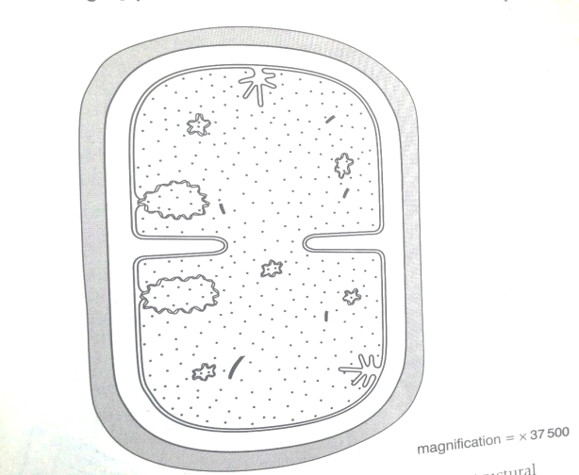

* 1. With reference to figure, state three structural features of prokaryotic cells that are not shown by eukaryotic cells. /3 **marks**
  2. Plant cells divide by mitosis, not binary fission.
     1. State three roles of mitosis in plants. /3 **marks**
     2. Explain why cells that are produced as a result of mitosis are genetically identical. /**2marks**

1. Copy and complete the following of the techniques used in gene technology / **5marks**

|  |  |
| --- | --- |
| Technique using | Purpose |
| 1. Restriction enzymes |  |
|  | To join DNA fragment together |
| 1. Vectors such as plasmids |  |
| 1. Genetic markers |  |
| 1. PCR |  |
| 1. Reverse transcriptase |  |
| 1. DNA probes |  |
|  | To make a gene from scratch |
|  | To separate fragments of DNA |
| 1. DNA sequencing |  |

1. Explain the meaning of the following /**4marks**

a. Genetic isolation

b. Reproductive isolation

1. 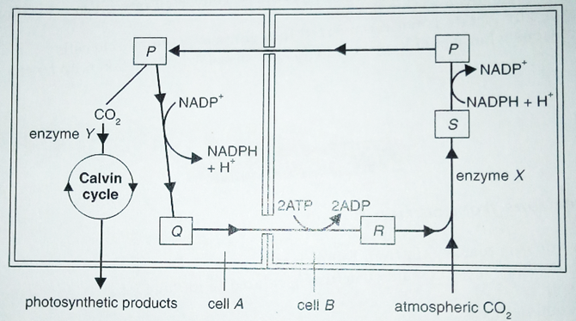The diagram below shows an outline of the main stages in the Hatch and Slack pathway in a C4 plant.
   1. Give the name of cell A and cell B. /**2marks**
   2. Name the enzyme X and enzyme Y /**2marks**
   3. State two differences between the mode of action of enzyme X and enzyme Y. /**2marks**
   4. Name the substances P, Q, R and S. /**2 marks**
2. The diagram below shows the changes in potential difference across an

axon membrane as a nerve impulse passes

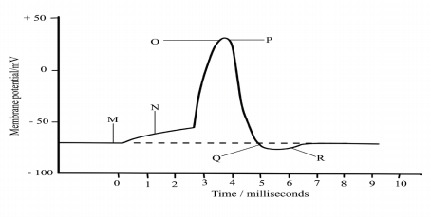

a. State what happens at M, N, O, P, Q and R as shown in the graph /**3marks**

b. Name two factors that can determine the speed of transmission of a nerve /**1mark**

impulse and how each affects the speed

c. Explain why the initiation of an action potential is considered a positive feedback mechanism /**1mark**

1. Copy and complete the table below to show the differences between mesophyll and bundle sheath cells in C4 plants. Insert a tick (✓) when an item is present in the cell and a cross (✗) when it is not. /**5marks**

|  |  |  |
| --- | --- | --- |
| **Item** | **Mesophyll cell** | **Bundle sheath cell** |
| PEP Carboxylase |  |  |
| Rubisco |  |  |
| Enzymes of Calvin cycle |  |  |
| High concentration of oxygen |  |  |
| Light dependent reactions |  |  |

**SECTION B: ATTEMPT ONLY THREE QUESTIONS OF YOUR CHOICE**

1. Starch in the diet is digested by the enzymes amylase and then maltase to form glucose. Glucose must be absorbed into the body so that it can be used by cells as substrate for respiration. The glucose is absorbed from the exchange surface of the small intestine into the epithelial cells that line it. This absorption occurs partly by diffusion.
2. Glucose molecules mostly diffuse into the cells through the pores in the proteins that span the phospholipid bilayer. Why do they not pass easily in the phosphor lipid layer? /**4marks**
3. State the two changes to the structure of plasma membranes that would increase the rate at which glucose diffuses into a cell. /**2marks**
4. The other molecule required by cells for respiration is oxygen. This diffuses into the blood through the epithelial layers of the alveoli and blood capillaries.By how much would each of the following changes increase or decrease the rate of oxygen?
5. The surface area of the alveoli is doubled. **/1mark**
6. The surface area of the alveoli is halved and the oxygen concentration gradient is doubled. /**1mark**
7. The oxygen concentration gradient is halved and the total thickness of the epithelial layers is doubled. /**1mark**
8. The oxygen concentration of the blood is halved and the carbon dioxide concentration of the alveoli is doubled /**1mark**
9. Fat and glycogen are energy storage compounds in animals.

a) Compare the two storage compounds in terms of their suitability as energy storage compounds. /**4marks**

b) State the advantages of storing fat over glycogen. /**2marks**

c) State the advantages of storing glycogen over fat. / **2marks**

d) Why is glycogen more useful as storage compound in intestinal parasite? /**2marks**

1. a) Explain the meaning and contribution of the following terms as related to evolution.

i) Non disjunction /**3marks**

ii) Environmental resistance /2**marks**

iii) Natural selection / 3**marks**

b) What is the contribution of cell biology to the study of evolution? /**2marks**

1. Discuss the adaptive significance of habituation, imprinting, classical conditioning and operant conditioning **10 marks**
2. The Figure below shows how sickle cell anaemia has affected a family line. Sickle cell anaemia is a recessive genetic defect, which is not sex linked. (Individuals are numbered 1,2, 3,………………….12)

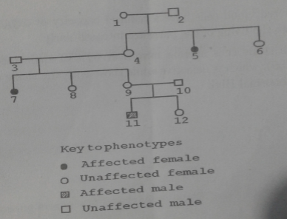

1. State the numbers of all the individuals in the family line that are certain to be heterozygous for this gene. **/2 marks**
2. What is the probability that individual 6 is heterozygous for this gene? (Show your working) **/4 marks**
3. The parasite which causes malaria digests haemoglobin in the red blood cells. Suggest two reasons why an individual who is heterozygous for this gene may show resistance to malaria. **/2 marks**
4. State the difference between individuals who have sickle cell anaemia and those that have sickle cell trait.  **/2 marks**

**MINISTRY OF EDUCATION SCHOOL YEAR:2020/2021**

**SOUTHERN PROVINCE TERM III**

**RUHANGO DISTRICT DATE:……/6/2021**

**PROMOTION: S 6 DURATION: 3hours**

**MARKING GUIDE OF BIOLOGY S6**

**SECTION A: Answer to all questions 70marks**

1. In the making of urine, glucose is initially lost from the blood but is then reabsorbed back into blood by the kidney cells. Explain why it is important that this reabsorption occur by active transport rather than diffusion. **2mks**

**ANS/ - Diffusion can reabsorb 50% of the glucose lost from the blood. The 50% will be lost from the body.**

**- Active transport can absorb all the glucose needed, less or none lost from the body.**

1. One of the properties of DNA is its ability to replicate.
2. What does DNA replication mean?**1mk**

**ANS/ DNA replication is the process in which a cell’s entire DNA is copied, or replicated.**

1. In which phase of the cell cycle does this process occur?**1mk**

**ANS/ This process occurs during the Synthesis (S) phase of the eukaryotic cell cycle.**

1. Explain how DNA undergoes semi conservative replication. **2mks**

**ANS/ In the semi-conservative model, the two parental strands separate and each makes a copy of itself. After one round of replication, the two daughter molecules, each comprises one old and one new strand.**

1. Explain the changes in the concentration of sodium ions in the renal fluid along the **6marks**
2. Descending limb of loop of Henle
3. Ascending limb of the loop of Henle
4. Collecting duct

**i. There is increase in the concentration of sodium ions in the renal fluid in the descending limb of the loop of Henle**

**Explanation: Water is extracted from the thin limb of loop oh Henle by osmotic forces generated in the hypertonic medullary interstitium. This concentrates the renal fluid and concentration of sodium ions appears to rise.**

**ii. there is reduction in the concentration of sodium ions in the renal fluid of the thick ascending limb.**

**Explanation**

**There is the site of active reabsorption of NaCl. Sodium ions are pumped out of the renal fluid into the surrounding renal interstitium, reducing its concentration in the renal fluid.**

**iii. there is reduction in the concentration of sodium ions in the renal fluid of the collecting ducts.**

**Explanation**

**Reabsorption of sodium ions occurs here by the action of aldosterone. The process occurs by reabsorption of sodium ions in exchange for potassium and hydrogen ions.**

1. Evaluate the contribution of biodiversity to human wellbeing. **2marks**

**Contribution of biodiversity to human well-being.**

* **Good health and productive livelihoods depend on ecosystem products and services, such as availability of fresh air, food, fuel sources, esthetic services, financial/economical gains, etc...**
* **Ecosystem services and goods contribute positively in human health promotion, diseases prevention and public health. But, biodiversity loss and ecosystem**

**change may limit discovery of new components of biodiversity used in traditional medicine and put at risk community health development.**

**Any 1 good idea award 2marks**

1. Explain why antibiotics are not prescribed for viral diseases **1mark**

***idea that* viruses have no, sites / targets, where antibiotics can work ; viruses have no, cell walls / ribosomes / cell membranes ;**

**Or have different enzymes**

***idea that* even if antibiotics could affect viruses, they are within cells, antibiotics cannot reach them**

1. The figure shows the Calvin cycle.



(a) (i) Name enzyme A, substances B and one of the substances formed at C. **(3 marks)**

**A- RIBISCO**

**B- Glycerate phosphate**

**C- Glucose**

(ii) Name the precise site of the reactions of the Calvin cycle. **(1 mark)**

**Stroma of chloroplast reject chloroplast**

(iii)State the number of carbon atoms in ribulose biphosphate. **(1 mark)**

**FIVE atoms**

(b) Discuss the roles of pigments and electron carriers in photosynthesis. **(2 marks**

**The many pigment molecules in each photocenter act as antennae to absorb light and transfer the energy of their excited electrons to a chlorophyll molecule that serves as a reaction center High-energy electrons are then transferred through a series of membrane carriers, coupled to the synthesis of ATP and NADPH.**

1. Give the appropriate term:
2. Relaxation of heart muscle ( **diastole**)
3. A bacterium with rod like shape (**bacillus)**
4. The functional unity of a muscle. **(Sarcomere**) **4marks**
5. Amylase present in saliva **(enzyme)**
6. a) What is the function of the protein found in chromosomes? **2mark**

**b)** How is the considerable length of a DNA molecule compacted into a chromosome**? 1mark**

**c)** Suppose the total length of all the in a single human muscle cell is 2.3 meters.

**i)** If all the DNA were distributed equally between the chromosomes.

What would be the length of DNA in each one? **1mark**

**ii)** What do you think the length of DNA is in a brain cell? **1mark**

**a) It fixes the DNA into position.**

**b) It is looped and coiled a number of times.**

**c)i) 2.3/46 =0.05m( 50mm)**

**ii) 2.3 meters ( all cells have the same quantity of DNA)**

1. Human breast milk is produced and secreted by gland cells. These gland cells have adaptations that include many mitochondria and many Golgi vesicles.The milk contains a high concentration of protein.

Explain the role of these adaptations in the production and secretion of breast milk. **2marks**

* **(Many mitochondria) release energy / ATP for movement of vesicles / synthesis of protein / active transport; 1mark**
* **(Many Golgi) vesicles transport protein / glycoprotein / milk to cell membrane / out of cell; 1mark**

1. The figure below shows a bacterial cell dividing by binary fission.



* 1. With reference to figure, state three structural features of prokaryotic cells that are not shown by eukaryotic cells. [3 **marks**]
  2. Plant cells divide by mitosis, not binary fission.
     1. State three roles of mitosis in plants. [3**marks**] ii. Explain why cells that are produced as a result of mitosis are genetically identical. [**2marks**]

**Answer**

**a) -Prokaryotic cell lacks a true nucleus.**

**-It has circular DNA rather than linear.**

**-Its DNA is not associated with histones.**

**-Its internal organelles are not bounded by a double membrane.**

**-its ribosomes are small( 70 s).**

**-Its cell wall is made of murein/ peptidoglycan.**

**-Presence of mesosomes.**

**b) i) Growth, repair, asexual reproduction, replacement ,genetic stability and regeneration.**

**ii)** They are identical because in the **anaphase stage of mitosis**, **identical sister chromatids separate and enter each new cell**. The chromatids are identical because during **the semi-conservative replication of DNA, each strand acts as a template for the complementary strand** through the pairing of the nucleotide bases ( adenine with thymine and guanine with cytosine). **The resulting two DNA helices are therefore identical and so the two cells formed during mitosis have** identical alleles and hence the same genotypes.

1. Copy and complete the following of the techniques used in gene technology **5marks**

|  |  |
| --- | --- |
| Technique using | Purpose |
| 1. Restriction enzymes |  |
|  | To join DNA fragment together |
| 1. Vectors such as plasmids |  |
| 1. Genetic markers |  |
| 1. PCR |  |
| 1. Reverse transcriptase |  |
| 1. DNA probes |  |
|  | To make a gene from scratch |
|  | To separate fragments of DNA |
| 1. DNA sequencing |  |

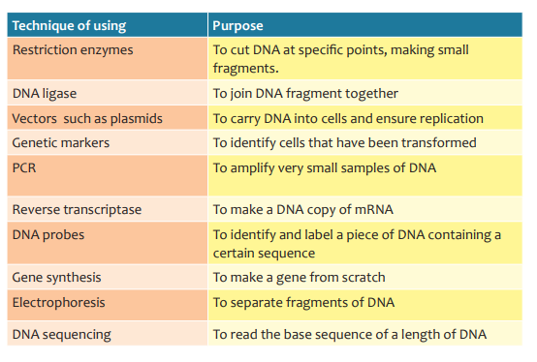

1. Explain the meaning of the following **4marks**

a. Genetic isolation

b. Reproductive isolation

a) **Genetic isolation** **occurs when mating can occur but fertilization is not** **possible and or even when it occurs, the product is sterile or inferior offspring due to incompatible genetic constitution between organisms of a population**

**b)** **Reproductive isolation involve failure of interbreeding among organisms of a population. This may be as a result of attractiveness between males and females or non-correspondence of genitals**

1. 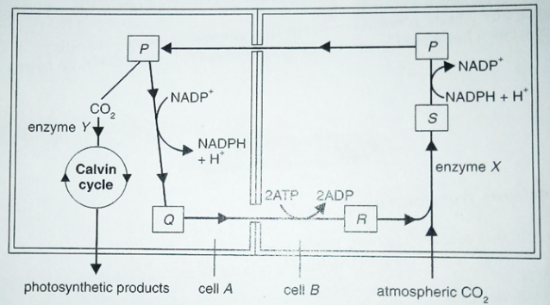The diagram below shows an outline of the main stages in the Hatch and Slack pathway in a C4 plant.
   1. Give the name of cell A and cell B. **2marks**
   2. Name the enzyme X and enzyme Y **2marks**
   3. State two differences between the mode of action of enzyme X and enzyme Y. **2marks**
   4. Name the substances P, Q, R and S. **2 marks**

**a) cell A: bundle sheath cell**

**Cell B : mesophyll cell**

**b)enzyme X :RUBISCO**

**Enzyme Y: PEP carboxylase**

**c) rubisco can fix two different substrates carbon dioxide and oxygen but PEP carboxylase fix only carbon dioxide**

**d) P=MALATE Q=PYRUVATE R=PEP S= OXALOACETATE**

1. The diagram below shows the changes in potential difference across an

axon membrane as a nerve impulse passes



a. State what happens at M, N, O, P, Q and R as shown in the graph **3marks**

b. Name two factors that can determine the speed of transmission of a nerve **1mark**

impulse and how each affects the speed

c. Explain why the initiation of an action potential is considered a positive feedback mechanism **1mark**

**Answer**

a) M – **Represents the resting potential**. The resting potential of the axon is –70mV. The

inside of the axon is negatively charged with respect to the outside of the neurone.

The resting potential is maintained by the sodium potassium pump and the relative

permeability of axon membrane to K+ and Na+ ions.

N**- The axon is stimulated**, some voltage- gated sodium channels open and Na+ ions

diffuse into the axon down a concentration gradient and electro-chemical gradient.

The axon membrane is polarized.

O**- The threshold level is exceeded**. More voltage- gated sodium channels open and

more Na+ ions diffuse rapidly into the axon. This is an example of positive feedback.

The membrane potential reverses from -70mV to +40mV. The inside of the axon

membrane is positively charged with respect to the outside.

P- **Repolarisation occurs**. The sodium channels closed and the voltage gated potassium

channels open. Potassium ions diffuse out of the axon down a concentration and

electro-chemical gradient and the membrane potential decreases.

Q- **Hyperpolarisation occurs**. The potassium channels are slow to close. An excess

of K+ ions diffuse out from the axon. The inside of the axon become more negative

slightly below -70mV.

R- **Within a few milliseconds the K+ channels close. There is a short period where**

**membrane protein channels undergo conformational changes.** During this period,

the membrane becomes refractory and cannot respond to a normal stimulus.

The resting potential is then re-established by the Na+/K+ pump and the different

permeability of membrane to K+ and Na+ ions.

b) The two factors that can determine the speed of transmission of a nerve impulse

and how each affects the speed: **0.5 mark for a correct factor**

**• Presence of a myelin sheath which acts as an electrical insulator. The action**

**potential leaps from one node of Ranvier to the next node. This speeds up**

**the rate of transmission of nerve impulse.**

**• The lager the diameter, the faster the speed of transmission**

c**) Sodium voltage –gates are sensitive to voltage changes. When some voltage –**

**gated sodium channels are stimulated to open, Na+ ions diffuse into the neurone.**

**This in turn stimulates more voltage –gated sodium channels to open and there is a**

**rapid influx of Na+ ions. This is an example of positive feedback mechanism.**

**1mark for a correct answer**

1. Copy and complete the table below to show the differences between mesophyll and bundle sheath cells in C4 plants. Insert a tick (✓) when an item is present in the cell and a cross (✗) when it is not. **5marks**

|  |  |  |
| --- | --- | --- |
| **Item** | **Mesophyll cell** | **Bundle sheath cell** |
| PEP Carboxylase |  |  |
| Rubisco |  |  |
| Enzymes of Calvin cycle |  |  |
| High concentration of oxygen |  |  |
| Light dependent reactions |  |  |

**Answer**

|  |  |  |
| --- | --- | --- |
| **Item** | **Mesophyll cell** | **Bundle sheath cell** |
| **PEP Carboxylase** | **v** | **x** |
| **rubisco** | **x** | **v** |
| **Enzymes of calvin cycle** | **x** | **v** |
| **High concentration of oxygen** | **v** | **x** |
| **Light dependent reactions** | **v** | **x** |

**SECTION B: ATTEMPT ANY THREE QUESTIONS OF YOUR CHOICE**

1. Starch in the diet is digested by the enzymes amylase and then maltase to form glucose. Glucose must be absorbed into the body so that it can be used by cells as substrate for respiration. The glucose is absorbed from the exchange surface of the small intestine into the epithelial cells that line it. This absorption occurs partly by diffusion.
2. Glucose molecules mostly diffuse into the cells through the pores in the proteins that span the phospholipid bilayer. Why do they not pass easily in the phosphor lipid layer? **4marks**
3. State the two changes to the structure of plasma membranes that would increase the rate at which glucose diffuses into a cell. **2marks**
4. The other molecule required by cells for respiration is oxygen. This diffuses into the blood through the epithelial layers of the alveoli and blood capillaries.By how much would each of the following changes increase or decrease the rate of oxygen?
5. The surface area of the alveoli is doubled. **1mark**
6. The surface area of the alveoli is halved and the oxygen concentration gradient is doubled. **1mark**
7. The oxygen concentration gradient is halved and the total thickness of the epithelial layers is doubled. **1mark**
8. The oxygen concentration of the blood is halved and the carbon dioxide concentration of the alveoli is doubled **1mark**

**a) Because only lipid-soluble substances diffuse across the phospholipid bilayer easily. Water soluble ones such as glucose diffuse only very slowly. 4marks**

**b) It could increase its surface area with microvilli or have more proteins with pores that span the phospholipid bilayer(N.B. the thickness of the plasma membrane does not vary to any degree. 2mark**

**c) i) Increases two times/doubles 1mark**

**ii) no change 1mark**

**iii) Decreases four times/ it is one quarter. 1mark**

**iv) Increases two times/ doubles( the CO2 is irrelevant) 1mark**

1. Fat and glycogen are energy storage compounds in animals.

a) Compare the two storage compounds in terms of their suitability as energy storage compounds. **4marks**

b) State the advantages of storing fat over glycogen. **2marks**

c) State the advantages of storing glycogen over fat. **2marks**

d) Why is glycogen more useful as storage compound in intestinal parasite? **2mark**

**Answer**

**a) similarities 2marks any two similarities**

**Both are less soluble in water: None of stored substance is lost in solution.**

**Both are less chemically reactive: can be stored over a long time without alteration.**

**Both are compactly arranged: very much can be packaged in a small space.**

**Differences 2marks any two correct differences**

|  |  |
| --- | --- |
| **Fat** | **Glycogen** |
| **-Yield more energy per gram**  **- Has less weight minimum while storing more energy**  **- Yield more metabolic water** | * **Yields less energy per gram** * **Has more weight and may lead to over weight is stored in large quantities** * **Yields less metabolic water** |

**b)**

* **Fat yields more metabolic water upon oxidation**
* **Fat yields more energy per gram upon oxidation**
* **Fat is completely insoluble in water: none is lost in solution**
* **Fat forms an insulating layer under the skin: helps in temperature regulation apart from energy storage.**
* **Fat is ligther than glycogen and helps to keep body weight to minimum.**

**c)**

* **Break down of fat to fatty acid which can then be utilised is a slow process because it is induced by hormones.**
* **Conversion of glycogen to glucose is fast because it involves enzymes which are readily available in muscles.**
* **Glucose from glycogen enters directly into glycolysis to produce energy.Fatty acids have to first undergo beta oxidation.**
* **Oxidation of fats produces more heat, which would lead to burning out of the muscle cells.**
* **On top of lactic acid, anaerobic respiration of fats also produces ketocids.This would lead to lethal acid accumulation in muscles.**

1. a) Explain the meaning and contribution of the following terms as related to evolution.

i) non disjunction **3marks**

ii) environmental resistance **2marks**

iii) natural selection **3marks**

b) What is the contribution of cell biology to the study of evolution? **2marks**

**Answer**

a)(i) -Non-disjunction: **Failure of two homologous chromosomes of a pair to separate to opposite** poles at Meiosis I so **that one daughter cell has both chromosomes and the other neither.** It is a **type of mutation (an addition) which introduces new genetic novelities and contributes to speciation**. **3marks**

(ii) -Environmental resistance: Factors of environment which limit the growth of a population.

E.g. shortage of food, water,O2,etc. Evolution operates by natural selection of those characters that adapt organisms to the environmental disabilities and therefore these play a role of directing the pace of evolution. **2marks**

(iii) -Natural selection: The **influence of environmental pressures** like predation, shortage of food, etc on **the reproductive potentials / successes** of organisms such that **there is differential contribution to the succeeding generations depending on the extent of such pressures**. **3marks**

b) Cell biology: it provides evidence for evolution. The basic similarity in the structure and functioning of cells, and the ubiquitous occurrence of many biochemical molecules, suggests a common ancestry for all animal and plant cells. **2marks**

1. Discuss the adaptive significance of habituation, imprinting, classical conditioning and operant conditioning **10 marks**

Answers

* **Learning** is a change of behavior that results from experience.
* **Habituation** is a type of learning in which an animal learns to ignore a repeated, irrelevant stimulus so the animal can focus on finding food and carrying out other life activities.
* **Imprinting** establishes a parent–offspring bond during a critical period early in development, ensuring that the offspring recognizes the mother.
* **In classical conditioning**, an association is formed between some normal body function and a new stimulus. This type of learning allows an animal to make an association between two stimuli.
* **In operant conditioning**, an animal learns a behavior to receive positive reinforcement or to avoid punishment. This type of learning is important in many natural situations, including young herring gulls perfecting their pecking behavior to obtain food.

**2MARKS FOR EACH CORRECT ANSWER**

1. The Figure below shows how sickle cell anaemia has affected a family line. Sickle cell anaemia is a recessive genetic defect which is not sex linked. (Individuals are numbered 1,2, 3,12)



1. State the numbers of all the individuals in the family line that are certain to be heterozygous for this gene. **(2 marks)**
2. What is the probability that individual 6 is heterozygous for this gene? (Show your working) **(4 marks)**
3. The parasite which causes malaria digests haemoglobin in the red blood cells. Suggest two reasons why an individual who is heterozygous for this gene may show resistance to malaria. **(2 marks)**
4. State the difference between individuals who have sickle cell anaemia and those that have sickle cell trait. **(2 marks)**

**Answer**

**(a) 4 and 9**

**Note 3,9 and 10, must both be heterozygous in order to be able to produce an affected individual in their offspring. However, 3 and 10 are just partners, only 4 and 9 belong to the family line**

**(b) Possible heterozygous include 1,2,3,4,6,8,9,10,12.**

**Number of possible heterozygotes: 9**

**Probability that 6 is heterozygous 1/9**

**(c)**

* **Some of their red blood cells have a reduced capacity of oxygen carriage so that they cannot support the living of the parasites intracellularly**
* **Some of their red cells are sickle shaped and fragile that their life span is markedly reduced**
* **Some of their red blood cells contain hemoglobin S which is not a substrate for digestion by the parasite**

**(d)**

**Individuals with sickle cells anaemia have over 60% of their red blood cells containing haemoglobin S, which is defective while those with the sickle cell trait have not more than 50% of the abnormal haemoglobin S.**