MINISTRY OF EDUCATION SCHOOL YEAR: 2020/2021
SOUTHERN PROVINCE TERM III
RUHANGO DISTRICT- DARE:…/…./2021
PROMOTION: S6 DURATION: 3HOURS

CHEMISTRY EXAMINATIONS FOR S6 MCB, PCB, PCM, BCG /100MARKS

INSTRUCTIONS:
This paper consists of three sections A,B and C
- Attempt all questions in section A /55marks
- Attempt any three questions in section B /30marks
- Section is compulsory /15marks
- Periodic table is not allowed

Section A: attempt all question 55marks

1. The ester CH₃CH₂CH₂CO₂CH₂CH(CH3)₂ was hydrolyzed under acidic conditions.
What are the organic products of this hydrolysis? (1marks)
A) Butanoic acid and 2-methylpropan-1-ol B) Butanoic acid and 2-methylpropan-2-ol C) Butan-1-ol and 2-methylpropanoic acid D) Bropanoic acid and 2-methylpropan-1-ol
2.Calculate the percentage composition of oxygen in hydrated sodium sulphate, Na₂SO₄.10H₂O (Na=23, S=32, O=16, H=1) (2marks)
3.An element on the periodic table can be represented as${}_{29}^{64}M$
a) How may protons and electron does element M has (2marks)
b) Most of the compounds of element M appear as blue in color. Explain - (2marks)
4. a) Differentiate nuclear fusion from nuclear fission of the radioactive nuclide (2marks)
b) A short decay series of Thorium is shown below. calculate the number of protons of each new elements A, B and C formed. (1.5marks)
${}_{90}^{232}{Th}$ABC
5. When a constant current was passed through an aqueous solution of copper (II) nitrate for one hour the mass of the copper cathode increased by 15.24 g. Calculate the current in ampere (F=96500C, C=63.5) (2marks)
6. Compounds Q and R have the same molecular formula C₄H₈O. Compound Q on oxidation turns the orange color of acidified potassium dichromate to green but R does not. When a solution of iodine is added followed by enough solution of sodium hydroxide, a pale yellow precipitate is formed in a container containing compound R while Q does not react.
a) Write the structural formula of compound Q and R and their name according to IUPAC nomenclature style (2marks)
b) Write the formula of the pale yellow precipitate formed when R react with iodine solution. (1marks)
c) The reduction of Q gives a compound P
(i) Identify the compound P (1marks)
(ii)One of the isomers of P gives positive results immediately when reacted with a solution of ZnCl₂ acidified by HCl (Lucas reagents). Identify the isomer. (1marks)
7. (a) Explain what is meant by the term average bond enthalpy. (1marks)
b. Use the average bond enthalpy data below to calculate a value for the molar enthalpy change for the following reaction. (2marks)
C3H8(g) + 5O2(g)  3CO2(g) + 4H2O (g)
Bond | C–C | C–H | O=O | C=O | H–O
Average bond enthalpy/kJ/mol | 348 | 412 | 496 | 743 | 463
8. Rubber is a natural polymer which is formed form monomer; 2-methyl 1,3-butadiene
a) Write the structure of 2-methyl 1,3 butadiene (1.5marks)
b) Describe how rubber (polyisoprene) is formed by joining 3 molecules of 2-methyl 1,3 butadiene (2marks)
c) Write the repeating unit of the polymer formed in (b) above (2marks)
d) Give one use of rubber (1mark)
9. a) For the reaction 2A_{(g)}+B_{(g)}5C_{(g)}, the initial concentration of A and B are 1.5M and 0.7M respectively. If the equilibrium concentration of C is 2M. calculate the value of Kc and state its unit (3marks)
b) What it the effect increasing pressure on the position of equilibrium above (2marks)
10. Explain the following observation;
a) Water is preferably used as coolant than ethanol (both water and ethanol are liquids with the specific heat capacities of 4.18J/g.⁰c and 2.24J/g⁰c respectively) (2marks)
b) Aluminum utensils are not washed in strong alkaline solutions (2marks)

11.a) Define the term “buffer solution” (1mark)
b)0.61g of benzoic acid (C₆H₅COOH) were dissolved in 1L of 0.02M sodium benzoate to form a buffer solution. Calculate the PH the buffer solution formed(C=12, H=1,O=16, Ka=6.3×10⁻⁵mol/dm) (2marks)
c) State what would happens to the PH of the solution in (b) above when the small amount of the following were added
(i)sodium hydroxide solution (ii)hydrochloric acid (2marks)
12. Chlorine is used in the preparation of bleaching agents and iodine. (a) Write the reaction of Chlorine with water and mention the bleaching group. (2marks) (b) Bromine is extracted from sea water by oxidising bromide ions with chlorine gas. (i) Write the ionic equation for this reaction. (2marks (ii) Explain why chlorine is strong oxidising agent compared to bromine. (2marks)
13. Use the data below, where appropriate, to answer the questions which follow
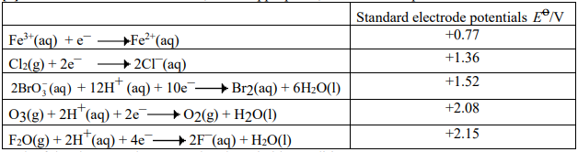
Each of the above can be reversed under suitable conditions
a) (i) Identify the most powerful reducing agent in the table. (1mark)
(ii) Identify the most powerful oxidizing agent in the table. (1mark)
(iii) Identify all species in the table which can be oxidized in acidic solution by
BrO³⁻(aq) (2marks)
(b) The cell represented below was set up.
Pt|Fe²⁺(aq), Fe³⁺ (aq) || BrO₃⁻ (aq), Br₂ (aq)|Pt
(i) Deduce the e.m.f. of this cell and tell whether this reaction is feasible or not. (2marks)
(ii) Write a half-equation for the reactions occurring at each electrode. (2marks)

Section B: Attempt only three questions
14 (a) Define the term standard enthalpy of combustion. (2 marks)
(b) Write an equation for the complete combustion of ethanol, C₂H₅OH. (1 mark)
(c) The following table gives some standard enthalpies of formation.
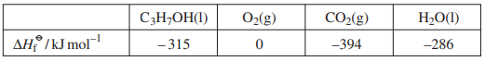
Use these data to calculate a value for the enthalpy of combustion, ∆Hc , of propan-1-ol, C₃H₇OH(l) + 4O₂(g) → 3CO₂(g) + 4H₂O(l) (3 marks)
(d) In an experiment 0.92 g of propan-1-ol, C₃H₇OH, was burned and the heat given off used to raise the temperature of 250 g of water. The temperature rise was 16 °C. The specific heat capacity of water is 4.2 J K⁻¹ g⁻¹. Calculate a value for the enthalpy of combustion of one mole of propan-1-ol. (3 marks)
(e) Suggest why the experimental value of the enthalpy of combustion obtained in part (d) is less reliable than the value obtained in part (c). (1 mark)
15. (a) (i) On the axes below, draw a Maxwell-Boltzmann distribution of molecular energies for a gas at temperature T1 and T2 greater than T1 . Ea is the activation energy for a reaction involving this gas. (2marks)
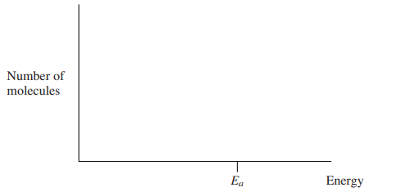
(ii) State the meaning of the term activation energy. (1mark)
(iii) Explain why reactions involving gases become faster as the temperature
increases. (1mark)
b) (a) The initial rate of the reaction between the gases P and Q was measured in a series of experiments at a constant temperature and the following rate equation was determined.
rate = k[P][Q]²
(i) Complete the table of data below for the reaction between P and Q. (3marks)
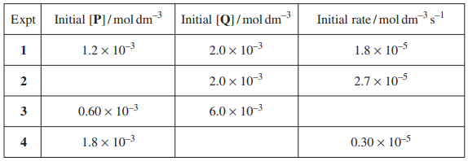
(ii) Using the data from experiment 1, calculate a value for the rate constant, k, and state its units. (3marks)
16 (a) A polymer is formed when propane-l,3-diamine reacts with pentanedioic acid. Name the type of polymerisation reaction which occurs and draw the structure of the repeating unit of the polymer formed. (2 marks)
(b) The repeating unit shown below represents the polymer commonly known as poly (vinyl acetate) or PVA.
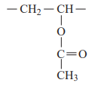
(i) Draw the structure of the monomer which is used to make PVA. (1mark)
(ii) Draw the repeating unit of the polymer formed when PVA reacts with an excess of aqueous sodium hydroxide. (1mark)
(c) The amino acids alanine and serine are shown below.
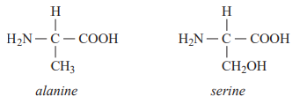
- Draw the structures of the two dipeptides formed by the reaction of alanine with serine. (2marks)
- Draw the structure of the zwitterion of serine. (1mark)
- Draw the structure of the organic compound formed when alanine reacts with methanol in the presence of a small amount of concentrated sulphuric acid. (1mark)
- Draw the structure of the organic compound formed when one molecule of serine reacts with two molecules of ethanoyl chloride. (2marks)
17.There are trends in the properties of the elements, and of their compounds, both across periods and down groups in the Periodic Table.
(a) There is a general increase in the values of the first ionisation energies of the Period 3 elements Na to Ar.
(i) State the meaning of the term first ionisation energy of an element. (1 mark)
(ii) Explain this general increase in the values of the first ionisation energies. (1 mark)
- Explain why the value of the first ionisation energy of Al is lower than that of Mg. (1mark)
(b) The boiling points of some hydrogen halides are shown in the table below.
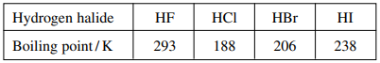
Explain, in terms of the intermolecular forces present, why
(i) The boiling point of hydrogen fluoride(HF) is much higher than those of the other hydrogen halides. (1mark)
(ii) The boiling points increase from HCl to HI. (1mark)
(c) Write equations for the reaction of Na2O and of SO2 with water. (2marks)
(d) Write an equation for the reaction of P4O10 with an excess of aqueous sodium hydroxide. (1mark)
18. 7.00 g of an impure sample of tin were reacted with dilute HCl to convert it to Sn²⁺ ions in aqueous solution. The solution was made up to 1dm³ with distilled water. 25.0cm³ of this solution were titrated with 0.02M of acidified KMnO₄ solution. 24.00cm³ of the MnO₄ ⁻ solution were needed to react completely with 25.0cm³ of the Sn²⁺ (aq) .
The relevant half-equations are:
MnO₄ ⁻ + 8H⁺ + 5e- → Mn²⁺ + 4H₂O
Sn²⁺ → Sn⁴⁺ + 2e
a) Write a well-balanced redox equation for the reaction between Sn²⁺ and acidified MnO₄– . (2marks)
b) Calculate the changes in oxidation number of manganese (Mn) in the overall redox reaction. (2marks)
c) Calculate the number of moles of MnO₄ ⁻ in 24.00 cm³ of the solution. (2marks)
d) Calculate the number of moles of Sn²⁺ in 25.0 cm³ of solution and hence the molar concentration of Sn²⁺ . (2marks)
e) Calculate the percentage of tin in the original sample of of tin [ Ar(Sn) = 119] (2marks)

SECTION C: THIS SECTION IS COMPULSORY/ 15MARKS
ALTERNATIVE TO PRACTICAL CHEMISTRY
19. A student prepares a sample of sodium sulfate crystals using a titration method.
The student transfers 25.0 cm3 of 1.00 mol /dm³ sodium hydroxide to a conical flask and adds dilute sulfuric acid from a burette. After each addition of sulfuric acid, the student records the pH of the solution, measured by a pH meter.
The apparatus and table of results are shown.
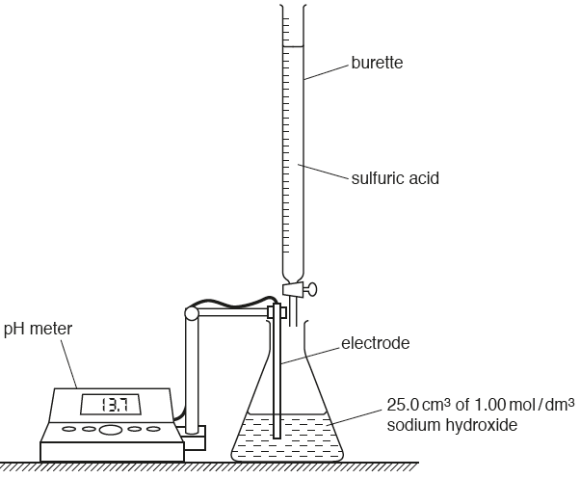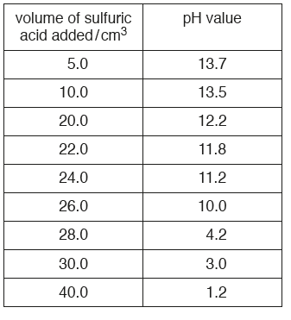
(a) Plot the points on the grid. Draw a smooth curve through all of the points. Extend your line to cross the y-axis. (5marks)
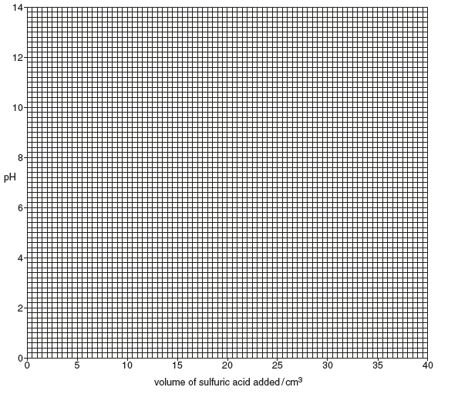
(b) Use the graph to answer the following questions.
(i) What is the pH of 25.0 cm3 of 1.00 mol / dm3 sodium hydroxide (1mark)
(ii) What is the pH of the solution when 15.0 cm3 of acid is added? (1mark)
(c) (i) At the end-point of the titration, the pH changes rapidly when only a small volume of acid
is added. Use your graph to suggest the pH of the solution at the end-point. (1mark)
(ii) Using your answer to (i) and your graph, what volume of acid is required to neutralise
25.0 cm3 of 1.00 mol / dm3 sodium hydroxide? (2marks)
(d) Sulfuric acid reacts with sodium hydroxide.
H2SO4 + 2NaOH → Na2SO4 + 2H2O
Using the equation and your answer to (c)(ii), calculate the concentration of sulfuric acid
used in the experiment. (2marks)
(e) The experiment is repeated using different masses of sodium chloride. The results are shown in the table
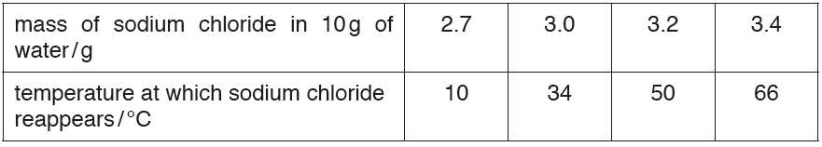
- Plot the graph of solubility of sodium chloride(NaCl) on the grid against temperature. (2marks)
- Explain the effect of temperature on solubility. (1marks)

Good luck!!!!!!!!!!!!!!!!!!!
MINISTRY OF EDUCATION SCHOOL YEAR: 2020/2021
SOUTHERN PROVINCE TERM III
RUHANGO DISTRICT
PROMOTION: S6

CHEMISTRY EXAMINATIONS MARKING GUIDE/100MARKS

SECTION A
1. A /1marks
2. Mr=324g/mol
% oxygen=224g*100/324g=69% /2marks
3.a) P=A-Z, P=64-29=35protons/ 2marks
b) Most of compounds of copper are in the stable oxidation state of +2 in which the 3d-orbital is partially filled. The electrons in this 3d orbital tend to move to higher energy level and as they come back they emit radiations falling in the visible region of the spectrum. (Blue color). /2marks
4.a) Give full marks for one difference among the following/ 2marks
Nuclear fission | Nuclear fusion
1. Bigger nuclei(heavier nuclei) splits into smaller nuclei | 1. Lighter nuclei fuse together to form the heavier nuclei
2.It does not require high temperature | 2. Higher temperature is required
3. A chain reaction set in | 3. It is not a chain reaction
4. It can be controlled | 4. Can’t be controlled
5.At the end of reaction nuclear wave is left behind | 5.No nuclear waste is left at the end of fusion reaction
b) According to decay series, elements A, Band C are represented as ${}_{88}^{228}A$, ${}_{89}^{228}B$, ${}_{87}^{224}C$ respectively
P=A-Z, so, A has 140protons, B has 139protons and C has 137protons. /Give 0.5 mark for a correct number of protons
5.M=$\frac{I.t.m}{n.F}$
I=$\frac{M.n.F}{t.m}$=$\frac{15.24*2*96500}{3600*63.5}$=12.86A/2marks
6. a) Q:CH₃CH₂CH₂CHO(butanal) OR CH₃CH(CH₃)CHO (2-methyl propanal)/ 1mark
R: CH₃COCH₂CH₃ (butanone)/1mark
b) yellow precipitate CHI₃ /1mark
c) (i)P:CH₃CH₂CH₂CH₂OH OR CH₃CH(CH₃) CH₂ OH /1mark
(ii) Isomer of P: 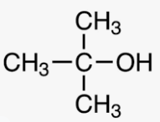 2-methyl propan-2-ol /1mark
7.a) The average bond enthalpy is the amount of energy required to break a specific type of bond. /1mark
b)
Enthalpies of bond broken | Enthalpies of bonds formed
2C-C, =2*348=696  8C-H, =8*412=3296  5O=O, =5*496=2480  TOTAL=6472KJ/mol | 6C=O, =6*743=4458  8H-O, =8*463=3704  TOTAL=8162KJ/mol
Hr.= (6472-8162) KJ/mol= -1690KJ/mol/2marks
8. a) CH₂=CH(CH)₃CH=CH₂: 2-methyl 1,3- butadiene/2marks
b) 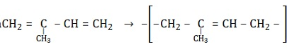3 /2marks
c) 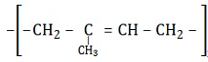 /2marks
d) Natural rubber is used in manufacture of :
- Rubber tubes
- Shoes soles and door stoppers /1marks for a correct use of rubber
- Rubber bands
- Rubber hoses and rubber cups
9. a)
 | 2A(g) | B(g) | 5C(g)
Initial(mol/dm³) | 1.5 | 0.7 | 0
Change(mol/dm³) | -0.8 | -0.4 | 2
Equilibrium(mol/dm³) | 0.7 | 0.3 | 2
Kc=[C]⁵/[A]²[C]=(2)⁵/(O.7)²(0.3)=217.68mol²dm⁻⁶ /3marks
b) increasing pressure shift the equilibrium in the position where there is a big number of moles. i.e forward reaction is favored/ 2marks
10) a) The high specific heat of water allows it to absorb a lot of heat energy without large increase in temperature/2marks
b) This is because alumimium reacts vigorously with alkalis like NaOH solution forming aluminate and hydrogen gas. 2Al(s) + 2NaOH(aq)+ 6H₂O(l)2NaAl(OH)_{4 (aq)} + 3H₂ /2marks
11. a) Buffer solution is a mixture of weak acid and its conjugate base or weak base and its conjugate acid which resist to the PH change when a small amount of strong acid or base is added./ 1mark
b) M of C₆H₅COOH is 122g/mol
[Adic]=0.6/122=0.005M
PH=PKa +log$\frac{[salt]}{[Acid]}$, PH=-log(6.3*10⁻⁵)+log$\frac{[0.02]}{[0.005]}$, PH=4.8 /3marks
c) i) The addition of H+ reacts with excess C₆H₅COO- to form C₆H₅COOH to maintain the equilibrium hence the PH remains constant.
eqn: C₆H₅COO⁻ + H⁺ ⎯⎯ → C₆H₅COOH /1mark
ii) The addition of OH⁻ reacts with C₆H₅COOH to form C₆H₅ COO- and water to maintain the equilibrium hence the PH remains constant.
eqn: CH3COOH + OH⁻ ⎯⎯ → C₆H₅COO⁻ + H₂O /1mark
12.a) Cl₂ (g)+H₂O(l) HCl(aq)+HClO(aq)
The bleaching group is HClO (aq)/2marks
b) 2Br⁻(aq)+Cl₂(g) 2Cl⁻(aq)+ Br₂(g)/2marks
c) Chlorine has the ability to take electrons from the other ions than bromine due to its higher electronegetivity13.a) i) Fe²⁺ /1mark
ii) F₂O /1mark
iii)Fe²⁺ and Cl⁻ /2marks
b) i)emf=E_{cathode} – E_{anode}=1.52V-0.77V=0.75V /2marks
ii) Anode: Fe²⁺ (aq)Fe³⁺ (aq)+1e⁻ /1mark
Cathode: BrO₃⁻ (aq) + 12H⁺ (aq)+ 10e⁻ Br₂ (aq)+6H₂ O(l)/1mark
SECTION B
14
- Enthalpy change when 1 mole of compound is completely burned in oxygen under standard conditions [2]
- C2H5OH + 3O2 Æ 2CO2 + 3H2O 1mark
- ΔH = Σ ΔHf products - Σ ΔHf reactants (or correct cycle)
(−393 x 3) + (−286 x 4) – (−315) = − 2011 kJmol- [3marks]

- Q = mcΔT 1 250 x 4.2 x 16 = 16800 J [1mark]
Moles propanol = 0.92/60 (= 0.0153) [1mark]
ΔHc = 16800/0.0153 = − 1096 kJmol−1 (allow answers in range − 1090 to − 1120 ) [1mark]
- Heat loss occurs in (d)/ no heat loss in (c) / incomplete combustion in (e) [1mark]

15
- (i)
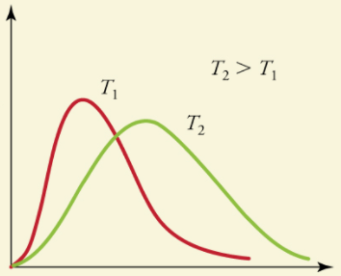 [2marks]
- Minimum energy needed for a reaction to occur [1mark]
- More molecules have energy greater than the activation energy
Therefore there are more successful collisions [1mark]
b) (i) Expt 2 : 1.8 x 10⁻³ Expt 3 : 8.1 x 10⁻⁵ Expt 4 : 6.7 x 10⁻⁴ [3marks]

(ii) k = $\frac{Rate}{\left[P\right]{[Q]}^{2}}= \frac{{1.8×10}^{-3}}{(1.2×{10}^{-3}){(2.0×{10}^{-3})}^{2}}$ [3marks]
= 3750 ml⁻²dm⁶s⁻¹

16
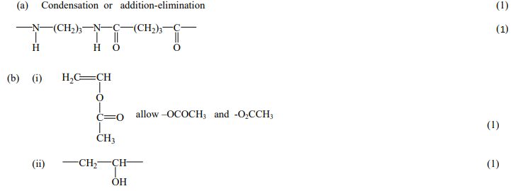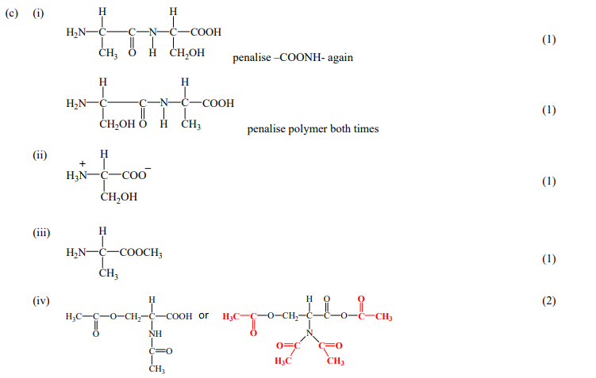

17. a)
- Energy required to remove one electron from a gaseous atom. [1mark]
- Increase in number of protons/nuclear charge; Decrease in size / e- closer to nucleus same/similar shielding / same shells [1mark]
- Electron removed from 3p orbital/sub-shell in Al rather than 3s in Mg; [1mark]
Or Al loses e- which is of higher energy /is further away from nucleus /is shielded by 3s electrons;
(b) (i) HF has hydrogen bonding / allow H-bonding [1mark]
(ii) Van der Waals’ forces / increase with size / surface area increase (HCl to HI) [1mark]
(c)Na2O(s) + H2O(l) → 2NaOH(aq) [1mark]
SO3(g) + H2O(l) → H2SO4(aq) [1mark]
(d) P4O10 + 12NaOH(aq) → 4Na3PO4(aq) + 6H2O(l) [1mark] (accept unbalanced equation)
18
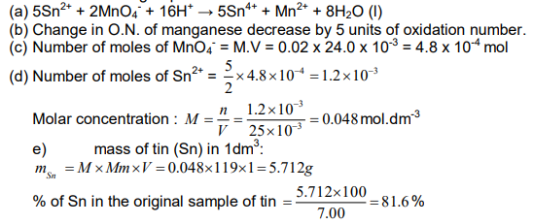
SECTION C: 15 MARKS
19.
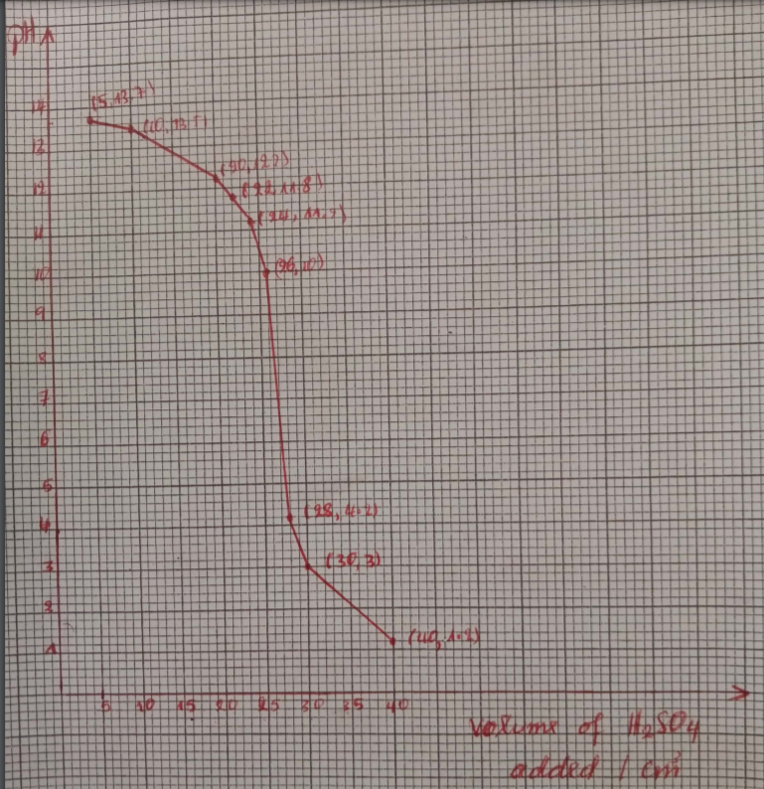

a)  (b)(i)  (II)  C(i)  (ii)  d)  e) (i)  (ii) | M1 All points plotted correctly (2)  M2 Smooth curve (1)  M3 Extension of line to cross y-axis (2)  13.9 (1)  13.0 (1)  7.0 (1)  27.5 (cm3) (2)  (Moles H2SO4 =) 0.0125 (2)  0.455 mol / dm3 (1)  based on 6(c)(ii) = 27.5 cm3  Graph - points (1), line (1)  As temperature increases the solubility increase (2)
