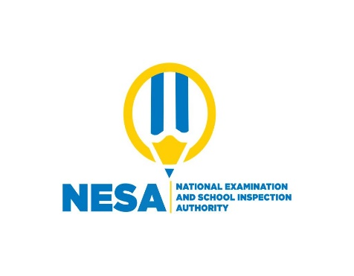
ENGLISH

P2 END OF YEAR EXAMINATIONS, 2021
SUBJECT: ENGLISH
PUPIL’S NAME: ………………………………………………………………………………………………
SCHOOL: ………………………………………………………………………………………………………….
DURATION: 2 HOURS
MARKS:
/20

INSTRUCTIONS

- Don’t open this question paper until you are told to do so.
- All questions are compulsory.
- Read each question carefully before answering it.
- Answer the questions in the space provided on this question paper.
- Use only a blue or black pen.

- GRAMMAR
- Choose the best answer. (3 marks)
- She ………….a girl (are, is)
- I ………… a pen (has, have)
- Every day, we……..to school (go, goes)

- Complete by filling in: a, an (3 marks)
- This is ……..animal.
- She is……….teacher.
- They have……..ball.

- Complete by filling in the missing letters. (3 marks)
- B….x
- F…ther
- C…t

- Complete with: our, his, her (3 marks)
- She lost……………...bag.
- He ate………………..food.
- We cleaned ………………..class.

- Change the following words into plural. (3 marks)
- A bag.………………..………………
- A dish …………………………..……
- A bus ……………….…………….....

- VOCABULARY
A. Match the words in A with their opposites in B. (3 marks)
A B
Good Girl
Father Bad
Boy Mother

B. Name the following objects. (2 marks)
- 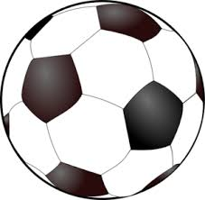 This is a …………..

- 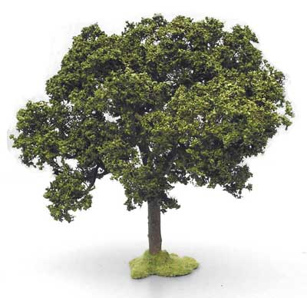 This is a ……………….

Marking Guide
I. GRAMMAR
- Choose the best answer (3 marks)
- is
- have
- go

B. complete by filling in: a, an (3 marks)
1) an
2) a
3) a
C. Complete by filling in the missing letters (3 marks)
- Box
- Father
- Cat
D. Complete with: our, his, her (3 marks)
- her
- his
- our
H. Change the following words into plural (3 marks)
- bags
- dishes
- buses
II. VOCABULARY (3 marks)
A. Match A with B
A B
Good Bad
Father Mother
Boy Girl

B. Name the objects. (2 marks)
- A ball
- A tree

