ENGLISH

P3 END OF YEAR EXAMINATIONS, 2021

SUBJECT: ENGLISH

Duration: 2 Hours
/30
Marks:

INSTRUCTIONS

- Don’t open this question paper until you are told to do so.
- All questions are compulsory.
- Read each question carefully before answering it.
- Answer the questions in the space provided on this question paper.
- Use only a blue or black pen.

Section A: Comprehension
Read the story below carefully and answer the questions that follow in full sentences.
Using fresh products
Madame Jane Dusabe lives in Muhanga District. She has three children. These are: Agnes, Alice and Tom Ganza. Jane gave Alice two thousand Rwandan francs to buy bread. The bread costs 1200Frw. They ate the bread. After a short while, everyone had a stomachache. Jane checked the packaging instructions and found out that the bread had expired. Madam Jane Dusabe told her children “Always check the expiry date before buying any product. Eating expired products is bad for our health”
Questions (5 marks)
- What is the heading of the story?.......................................................................
- What did Alice buy?................................................................................................
- Why do you think they all had stomachache?....................................................
- How much balance did Alice take back home?...................................................
- What does this story teach you?..........................................................................

Section B: Grammar
- Complete the sentences by filling in: “is” or “are” (3 marks)
- This dress ……………very big.
- Those …………….pencils.
- You ………………not very busy.

- Fill in the gaps with the correct article: “ a” , “an ” or “the ” (3 marks)

- It was ……… evening I shall never forget.
- Who is ………..tallest pupil in your class?
- I shall go to the shop and buy ……….. envelope

- Choose the right answer from the brackets to complete the sentences. (3 marks)
- Yesterday, I …………………four pens but I remain with one. (had / have)
- A lion ……………………… a big animal. (is / was / were)
- She ………………………… her homework with her father. (goes / does)

- What time is it? (2 marks)
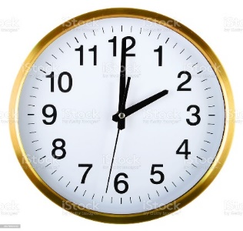 It is ……………………………

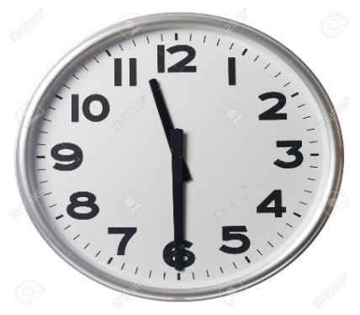 It is ……………………………

- Complete each of these sentences with “some” or “any”. (3 marks)
- Give me ………… water to drink.
- Has………… pupil been sent home because of school fees?
- There is ……… tea in the flask.

- Re-arrange these words to make good sentences. (2 marks)
- I / bicycle / my / riding / am. …………………………………………………….
- I / volleyball / play / like / to. ……………………………………………………..
Section C: Vocabulary
I. Write these words correctly. (2 marks)
- lyap ( p _ _ _ )
- labl ( b _ _ _ )

- Match people with their jobs. (2 marks)

A B
- Doctor a) grows crops
- Farmer b) treats sick people
Section D: Composition
Use these words in the box to fill in the gaps. (5 marks)
Milk dogs home donkeys hens
We have different animals at …………………… They have different uses. From cows we get ……………..We get eggs from ……………………
……………………….guard our homes and protect us. Horses and …………..are used for transport.
MARKING GUIDE
Section A: Comprehension
Questions (5 marks)
- What is the heading of the story? Using fresh products
- What did Alice buy? bread
- Why do you think they all had stomachache? The bread was bad/had expired
- How much balance did Alice take back home? 800 Frw
- What does this story teach you? To eat fresh products

Section B: Grammar
- Complete the sentences by filling in: is or are (5 marks)
- This dress is very big.
- Those are pencils.
- You are not very busy.

- Fill in the gaps with the correct article “ a” , “an ” or “the ”
(3 marks)

- It was an evening I shall never forget.
- Who is the tallest pupil in your class?
- I shall go to the shop and buy an envelope

- Choose the right answer from the brackets to complete the sentence.
(3 marks)
- Yesterday, I ……… had …four pens but I remain with one. (had / have)
- A lion ……… is ……………… a big animal. (is / was / were)
- She …………… does …… her homework with her father. (goes / does)

- What time is it? (2 marks)
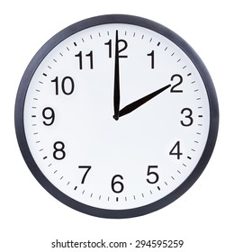 It is two o’clock

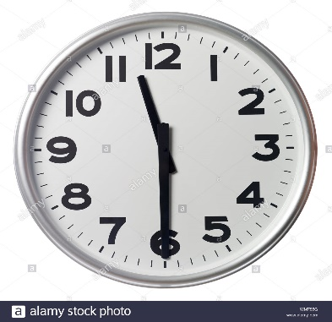 It is half past eleven

- Complete each of these sentences with “some” or “any ” (3 marks)
- Give me some water to drink.
- Has any pupil been sent home because of school fees?
- There is some tea in the flask.

- Re-arrange these words to make good sentences. (2 marks)
- I / bicycle / my / riding / am. I am riding my bicycle.
- I / volleyball / play / like / to. I like to play volleyball.

Section C: Vocabulary
I. Write these words correctly. (2 marks)
- lyap ( p lay )
- labl ( b all )

- Match people with their jobs. (2 marks)

A B
- Doctor a) treats sick people (1)
- Farmer b) grows crops (2)

Section D: Composition
Use these words in the box to fill in the gaps. (9 marks)
dogs home milk donkeys hens

We have different animals at home. They have different uses. From cows we get Milk. We get eggs from hens.
Dogs guard our homes and protect us. Horses and donkeys are used for transport.

