**MINISTRY OF EDUCATION**

**RUHANGO DISTRICT**

**MATHEMATICS EXAM OF THE THIRD TERM 2021 FOR S3**

**DURATION: 3 Hours**

**INSTRUCTIONS:**

1. This paper has **TWO**sections: **A** and **B**

**SECTION A:** Attempt **ALL** questions **(55 MARKS)**

**SECTION B:** Attempt **ANY THREE** questions **(45MARKS)**

1. **Use of non-programmable calculators is** allowed.
2. Use only **a blue or black ink pen** to write your answers
3. Show clearly all the working steps. Marks will **not be awarded for the answer without all working steps.**

**SECTION A (ANSWER ALL QUESTIONS)**

1. Without using calculator, evaluate:

$\frac{3\frac{1}{3} - 1\frac{5}{6} × \frac{3}{11}}{1\frac{3}{4} + 7\frac{2}{3} ÷3\frac{5}{6}}=$**/3marks**

1. a) Find the ratio $x :y$ given that $\left(2x^{2 }+ 5y^{2}\right)÷y^{2}= \left(12x +y\right) ÷ 2y$

b) Find the integral values of $x$ which satisfy the simultaneous inequalities

$3x -2 <10 +x ≤2 +5x$**/4marks**

1. Simplify  Leaving your answer in surds with rational

denominator. **/3marks**

1. Solve the following system of two equations using the graphical method:

$\left\{\begin{aligned}x+2y=4 \\ -x+2y=8\end{aligned}\right.$**/3marks**

1. Find the solution set for $0≤2x-3 ≤x+8$
2. If $x$ is a prime number
3. If $x$ is an even integer.**/4marks**
4. Evaluate the following giving your answer in the base five.

${454}_{six}+ {833}_{nine}- {221}_{three}$**/3marks**

1. 100 000 RWF was invested. The simple interest after two years was 16 000 RWF. Find the annually rate**/3marks**
2. Given that $x$ and $y$ are proportional to 6 and 4 and that $2x +3y =72$. Determine the values of $x$ and $y$. **/4marks**
3. Consider the polynomial $P\left(x\right)=x^{4}-\left(1+\sqrt{2}\right)x^{3}+\left(1+\sqrt{2}\right)x^{2}-\left(1+\sqrt{2}\right)x+\sqrt{2}$
4. Calculate $P(\sqrt{2})$.

Divide $P(x)$ by $x-\sqrt{2}$**/5marks**

1. Given the vectors $\vec{a } = \left({3 \atop -2}\right)$, $\vec{b }= \left({-1 \atop 2}\right)$ and $\vec{c }= \left({-4 \atop 2}\right)$. Find:
$\left\| 3\vec{a }\right.- 4\vec{b }+ \frac{1}{2}\left.\vec{c }\right\|$

2. Find the coordinates of $\vec{d }$ if abcd is a parallelogram and sketch the parallelogram

abcd in XY-plane. **/6marks**

1. Find the distance between two points nearest tenth**/3mks**
2. Given that A $=\left(3, -2\right)$, B $= \left(-5, 4\right)$ and C $\left(-1, -5\right)$
3. Find the equation of the straight line passing through points A and B.
4. Find the coordinates of point D if ABDC is a parallelogram.
5. Draw the parallelogram ABDC in Cartesian plane. **/6marks**

13. Show that the points A (0, –**2**), B(2, **4**) and C (–1, –5) are collinear**/3marks**

14. Calculate and simplify:**/3marks**

15. Without using calculator,evaluate: $5.2×\left({3.75}^{2}-{1.25}^{2}\right)$**/2marks**

**SECTION B (CHOOSE ONLY THREE QUESTIONS)**

1. The figure below shows the marks in percentage obtained by candidates in an English test

|  |  |  |  |  |  |  |  |  |  |
| --- | --- | --- | --- | --- | --- | --- | --- | --- | --- |
| 72 | 70 | 66 | 74 | 81 | 70 | 74 | 53 | 57 | 62 |
| 58 | 92 | 74 | 67 | 62 | 91 | 73 | 68 | 65 | 80 |
| 78 | 67 | 75 | 80 | 84 | 61 | 72 | 72 | 69 | 70 |
| 76 | 74 | 65 | 84 | 79 | 80 | 76 | 72 | 68 | 63 |
| 82 | 79 | 71 | 86 | 77 | 69 | 72 | 56 | 70 | 67 |
| 76 | 56 | 86 | 63 | 73 | 70 | 75 | 73 | 81 | 64 |

1. By arranging the data in classes of 50-54, 55-59, etc make frequency table.
2. Using your grouped data, calculate the mean and the median **/15marks**
3. Given that $A\left(1,2\right)$, $B\left(3,2\right)$ and $C\left(2,1\right)$
4. Draw the triangle $ABC$ on a Cartesian plane.
5. The image of $A$ by the translation is $A^{'}\left(-3,2\right)$. Find the coordinates of $B^{'}$ and $C^{'}$ the images respectively of $B$ and $C$ by the same translation and draw triangle $A^{'}B^{'}C^{'}$ in the same Cartesian plane.
6. The image of $B$ by reflection is $B^{''}\left(-7,2\right)$

Determine the coordinates of $A^{''}$ and $C^{''}$ images of $A$ and $C$ respectively by the same reflection.

1. Indicate the equation of the line of reflection and draw the triangle $A^{''}B^{''}C^{''}$ in the same Cartesian plane.

Let the rotation of Centre $O$, origin of axes, angle $-{90}^{o}$. Find the coordinates of $A^{'''},B^{'''}$ and $C^{'''}$ image respectively of $A , B$ and $C$ by this rotation. Draw the triangle $A^{'''}B^{''}'C^{'''}$ in the same Cartesian plane**/15marks**

1. Given the polynomial function $P\left(x\right)=2x^{3}-5x^{2}-19x+42$
2. Find the quotient and the remainder of the division of $P(x)$ by $2x-7$
3. Factorise $P\left(x\right)$ completely.
4. solve the equation $P\left(x\right)=0$**/15marks**
5. a)In a school, students must take at least one of these subjects: Math, Physics and Chemistry. In a group of 50 students, 7 take all three subjects, 9 take Physics and Chemistry only, 8 take Math and Physics only and 5 take Math and Chemistry only. Of these 50 students $x$ take Maths only, $x$ take Physics only and $x +3$ take Chemistry only. Draw the Venn diagram, find $x$, and hence find the number taking Maths.

b)A student of S3 deposited on his account an amount of 15000frw on a compound interest rate of 5% per annum (per year). Find his accumulated amount after 3 years.**/15marks**

1. a)Calculate the values of $m$ and $n$ if the polynomial $P\left(x\right)=2x^{3}+mx^{2}+nx+10$ has $-2$ as the root and also $2x-1$ is a factor of $P\left(x\right).$

b) Factorize completely $P(x)$

c)Deduce the roots of the equation $P\left(x\right)=0$**/15marks**

**Good Luck !!!!!!!!!!!!!!!!!!!!**

**MARKING GUIDE OF MATH DISTRICT EXAM S3 (TERM THREE, 2021)**

1. $\frac{3\frac{1}{2} – 1\frac{5}{6} × \frac{3}{11}}{1\frac{3}{4} +7\frac{ 2}{3} ÷3\frac{5}{6} } = \frac{\frac{7}{2} – \frac{11}{6} × \frac{3}{11}}{\frac{7}{4} + \frac{23}{3} ÷ \frac{23}{6}} =\frac{\frac{7}{2} – \frac{1}{2}}{\frac{7}{4} + \frac{23}{3} ×\frac{6}{23}} =$**(2mark)**

$\frac{3}{\frac{7}{4} +2} = \frac{3}{\frac{15}{4}} = \frac{3 ×4}{15} = \frac{4}{5}$**(1mark)**

1. a)



 **(2mark)**

b) 

On the line number line



The integral values of x are: 2,3,4 and 5. **(2mark)**

 **(2mark)**

 **(1mark)**

1. For

|  |  |  |
| --- | --- | --- |
| x | 0 | 4 |
| y | 2 | 0 |

**(1mark)**

|  |  |  |
| --- | --- | --- |
| x | 0 | -2 |
| y | 4 | 2 |

**(1mark)**

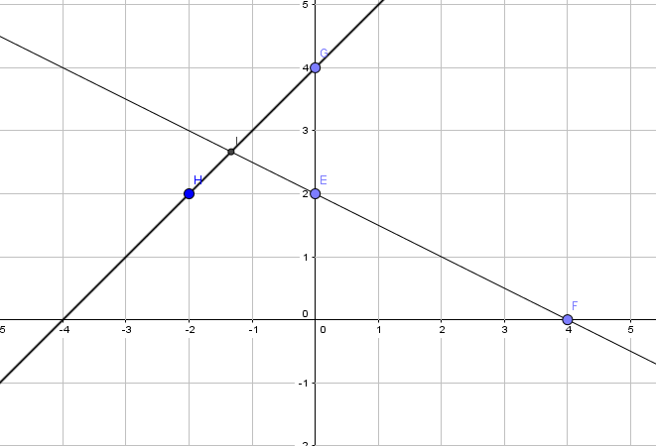

S= $\left\{(-1.33;2.67)\right\}$**(2mark)**

1. $0 ≤2x-3 ≤x+8$ $⟺2x-3 ≥0$ and $2x-x ≤8+3$ $⟺2x ≥3$ and $x ≤11$ $⟺x ≥\frac{3}{2}$ and $x ≤11$ $⟺ \frac{3}{2}≤x ≤11$**(2mark)** a) The prime numbers between $\frac{3}{2}$ and 11 are 3 , 5 , 7 , 11. **(1mark)** b) Even integers between $\frac{3}{2}$ and 11 are 4 , 6 , 8 , 10 **(1mark)**
2. ${454}_{six}=4×6^{2}+5×6^{1}+4×6^{0}=144+30+4=178$**(0.5mark) ${833}_{nine}=8×9^{2}+3×9^{1}+3×9^{0}=648+27+3=678$** **(0.5mark) ${221}_{three}=2×3^{2}+2×3^{1}+1×3^{0 }=18+6+1=25$**  **(0.5mark)**

In base ten, $178+678-25=831$**(0.5mark)**

831 $÷$ 5 remainder

166 1

33 1

6 3

1 1

0 1

${454}_{six}+ {833}_{nine}- {221}_{three}= {11311}_{five}$**(1mark)**

1. $I=P×r×n$**(1mark) $r=\frac{I}{P×n}$ $r=\frac{16000}{100000×2}$**  **(1mark)**

$r=0.08=8\%$

The annually rate is 8% **(1mark)**

1. $\frac{x}{6} = \frac{y}{4}$ and $2x +3y$ $=72$**(1mark)**

$$4x =6y ⟹2x =3y ⟹3y+3y=72 ⟹6y=72$$

$⟹y=12$**(2mark)**

$2x+2x=72 ⟹4x=72 ⟹x=18$**(1mark)**

$P\left(x\right)=x^{4}-\left(1+\sqrt{2}\right)x^{3}+\left(1+\sqrt{2}\right)x^{2}-\left(1+\sqrt{2}\right)x+\sqrt{2}$

2. $P\left(\sqrt{2}\right)={\left(\sqrt{2}\right)}^{4}-\left(1+\sqrt{2}\right){\left(\sqrt{2}\right)}^{3}+\left(1+\sqrt{2}\right){\left(\sqrt{2}\right)}^{2}-\left(1+\sqrt{2}\right)\sqrt{2}+\sqrt{2}$**(1mark)**

$=4-2\sqrt{2}\left(1+\sqrt{2}\right)+2\left(1+\sqrt{2}\right)-\sqrt{2}-2+\sqrt{2}$**(1mark)**

$=4-2\sqrt{2}-4+2+2\sqrt{2}-\sqrt{2}-2+\sqrt{2}$

$=0$**(1mark)**

1. Use synthetic division:

$\sqrt{2}\left|\begin{aligned} \underline{\begin{aligned}\begin{matrix}1 & -\left(1+\sqrt{2}\right) & 1+\sqrt{2} -\left(1+\sqrt{2}\right)\end{matrix} \\ \sqrt{2} -\sqrt{2} \sqrt{2} \\ \end{aligned}} \\ 1 -1 1 -1 \end{aligned}\right|\begin{aligned}\sqrt{2} \\ \\ -\sqrt{2} \\ \\ 0\end{aligned}$

$p\left(x\right)÷x-\sqrt{2}=x^{3}-x^{2}+x-1$**(2mark)**

 **(1mark)**

 **(1mark)**

 **(1mark)**

b) abcd is a parallelogram then  where 



 **(1mark)**

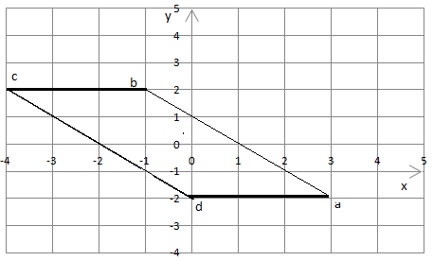 **(2mark)**

1.  **(3mark)**
2. $a) i) gradient m= \frac{4-(-2)}{-5-3}=\frac{6}{-8}=\frac{-3}{4}$**(1mark)**







 **(1mark)**





 **(1mark)**



    **(1mark)**

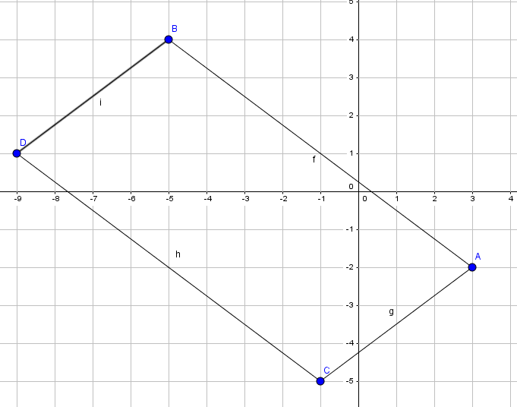**(2mark)**

 **(1mark)**

  **(2mark)**

Therefore, the given points are collinear

${\left(1+\sqrt{2}\right)}^{3}-{\left(1-\sqrt{2}\right)}^{3}=1+3\sqrt{2}+3\left(2\right)+2\sqrt{2}-\left(1-3\sqrt{2}+3\left(2\right)-2\sqrt{2}\right)$ $=7+5\sqrt{2}-\left(7-5\sqrt{2}\right)$**(2mark)**

$=10\sqrt{2}$**(1mark)**

1. $5.2×\left({3.75}^{2}-{1.25}^{2}\right)=5.2×\left(3.75+1.25\right)×\left(3.75-1.25\right)$**(1mark)**

$=5.2×5×2=65$. **(1mark)**

**SECTION B**

|  |  |  |  |  |
| --- | --- | --- | --- | --- |
| **Classes** | **f** | **x** | **Fx** | **CF** |
| 50-54 | 1 | 52 | 52 | 1 |
| 55-59 | 4 | 57 | 228 | 5 |
| 60-64 | 6 | 62 | 372 | 11 |
| 65-69 | 10 | 67 | 670 | 21 |
| 70-74 | 18 | 72 | 1296 | 39 |
| 75-79 | 9 | 77 | 693 | 48 |
| 80-84 | 7 | 82 | 574 | 55 |
| 90-94 | 3 | 87 | 261 | 58 |
| 95-99 | 2 | 92 | 184 | 60 |

**(Two marks for each column i.e. 10mark for the table)**

$\overline{X}=\frac{\sum{f×x}}{n}=\frac{4330}{60}=72.17$**(2mark)**

$Me=L+\frac{\frac{n}{2}-F}{f}×C$**(1mark)**

$$L=69.5$$

$$F=21$$

$$f=18$$

$$C=74.5-69.5=5$$

$=69.5+\frac{30-21}{18}×5$

$=69.5+2.5$

$$=72$$

The median is 72**. (2mark)**

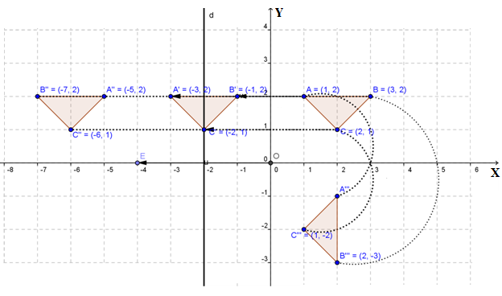

**(1.5 marks for each triangle, 2marks a line d i.e. 8marks for whale diagram)** b) Vector of translation is $\left({-3 \atop 2}\right)-\left({1 \atop 2}\right)=\left({-4 \atop 0}\right)$**(1mark)**

Coordinates of B’: $\left({3 \atop 2}\right)+\left({-4 \atop 0}\right)=\left({-1 \atop 2}\right)$**(1mark)**

Coordinates of C’: $\left({2 \atop 1}\right)+\left({-4 \atop 0}\right)=\left({-2 \atop 1}\right)$**(1mark)**

c) i) Under reflection coordinates of A’’ are (-5,2) and coordinates of C’’ are (-6,1)

ii) The line of reflection is given by $x=\frac{3+\left(-7\right)}{2}=\frac{-4}{2}=-2$

The equation of the line is $x=-2$**(1mark)**

d) Under a rotation of $-90°$ about the origin $\left(x,y\right)→(y,-x)$

$A^{'''}\left(2,-1\right)$**(1mark)**

$B^{'''}(2,-3)$**(1mark)**

$C^{'''}(1,-2)$**(1mark)**

1. a) i) $2x^{3}-5x^{2}-19x+42$ divides by $2x-7$ using long division.

$2x^{3}-5x^{2}-19x+42$ $2x-7$

$-2x^{3}+7x^{2}$ $x^{2}+x-6$

$2x^{2}-19x+42$

$-2x^{2}+7x$

$-12x+42$**(5marks)**

$12x-42$

0

The quotient $q\left(x\right)=x^{2}+x-6$

The remainder R = 0

ii) $P\left(x\right)= \left(2x-7\right)\left(x^{2}+x-6\right)$**(1mark) $=\left(2x-7\right)\left(x^{2}+3x-2x-6\right)$** **(1mark) $=\left(2x-7\right)\left[\left(x^{2}+3x\right)-\left(2x+6\right)\right]$** **(1mark) $= \left(2x-7\right)\left(x+3\right)\left(x-2\right)$** **(1mark)**

iii) $P\left(x\right)=0$ $⟺\left(2x-7\right)\left(x+3\right)\left(x-2\right)=0$**(1mark)**

$\left\{\begin{aligned}2x-7=0 \\ x+3=0 \\ x-2=0\end{aligned}\right. ⟺\left\{\begin{aligned}x=\frac{7}{2} \\ x=-3 \\ x=2\end{aligned}\right.$**( 1mark for each value I.e. 3maks)**

1. a)

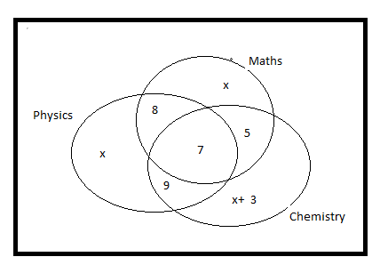**(7mark)**

 **(2mark)**

The number of students taking Maths is  **(1mark)**

b) $A=P{\left(1+\frac{r}{100}\right)}^{n}$. **(2mark)**

P =15000F, R =5%, T =3 years **(1mark)**

A = 15000 $×{(1.05)}^{3}frw$

A = 17,364,375 frw **(1mark)**

The accumulated amount of student after 3 years is 17,364,375 frws.

**(1mark)**



$a) P\left(-2\right)=0$

$⇒2{\left(-2\right)}^{3}+m{\left(-2\right)}^{2}+n\left(-2\right)+10=0⇒4m-2n=6 \left(1\right)$

$2x-1$ is a factor of $P\left(x\right)$, **(3mark)**

then $P\left(\frac{1}{2}\right)=0$

$⇒2{\left(\frac{1}{2}\right)}^{3}+m{\left(\frac{1}{2}\right)}^{2}+m\left(\frac{1}{2}\right)+10=0$

$⇒\frac{1}{4}+\frac{m}{4}+\frac{n}{2}+10=0$**(3mark)**

$$⇒1+m+2n+40=0$$

$⇒m+2n=-41 \left(2\right)$

$\left(1\right)$ and $(2)$ gives : $\left\{\begin{aligned}4m-2n=6 \\ m+2n=-41\end{aligned};\right.$**(3mark)**

$5m=-35$, $m=-7$.

$m+2n=-41$ and $n=-17.$

b) $P\left(x\right)=2x^{3}-7x^{2}-17x+10$

$=\left(x+2\right)\left(2x^{2}-11x+5\right)$

$=\left(x+2\right)\left[2x^{2}-10x-x+5\right]$

$=\left(x+2\right)\left[2x\left(x-5\right)-\left(x-5\right)\right]$

$=\left(x+2\right)\left(2x-1\right)(x-5)$**(3mark)**

C) $P\left(x\right)=0 ⇔\left(x+2\right)\left(2x-1\right)\left(x-5\right)=0$

$⇔x+2=0 or$

$2x-1=0or$

$x-5=0$

$⇔x=-2 or x=\frac{1}{2} or x=5$**(3mark)**