REPUBLIC OF RWANDA TERM III 2020-2021
MINISTRY OF EDUCATION
SOUTHERN PROVINCE DATE:
RUHANGO DISTRICT DURATION: 2 HOURS
PRIMARY SIX MATHEMATICS EXAMINATION/100 Marks
Index Number:

Pupil’s names: …………………………………………………… Class: ………………
INSTRUCTIONS:
- All 39 questions are compulsory.
- Read each question carefully before answering it.
- Answer all questions in provided space of the booklet.
- Avoid unnecessary work; this lead to loss of marks.
- Use blue or black pen and give legible answers.
Do rough work in this column | Show your answers in this column.
- Write the number in words (2)
48 005 206
- What is the place value of underlined digits? (2)
438.598
- Express 120 as a product of its prime factors. (2)
- Calculate:a) $\frac{3}{7}$ of 21 (1)
b) $\sqrt{25}+2^{2}$ (1)

- Round off: (2)
69437.901 to the nearest whole number.
- Work out: (2)
15 337 sec =… …hr.……..min…….sec
- Subtract 37.91 from 1000. (1)
- Find the lowest number that can be formed using the digits below:
2, 8, 3, 9, 1 (1)
- C0nvert$\frac{291}{14}$ as mixed fraction (2)
- Simplify: 2($3x-4)-2\left(x+4\right)=$ (2)
- Write in short form: (2)$4x^{4}y^{3}$x ${2x}^{2}y^{2}$=
- Write “ Eight hundred eighty eight million, eight hundred eighty eight thousand, eight hundred eighty eight” as figure form. (2)
- The actual length of a certain road is 300km.O n a map it is represented by 30 cm. What scale has been used? (2)
- Filling the missing numbers in the table below.

(2)
4 | 7 | 6 | .
9 | . | 13 | 21

- Two supplementary angles are X +40⁰ and 80⁰ . Find the size of X. (2)

- If a=2, b=3, c=0 (2)
Find 3ab-bc+6a
- Musa sold a trousers at 7500 Frw making a loss of 500 Frw . Find the percentage loss. (2)

(2)
- Simplify: (2)
- $2^{3}$+$3^{2}$
- $1^{3}+3^{0}+3^{2}$
- The LCM of two numbers is 30. One of the number is 10. If the GCF is 5, find the second number. (2)
- a) The simple interest on a capital of 800 000 Frw after 3 years is 12 000 Frw.
Find the interest rate per year. (2)
- Convert: 72 km/hr to m/sec (2)

- The salary of Mbabazi was 17 400 Frw ; it was increased in a ratio of 6 to 5 ;
Find her new salary. (2)
- Match 12- hr format to 24-hr format.
(2)
a) 12:45 i) 12:45 p.m
b) 07:30 ii) 9:15 p.m
c) 21:15 iii) 4:20 p.m
d) 16:20 iv) 7:30 p.m
- Find the bearing of town A from town B using clockwise side. (1)
N
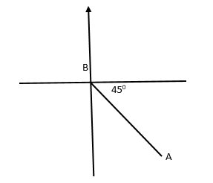
- Simplify completely: (2)
$(\frac{4}{15}$:$\frac{8}{45}$) + ($\frac{5}{7}$x$\frac{14}{15}$)
26 .Peter got 28 out of 40 marks in English test.Express his marks as percentage. (2
27.Find the volume of the figure below:(3)

14 cm

10 cm

28Find the 3 number sequences for the general rules below: (3)
2n + 3

29 .Find the volume of firewood in a stack measuring 3m by 2 m to 3m in desteres (dst). (3)

30Work out: (2)
- +5 x -2=
- -16 : -8=
31The figure below is an irregular polygon. Find the size of each angle. (6)
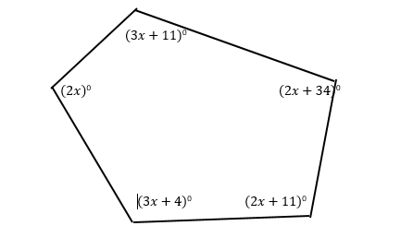
- .Calculate the length of side marked by the letter b and its area. (3)

b 10 cm

6Cm

33 .a) Which of these numbers is not a probability? (3)
-0.001; 0; 0.5; 4
b) Discuss the likelihood of the following events
i) I was born yesterday.
ii) The sun will rise tomorrow.

34.Tom and Mary shared some money ;Mary got $\frac{3}{11}$ of it . How much did Mary get if Tom got 50 352 Frw. (3)
- .The following are ages of pupils in primary six class.
11, 12, 13, 11, 12, 14, 11, 12, 13,11
- Complete the table below: (2)
Age | Frequency
11
12
13
14
Total
- What is the mode age?(1)
- Calculate the average age? (2)
- Find the range. (1)
- .A car travelling at 40 km/hr left town A at 8:00 a.m. Another car travelling at 60 km/hr followed after 1 hr. When did the second car overtake the first car? (4)
- Find the value of angles marked with the letters. (3)

a 70⁰e

b c d

f 120⁰

- Mary has 80 l of mixed honey and sells each litre at 1000. If there are 30 l of the first type which cost 1200 Frw per litre, find the price of one litre of the second type. (5)

- Calculate the total surface area and volume. (4)
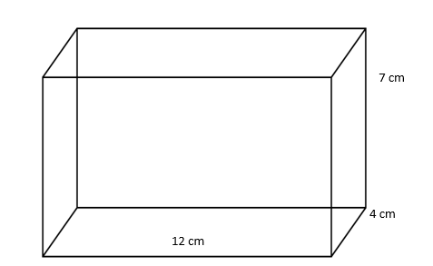

Good Luck!!!!!!!!!!

MARKING GUIDE FOR P6 MATHEMATICS EXAMINATION
- Forty-eight million, five thousand two hundred six.
- 4 is hundreds 5 is tenths.

120 | 2
60 | 2
30 | 2
15 | 3
5 | 5
1
120 = 2³ x 3 x 5

- a) $\frac{3}{7}$ x 21 = 9
b)5 + 4 = 9
- 69438

6. 4 hr 15 min 37 sec
7. 962.09
8. 12 389
9. 20$\frac{11}{14}$

10. $x=4$
11. ${8x}^{6}y^{5}$
12. 888 888 888
13.$\frac{1}{1 000 000}$
14.
4 | 7 | 6 | 10
9 | 15 | 13 | 21
15. X =60⁰

16. (3x2x3) – (3x0) + (6x2) = 30
17. % loss =6 ¼ % or 6.25%

18. a) (2x2x2) + (3x3) = 17
b) (1x1x1) + 1 + (3x3) = 11
19. 10 $×x=30×5$
$x=\frac{150}{10}$
$x=15$
20. ½% or 0.5%

21. 20 m/sec
22. 20 880 F

23. a i
b iv
c ii
d iii
24. 135⁰
25. 70%
26. S= 5 cm
Area= 25 cm²
27. R= D: 2= 7 cm
V= 1540 cm³
28. 5; 7; 9
29. 18m³ =180 dst

30. -10 +2
Sum of interior angles = (n-2) x 180⁰
$12x+60°=540°$
$x=40°$
1st = 80⁰ 2nd = 124⁰ 3rd = 91⁰ 4th = 114⁰ 5th = 131⁰

32. b = 8 cm Area = 24cm²
33. a) -0.001; 4
b) i) Impossible
ii) Certain
34. 18 882 F
35.
Age | Frequency
11 | 4
12 | 3
13 | 2
14 | 1
Total | 10

Mode= 11 average= $\frac{120}{10}$= 12
Range= 14 – 11= 3
36. Difference speed= 60 km/h – 40 km/h= 20 km/h
1st car had covered = 40 km/h
The time taken to catch up 40 km: 20 km/h= 2 h
The second car will overtake 9: 00 +2: 00= 11: 00 a.m
37. c= 70⁰ e= 120⁰- 70⁰= 50⁰ b= 50⁰ d= 60⁰ f= 60⁰+ 70⁰= 130⁰
a= 180⁰-( 70⁰=50⁰) = 60⁰
38. Mixed honey cost= 80 x 1000= 80 000 F
The cost of 1st type= 30x 1200= 36000 F
The cost of the second type= 80 000 – 36000 = 44 000F
Capacity of the 2nd type= 80l – 30l = 50l
The cost of 1l of the 2nd type = 44 000: 50= 880 F
39. TSA= 2(LXW) + 2(LXH) + 2(WXH)
=96+ 168+ 56 = 320 cm²
V= LXWXH= 12 cm x 7 cm x 4 cm= 336 cm³

