

**PHYSICS**

**02/07/2021**

**8:30 am – 11:30 am**

**SENIOR FOUR END OF YEAR EXAMINATIONS, 2021**

**SUBJECT: PHYSICS THEORY**

**COMBINATIONS:**

**PHYSICS-CHEMISTRY-MATHEMATICS (PCM)**

**MATHEMATICS- PHYSICS- COMPUTER SCIENCE (MPC)**

**PHYSICS –CHEMISTRY- BIOLOGY (PCB)**

**MATHEMATICS –PHYSICS- GEOGRAPHY (MPG)**

|  |
| --- |
| **/100**    **Marks:** |

**DURATION: 3 HOURS**

**INSTRUCTIONS:**

1. Do not open this question paper until you are told to do so.
2. Answer all questions: **100 marks**
3. Use only a **blue** or **black** pen.

**PART I: MULTIPLE CHOICE QUESTIONS (20 MARKS)**

Choose the letter that corresponds to the correct answer

**1)** Optical instrument used to view things that are far away is

a)compound microscope b)simple microscope c)telescope d)camera **(2 marks)**

**2)** Short sightedness/myopia can be corrected using

a) Convex lens b) convex mirror c) concave mirror d) concave lens **(2 marks)**

**3)** A10 kg box is accelerated from 2 m/s to 4 m/s.

Use work energy theorem to find work needed to accelerate the box

a)50 J b)20 J c)60 J d)100 J **(2 marks)**

**4)** What is the method used to produce electricity in hydroelectric power plant?

a) By boiling the water to produce steam

b)by pushing pistons by heat energy

c)by running dynamo by kinetic energy of water

d) by heating chargeable cells **(2 marks)**

**5)** For a particle performing a uniform circular motion, the acceleration is

a)constant in direction

b)constant in magnitude but not in direction

c)constant in magnitude and in direction

d)constant in neither magnitude nor in direction **(2 marks)**

**6)** The diagram shows the energy transferred in an electric lamp in one second

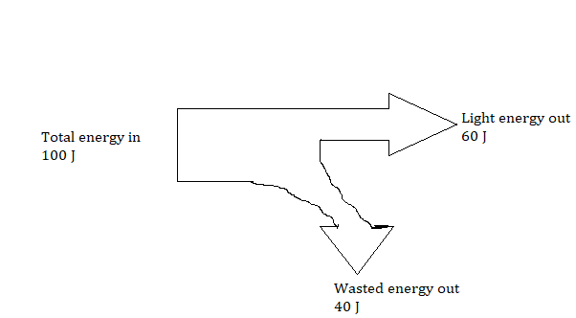

Wasted energy out is

a)electrical energy b)kinetic energy c)thermal energy d)chemical energy **(2 marks)**

**7)** A thermodynamic process in which the pressure stays constant is

a) adiabatic process b)isobaric process c) isochoric process

d)isothermal process **(2 marks)**

**8)** It is outer planet of the solar system

a)Saturn b) Mercury c) Venus d)Earth **(2 marks)**

**9)** In a Carnot cycle, the working medium rejects heat at a ……………..temperature

a)lower b)higher c)constant d)none of the mentioned **(2 marks)**

**10)** Which path shows a possible movement of an electron in the electric field shown below ?

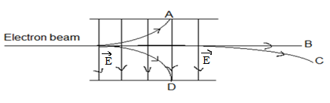

1. B b) A c) D d) C **(2 marks)**

**PART II: ATTEMPT ALL QUESTIONS (80 MARKS)**

**11)** a) List any two defects of lenses **(2 marks)**

b) An object of height 7 cm is placed at a distance of 25 cm in front of

a thin converging lens of focal length 35 cm. Find

(i)the location of the image **(2 marks)**

(ii) the size of the image **(2 marks)**

(iii) any two properties of the image  **(2 marks)**

c)(i) What do you understand by the term **dispersion of light** by a prism? **(1mark)**

(ii) A triangular glass prism (*n* = 1*.*6) is immersed in air (*n* = 1) as shown in figure below drawn not to scale.

A ray of light is incident on face AB making an angle of 20˚ with

the normal.

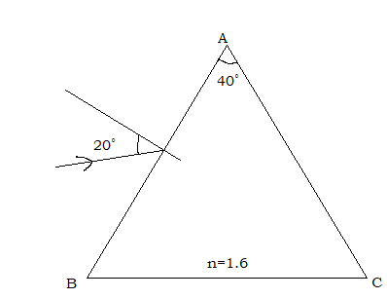

Find

1. The angle of refraction on the face AB **(2 marks)**

2. The angle of incidence on AC **(2 marks)**

3. The angle of emergence **(2 marks)**

**12)** a) State

(i) the types of static equilibrium **(3 marks)**

(ii) the conditions of equilibrium of a rigid body. **(2 marks)**

b)A uniform board with a weight of 240 N and a length of 2 m rests horizontally on two supports as shown below.

The support A is under the left end of the board while support B is 50 cm from the right end.

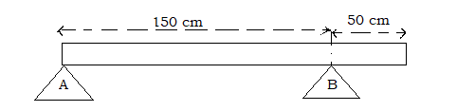

(i)Name the point where the weight of the board is applied **(2marks)**

(ii)Determine the location of the point of application of the weight of the board with respect to the support A. **(2marks)**

(iii)Draw a free body diagram showing the direction of each of the forces exerted on the board. **(3 marks)**

(iv)Use the conditions of equilibrium of a rigid body to determine the support force FA and FB .Take the support point A as a reference point  **(4 marks)**

**13)** a) Explain the terms below in words as used in electricity

(i) Electromotive force of a battery **(1mark)**

(ii) Resistance of a conductor **(1mark)**

b) Analyze the following electric circuit and then answer the following sub- questions. The battery has emf of 6 V and internal resistance r

The electric current I is 1.5 A.

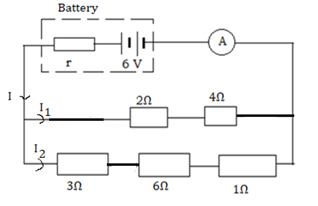

(i)Determine the equivalent resistance of all external resistors **(5 marks)**

(ii)Find the internal resistance of the battery **(2 marks)**

(iii)Calculate the terminal voltage of the battery **(2 marks)**

(iv)What does the symbol below represent? **(1 mark)**

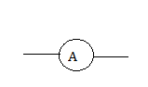

(v)Observe the given electric circuit then determine the reading of the measuring instrument below

 **(1mark)**

(vi)Determine

1)the current I1 **(2 marks)**

2)the current I2  **(2 marks)**

**14)** A model rocket flies horizontally off the edge of the cliff at a velocity

of 50 m/s . The canyon below is 100 m deep.

Acceleration due to gravity g=9.81 m/s2

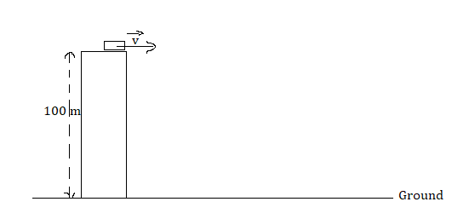

a) Determine the time of flight **(3 marks)**

b) How far from the edge of the cliff does the model rocket land?

**(3 marks)**

**15)** a) State any one Kepler’s lawof planetary motion **(3 marks)**

b) (i)Define the gravitational potential **(2 marks)**

(ii)Explain why values of gravitational potential near to an isolated mass are all negatives **(1 mark)**

c) The orbit of the Earth, mass 6x1024 kg, may be assumed to be a circle of radius 1.5x1011 m with the sun at its centre as illustrated in the figure.

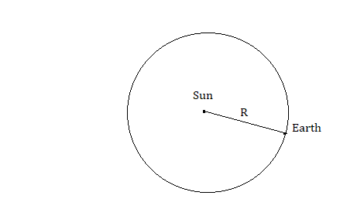

The time taken for one orbit is 3.2x107s

(i)Calculate the magnitude of the angular velocity of the Earth about the Sun **(2 marks)**

(ii)The magnitude of the centripetal force acting on the Earth **(2marks)**

(iii)State the origin of the centripetal force **(1mark)**

(iv)Determine the mass of the Sun.

Gravitational constant G=6.67x10-11 m3/kg s-2 **(4 marks)**

**16)**a)Copy and complete the following statements

(i)Unlike electric charges ………………………………each other **(1mark)**

(ii)Like electric charges …………………..each other **(1mark)**

b) Copy and draw electric field lines due to

(i) Parallel plate capacitor

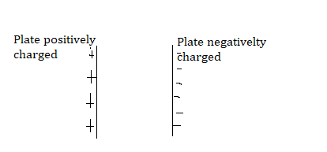  **(2 marks)**

(ii) Electric dipole (a pair of electric charges of equal magnitude but opposite sign separated by a small distance )

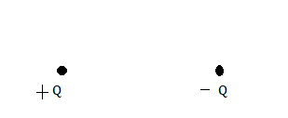

**(2 marks)**

c) The figure below shows two electric charges Q1 and Q2 **.**

Coulomb’s constantk =9x109 Nm2/C2

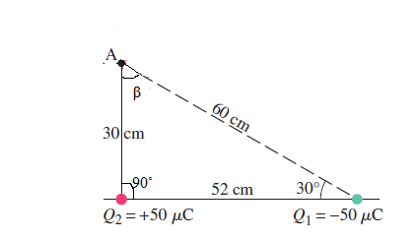

Find

(i)The magnitude of the electric field created by Q1 at point A **(2 marks)**

(ii) Copy the figure and indicate on it the directions of the electric field vectors due to two charges at point A and the direction of the resultant electric field **(3 marks)**

**S4 MARKING SCHEME PHYSICS 2021**

**PART I: MULTIPLE CHOICE QUESTIONS (20 MARKS)**

**1)c (2 marks) 2)** **d)(2 marks) 3) c (2marks)** networkW**=**

**4) c)(2 marks) 5) b)(2marks) 6) c)(2 marks 7) b)(2 marks) 8)a)(2 marks)**

**9)a)(2 marks) 10)b)(2 marks)**

**PART II (80 MARKS)**

**11)**a) Chromatic aberration **(1mark)** spherical aberration**(1mark)**

coma, astigmatism, barrel distortion ,pincushion distortion

b) (i)Image position**(1mark)**

 , p’=-87.5 cm **(1mark)**

(ii)the size of the image **(1mark)**

**(1mark)**

(iii)Properties of the image

Image is virtual **(1mark)** p’ is negative

Image is erect (upright) **(1mark)** hi is positive

Image is magnifiedhi is greater than ho

c) (i)The process of splitting of white light into seven colours by

prism **(1mark)**

(ii)1. The angle of refraction on AB

1xsin20˚ =1.6 sinr **(1mark)**

r=12.3˚**(1mark)**

2. The angle of incidence on AC

A=r+r’ **(1mark)**

r’=40˚-12.3˚ =27.7˚(**1mark)**

3. The angle of emergence

1.6xsin27.7˚=1xsini’ **(1mark)**

i’=48˚**(1mark)**

**12)**a)(i)Stable equilibrium **(1mark)**

Unstable equilibrium **(1mark)**

Neutral equilibrium **(1mark)**

(ii)Net force is equal to zero **(1mark)** or

 Algebraic sum of x and y components of the

external forces applied to the object must be equal to 0

respectively.

Net torque is equal to zero **(1mark)**

.The algebraic sum of the clockwise torques is equal

to the algebraic sum of the counterclockwise torques.

b) (i)Centre of gravity **(2marks)**

(ii)1m from the extremity A of the board **(2marks)**

(iii)Direction of forces

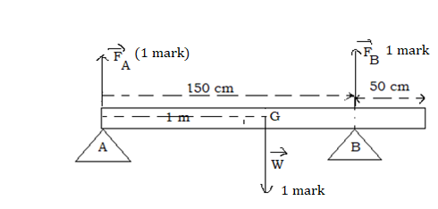

(iv)Torque is positive in anticlockwise direction and the reference

point is the support A

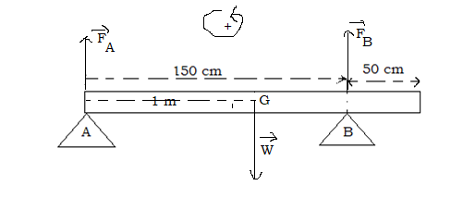

Torque of the support force  with respect to point A



Torque of the support force with respect to point A

 **(1 mark)**

Torque of the weight  with respect to point A

 **(1 mark)**



1.5 FB-240=0

FB= 240N/1.5=160 N **(1mark)**



FA+FB-240N =0

FA =240-160N=80N **(1mark)**

**13)**a)(i)Electromotive force is energy per unit electric charge that is

imparted by an energy source**(1mark)** such as electric generator

Or the work done on a unit of electric charge or the energy

thereby gained per unit electric charge

(ii)Resistance of the conductor is the opposition to the flow of

electrical current through a conductor**(1mark)**

You can also accept the potential difference across the

conductor divided by the electric current through it

b)(i)The 2 Ω and 4 Ω resistors are in series

R1 = 2Ω+4 Ω**(1 mark)**

=6 Ω**(1mark)**

The 3 Ω, 6Ω and 1 Ω resistors are in series

R2 =3 Ω+6Ω+1Ω

=10Ω**(1mark)**

The resistors having the resistances R1 and R2 are in parallel

**(1mark)**



The equivalent resistance R =3.75Ω **(1mark)**

(ii)The internal resistance E=(R+r)I **(1 mark)**



**(1mark)**

(iii)The terminal voltage V=RI **(1mark)**

=1.5 Ax3.75 Ω=5.625V **(1mark)**

(iv)Ammeter **(1mark)**

(v)The reading is I=1.5 A **(1mark)**

(vi) 1)the current **(1mark)**

**(1 mark)**

2) The current ** (1mark)**

**(1mark)**

**14)** a)The time of flight  **(1mark)**

**(1mark)**

**(1mark)**

b)The horizontal range x=vt**(1 mark)**

=50 m/s x4.5 s **(1mark)**

=225 m **(1mark)**

**15)**a)Every planet’s orbit is an ellipse with the sun at a focus

**(3marks)**

A line joining the Sun and a planet sweeps out equal areas in

equal times

The square of a plane’s orbital period is proportional to the cube of

its distance to the Sun.

b) (i)The work required to move a body of unit mass from

infinity to a givenpoint **(2 marks)**

(ii)Gravitational potential at infinity is zero hence the gravitational

forces are always attractive. So the work needs to be done against

the force in moving the body from the infinity to the given point

**(1mark)**

c)(i)The angular velocity **(1 mark)**

**(1mark)**

(ii)Centripetal force ** (1mark)**



=34.57x10**21**N **(1 mark)**

(iii)The origin of the centripetal force is gravitational potential

strength**(1mark)**

(iv)The mass M of the Sun

We know that the gravitational force is equal to the centripetal force

**(1mark)**

**(1mark)**

=1.94 x1030kg **(2 marks)**

**16)**a)(i)attract **(1mark)**

(ii)repel **(1mark)**

b)(i) **(2 marks)**

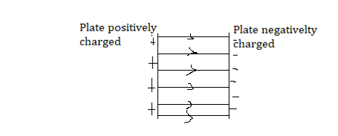

(ii)**(**2marks**)**

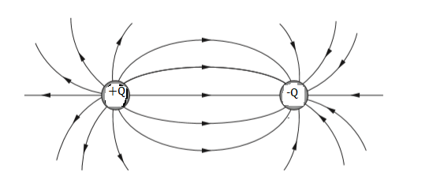

c)(i) **(1mark)**

**(1 mark)**

(ii)

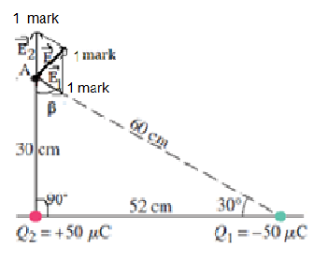

**PHYSICS**

**23/06/2021**

**8:30 am – 11:30 am**



**SENIOR FOUR END OF YEAR EXAMINATIONS, 2021**

**SUBJECT: PHYSICS PRACTICAL**

**COMBINATIONS:**

**PHYSICS-CHEMISTRY-MATHEMATICS (PCM)**

**MATHEMATICS- PHYSICS- COMPUTER SCIENCE (MPC)**

**PHYSICS –CHEMISTRY- BIOLOGY (PCB)**

**MATHEMATICS –PHYSICS- GEOGRAPHY (MPG)**

|  |
| --- |
| **/100**    **Marks:** |

**DURATION: 1 HOUR 30 MINUTES**

**INSTRUCTIONS:**

1. Do not open this question paper until you are told to do so.
2. Answer all questions: **100 marks**
3. Use only a **blue** or **black** pen.

**ATTEMPT ALL QUESTIONS (25 MARKS)**

In this experiment you will determine the refractive index n of the transparent glass block provided

**Apparatus required**

1 glass block

4 optical pins

4 drawing pins

A4 white sheet of paper

1 soft board

1 ruler of 15cm or 30cm

**Procedures**

a) Fix the plain white sheet of paper provided on the soft board using 4

drawing Pins.

b) Place the glass block on the sheet of paper and trace out its outline

ABCD as shown below

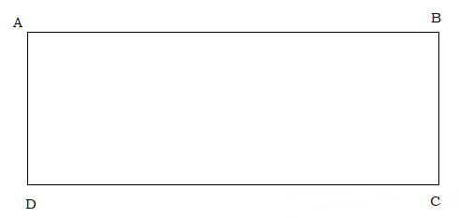

c) Remove the rectangular glass block.

d) Draw the normal NN’ to side AB, extended cross side DC, so that the

normal is 2.0 cm from A. Label the point F where NN’ crosses AB.

Label the point G where NN’ crosses DC.

e) Draw the line EF at an angle of 50˚ to the normal and to the left of the

normal NN’.E is a point outside the block and above AB on the ray tracing

sheet.

f) Stick optical pins P1 and P2 along EF

g) Replace the rectangular glass block with the aim of viewing the images of

pins P1 and P2 through the side CD.

h) Looking through the rectangular glass block from the opposite face CD,

stick two other optical pins P3 and P4 in line with the images of optical

pins P1 and P2

i) Remove the rectangular glass block and optical pins P1, P2, P3 andP4

j) Using a pencil and a ruler, join the points P3 and P4 to intersect with the

side CD at a point H.

k) Measure and record the length a of the line HG **(4 marks)**

l) Draw the line HF

m) Measure and record the length b of the line FH **(4 marks)**

n) Extend the straight line EF through the outline of the block to

intercept with the side CD at a point K.

o) Measure and record the length c of the line GK **(4 marks)**

p) Measure and record the length d of the line FK **(4 marks)**

q) Attach the sheet of paper used to your answer sheet and submit both

**(4 marks)**

**QUESTIONS**

1) Find the refractive index of the block using the equationn=cb/ad

**(3 marks)**

2) Does this refractive index make sense?

Justify your answer **(2 marks**)

**S4 MARKING SCHEME OF PHYSICS PRACTICAL EXAM 2021**

**(25 marks)**

The marking scheme will be prepared by the S4 Physics teacher.

Student and physics teacher will obtain the diagram as drawn below

q) Diagram drawn to scale **(4 marks)**

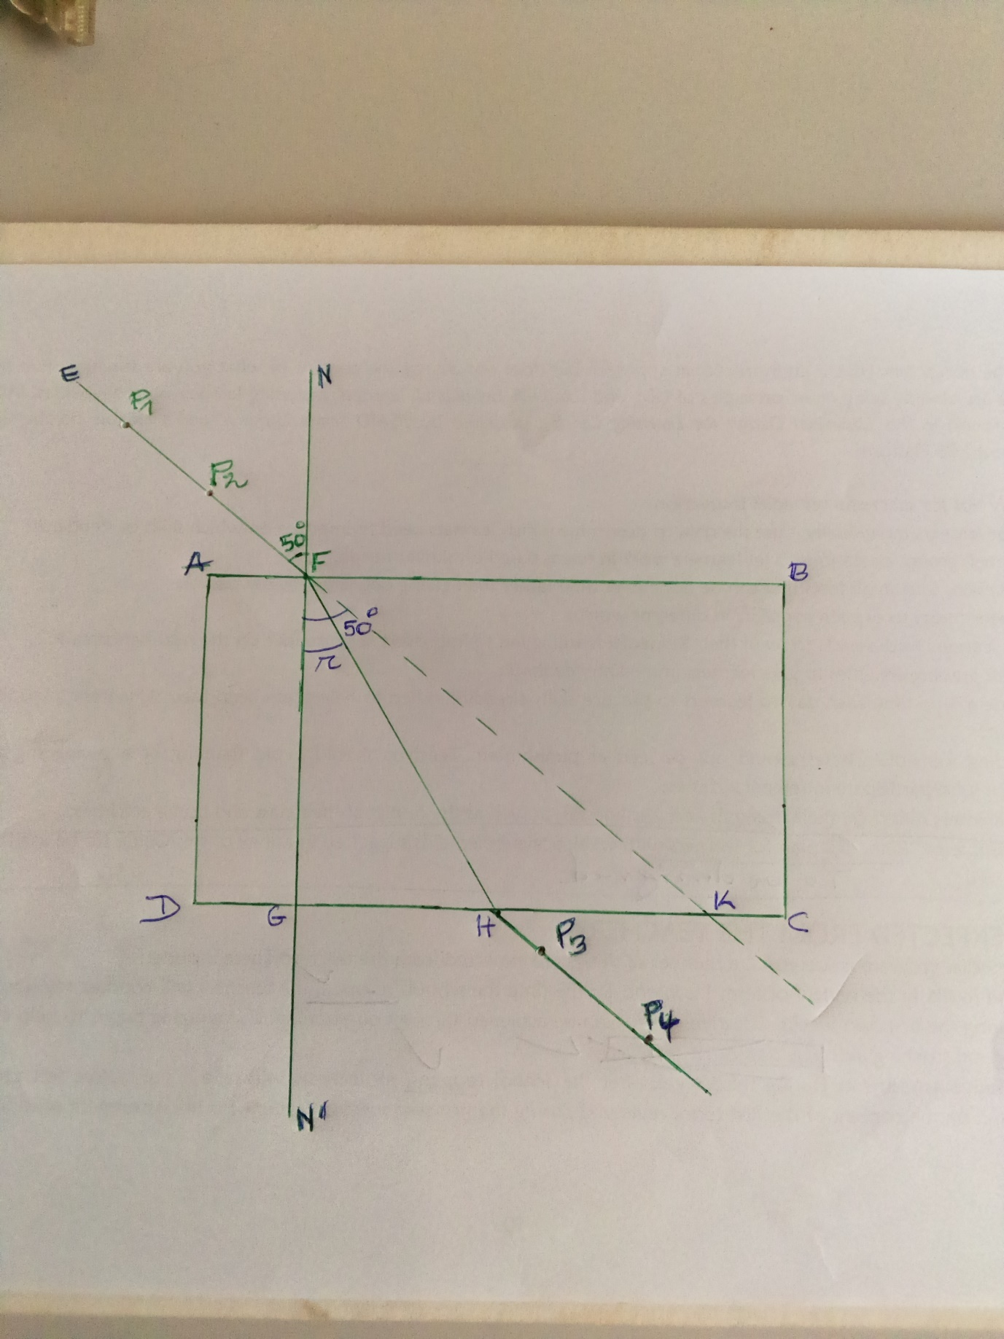

Theory: According to the law of refraction 







Then 

k)Value of a=4.1 cm(**4marks)**

m)Value of b=8 cm **(4marks)**

o)Value of c=8.4 cm**(4marks)**

p)Value of d=10.9 cm**(4marks)**

Question

1.Value of  **(3marks)**

2. This value is reasonable becausethe refractive index n of a

glass, varies from 1.45 to 2.00 **(2marks)**despite the sources of errors

**PHYSICS**

**23/06/2021**

**8:30 am – 11:30 am**



**SENIOR FOUR END OF YEAR EXAMINATIONS, 2021**

**SUBJECT: ALTERNATIVE TO PHYSICS PRACTICAL EXAM**

**COMBINATIONS:**

**PHYSICS-CHEMISTRY-MATHEMATICS (PCM)**

**MATHEMATICS- PHYSICS- COMPUTER SCIENCE (MPC)**

**PHYSICS –CHEMISTRY- BIOLOGY (PCB)**

**MATHEMATICS –PHYSICS- GEOGRAPHY (MPG)**

|  |
| --- |
| **/100**    **Marks:** |

**DURATION: 1 HOUR 30 MINUTES**

**INSTRUCTIONS:**

1. Do not open this question paper until you are told to do so.
2. Answer all questions: **100 marks**
3. Use only a **blue** or **black** pen.

**ATTEMPT ALL QUESTIONS (25 MARKS)**

A student carried out an experiment to find the spring constant of a steel

spring using Hooke’s law . The apparatus is shown below.

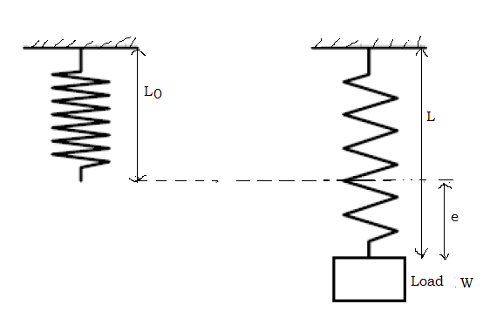

The student recorded the unstretched length L0=30 mm of the spring.

Then she/he added loads W to the spring, recording the new length L

each time. The readings are shown in the table below.

|  |  |  |
| --- | --- | --- |
| W/N | L/mm | e/mm |
| 0 | 30 |  |
| 1 | 32 |  |
| 2 | 33 |  |
| 3 | 36 |  |
| 4 | 39 |  |
| 5 | 40 |  |

Use your knowledge and acquired skills to analyze and answer the

following questions.

a)Calculate the extension e of the spring produced by each load, using

the equation e = L – L0. Record the values of ein the table.

**(6 marks)**

b) Draw the best-fit straight line of load W (along vertical axis) against the

extension e (on horizontal axis). **(11 marks)**

c) Calculate the gradient K (spring constant) of the graph **(4 marks)**

and interpret the obtained result.

d) From the graph, state the Hooke’s law. **(2 marks)**

e) Provide any two real life applications of the Hooke’s law. **(2 marks)**

**S4 MARKING SCHEME OF ALTERNATIVE TO PHYSICS PRACTICAL EXAM 2021(25 MARKS)**

(a)Table of results

|  |  |  |
| --- | --- | --- |
| W/N | L/mm | e/mm |
| 0 | 30 | 0**(1mark)** |
| 1 | 32 | 2**(1mark)** |
| 2 | 33 | 3**(1mark)** |
| 3 | 36 | 6**(1mark)** |
| 4 | 39 | 9**(1mark)** |
| 5 | 40 | 10**(1mark)** |

(b) Graph of w against e

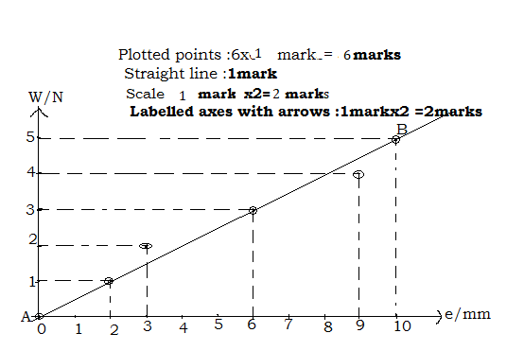

(c)The slope  **(2marks)**

NB: To calculate the slope, it is imperative to use the values different from

the table values. Interpretation of result

The spring stretches by 1 mm when a weight of 0.5 N is hung from

it**(2marks)**

d) Hooke’s law states that the force/load needed to extend or compress a

spring by some distance x is proportional to that distance**(2marks)**

e) Spring balance**(1mark),**Newton meter**(1mark)**,trampolines,

Balance wheel of the clock, spring of retractable pen,