MINISTRY OF EDUCATION
RUHANGO DISTRICT
PHYSICS EXAM OF THE THIRD TERM 2021 FOR SENIOR THREE
DURATION: 3 HOURS
Instructions:
- Section A: attempt all questions
- Section B: Attempt any three questions
- Section C: Is compulsory and answer on the graph paper
- You may use mathematical instruments and calculators
- Use only blue or black pen to write your answers

SECITION A: Attempt all questions (55)
- Read each statement below and write “TRUE” if it is correct or “FALSE” if is wrong.
- Luminous objects radiate light1marks
- Shadows and eclipse are due to the rectilinear propagation of light1marks
- Beams of light are parallel and diverging only 1marks
- The image formed in a pin-hole camera is erect(upright). 1marks
- What simple machines are they? 4marks
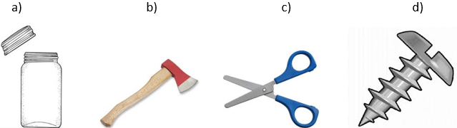

- Choice the best answer on the following statement:
a) Transformers are used to2marks
i. Convert AC into DC
ii. Convert DC into AC
iii. Step up DC voltage
iv. Set up or step down voltage
b) The core of transformer is laminated, so that2marks
- Ratio of the voltage across the secondary and primary is doubled
- The weight of the transformer can be kept low
- The rusting of the core is prevented
- Energy loss due to eddy currents is minimized
- The A step-down transformer is connected to a 240 v alternating current power supply. The primary coil has 1000 turns how many turns should the secondary coil have so as to operate a 12 v alternating current toy car? 3marks
- a) Explain the term: A lens 2marks
b) Draw the Image of the object is between lens and F and gives the characteristics of image formed. 6marks
- a) what is the difference between force and pressure? 4marks
b) calculate the pressure under a girl’s feet if her mass is 33.6kg and the area of contact of one foot is $84{cm}^{2}.$3marks
- a) Give any four application of Pascal’s principle in everyday life 4marks
b) why a convex mirror used as rear/back view mirrors of vehicles? 3marks
- a) A copper rod of length 2 m has its temperature changed from $15℃$ to$25℃$. Find the change in the length given that its coefficient of linear expansion
$α=1.7×{10}^{-5}K^{-1}$ 3marks
b) The quantity of heat required to raise the temperature of water from $10℃$ to $65℃$ is 6200 J. Calculate the heat capacity of water 3marks
- a) Two balloons inflated with air are tied with strings and held $1metre$ apart. Both the balloons are rubbed with fur. Why do the balloons move apart when brought close together?? 3marks
b) A plastic rod is rubbed with a dry cloth and becomes positively charged. Explain why the rod become positively charged? 3marks
- A nurse applies a force of 30N to the syringe. Give that the cross-sectional area of the tip of the needle is$1×{10}^{-7}m^{2}$, calculate the pressure produced at tip of the needle.
3marks
- a) Explain the following term:“Principal focus of spherical mirror”.3marks
b) By drawing find the image of the object placed on center of concave mirror

SECTION B: Attempt any three questions (30MARKS)
- a) State six most important environmentalfactorsaffecting plant growth.6marks
b)Identify two major effects of air pollution 2marks
c) State two causes of climate change natural2marks

- a) Copy the diagram below of a ray of light passing through a prism and complete it, and show the angle of deviation 2marks
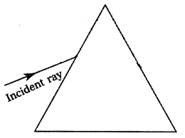
b) What meant by the “dispersion of white light”? 2marks
c) With respect order, state the colourspread out from the white light 4marks
d) State the laws of refractionof light 2marks

- a) Calculate the resistance equivalent of the following circuit.4marks

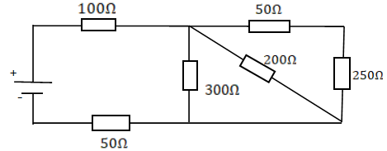
b) State Ohm's law 2marks
c) State any two effects of electric current2marks
d) explain why the filament of the lamp is usually made of tungsten2marks
- a) Explain why two steel needles hanging from the N pole of a magnet are not
parallel. 2marks
b) A bar magnet is heated. State the effect on its magnetic properties. How
does the domain theory of magnetism explain this effect? 4marks
c) What is a place where there is no magnetic field called? 2marks
d) State two uses of permanent magnets 2marks

SECTION C: This section is compulsory (15MARKS)
Use the graph paper on the drawing
- In an experiment to determine the specific heat capacity of a substance C, the following results were obtained

Temperature, t/$℃$ | 5 | 10 | 15 | 20 | 25 | 30
Quantity of heat, Q/J | 200 | 400 | 600 | 800 | 1000 | 1200
- Plot the graph of quantity of heat Q against temperature t10marks
- From the graph, find the gradient S of the graph showing clearly how you get your answer.3marks
- Use the formula S=mc to determine the specific heat of substance C. Take mass m, of the substance to be 20g.2marks

REPUBLIC OF RWANDA
MINEDUC
RUHANGO DISTRICT
MARKING GUIDE SENIOR THREE DISTRICT EXAMINATION 3rd TERM
Section A
- a) True 1mark
b) True 1mark
c) False1mark
d) False1mark
- simple machine is:
- Screw 1mark
- Wedge 1mark
- Lever1mark
- Screw1mark
- a) iv. Set up or step down voltage 2marks
b) iv. Energy loss due to eddy currents is minimized 2marks
- $\frac{V_{s}}{V_{p}}=\frac{N_{s}}{N_{p}}⟹\frac{12}{240}=\frac{N_{s}}{100}$ 3marks
$N_{s}=50turns$
- a) A lens is a piece of glass which is used to focus or change the direction of a beam of light passing through it. Or A lens is an object made by transparent material and bounded by one or two spherical surfaces. 2marks
b) 6marks

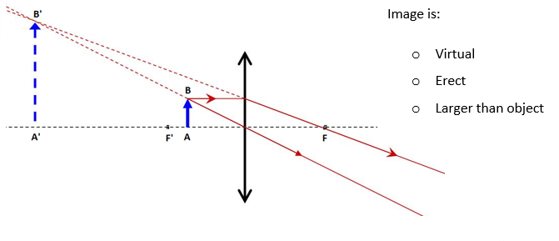

- a) difference between pressure and force 4marks
Force | Pressure
- Force is a pull or push of body  - Vector quantity  - F=ma  - Unit is Newton | - Is the normal force applied on unit area  - Scalar quantity  - P=F/A  - Unit is Pascal

b) $Area of both feet=84{cm}^{2}×2=168{cm}^{2}=0.0168m^{2}$
$Pressure=\frac{force}{area}=\frac{mg}{A}=\frac{33.6×10}{0.0168}=20000N$ 3marks
- a) four application of Pascal’s principle in everyday life 4marks
- Hydraulic press
- Hydraulic jack
- Hydraulic brake
- Hydraulic lift car
- Water tower
b) convex mirror produces always a virtual image, erect (upright), whose size is lass
than that of object. Or it has wider field of view with virtual image, erect and
smaller image. 3marks
- a)$∆θ=\left(25-15\right)℃=10℃$
$$∆l=l_{o}×α×∆θ=2×1.7×{10}^{-5}×10=112.73J/K 3marks$$
b) $Quantity of heat=heat capacity×variation of temperature$
$$heat capacity=\frac{quantity of heat}{variation of temperature}=\frac{6200J}{\left(65-10\right)K}=112.73J/K$$
3marks

- a) the balloons move apart when brought close together because those balloons have the same charge. 3marks
b) The rod become positive charged because, when you rub a dry cloth with a plastic rod electrons of plastic move and pas to the dry cloth and plastic rod loose the negative charge, then it becomes positive charged. 3marks
- $Pressure=\frac{Force}{area}=\frac{30N}{1×{10}^{-7}m^{2}}=3×{10}^{8}Pa$ 3marks
- a) Principal focus of spherical mirror is that point on principal axis to which all rays originally parallel and close to the principal axis converge, or from which they appear to diverge, after reflection from the mirror. 3marks
b) 3marks
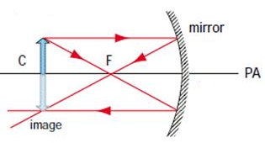
Section B
- a) 6marks
- Radiant energy
- Temperature
- Moisture supply
- Composition of the atmosphere
- Soil aeration and soil structure
- Soil reaction
- Supply of mineral nutrient
b) The following are some major effects of air pollution 2marks
- Acidification: this is a chemical reaction involving air pollutants creating acidic compounds in the atmosphere
- Eutrophication: this occurs when rain water dissolve chemicals like nitrogenous compounds in the atmosphere then drains into water bodies and soils.
- Particulate matter: air pollutants can be in the form of particulate matter, which can be very harmful to our health
c) The following are some natural causes of climate change 2marks
- Continental drift
- Volcanoes
- Ocean currents
- The earth’s tilt
- a) 2marks
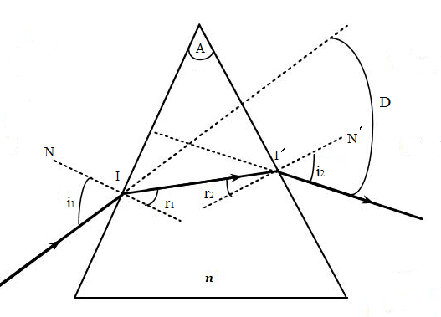with D angle of deviation
b) Dispersion of white light is the separation of the 7 colours by the prism when a white light pass through it. 2marks
Or Dispersion of white light is the splitting of white light into its component
c) red, orange, yellow, green, blue, indigo and violet 4marks
d) The laws of refraction are now stated as follows. 2marks
      - The incident ray, the normal, and the refracted ray all lie in the same plane at the point of incidence.
      - For light of a given frequency, the ration of to is constant for two media. That is (k: constant)
- a) 4marks
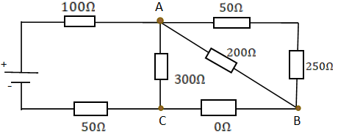
$$⇓$$
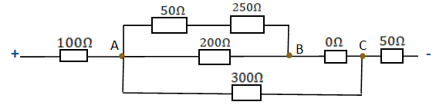
$$⇓$$
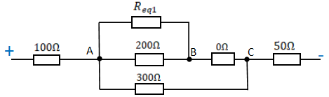
$R_{eq1}= 50Ω+25Ω=75Ω$
$$⇓$$
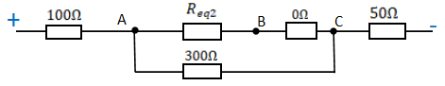
$$R_{eq2}=\frac{R_{eq1}×200Ω}{R_{eq1}+200Ω}=\frac{50Ω×200Ω}{50Ω+200Ω}=\frac{10000Ω^{2}}{250Ω}=40Ω$$
$$and R_{eq3}= 40Ω+0Ω=40Ω$$
$$⇓$$
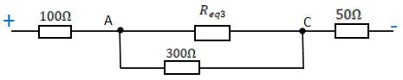
$$⇓$$
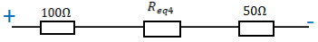
$$R_{eq4}=\frac{R_{eq4}×300Ω}{R_{eq4}+300Ω}=\frac{40Ω×300Ω}{40Ω+300Ω}=\frac{12000Ω^{2}}{340Ω}=35.29Ω=35Ω$$
$$⇓$$
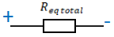
$$R_{ total}=100Ω+R_{eq4}+50Ω=100Ω+35Ω+50Ω=185Ω$$
b) The ratio of potential difference to current is a constant for a given conductor provided the physical conditions such as temperature remain constant. 2marks

Or “the current through a conductor between two points is directly proportional to the voltage across the two points”.
c) heat effect, chemical effect, magnetic effect 2marks
d)The filament of the lamp is usually made of tungsten since it has high-melting point. 2marks

- a) Two steels are induced by the magnet and their ends are both North poles, like poles of magnet repel 2marks
b) When a magnet is heated, it loses its magnetism. Heating a magnet makes the dipoles in the domain that were aligned in the same direction to turn back to their original disorder or random arrangement. 4marks
c) A neutral point 2marks
d) Uses of permanent magnets 2marks
  - Removing of iron pieces from the eyes of patients in hospitals.
  - Setting of six’s maximum and minimum thermometer in weather stations.
  - To show the direction as in compass needles for navigation.
  - Magnetic tapes use permanent magnets in audio and video recorders.

Section C: 15marks
