**MINISTRY OF EDUCATION SCHOOL YEAR:2021**

**SOUTHERN PROVINCE TERM: III**

**RUHANGO DISTRICT DATE: …/…/2021**

**PROMOTION: S6 DURATION: 3HRS**

**PHYSICS EXAMINATION FOR :MPG, MPC, PCB, PCM**

**INSTRUCTIONS: - Respect the order of questions and sections**

* **Use only blue or black pen**
* **Avoid deletion of answers**
* **Three sections: A,B&C**

**SECTION A: MULTIPLE CHOICE: ATTEMPT ALL QUESTIONS (10 Marks)**

1. A card marked IAHIO8 is standing upright in front of a plane mirror. Which of the following is NOT true?
2. The image is virtual
3. The image shifts its position as the observer shifts his position
4. The image appears as 8OIHAI to a person looking in the mirror
5. The image is caused mostly by specular rather than diffuse reflection
6. The image is the same size as the object
7. In a diesel engine, the fuel is injected by ________
8. Spark
9. Injected fuel
10. Ignitor
11. Heat resulting from compression air that is supplied from combustion
12. A small body containing ice, rock or cosmic dust revolving around sun giving off gas is called:
13. Meteorite B. Meteors C. Comet D. Star
14. An 800-N man stands halfway up a 5.0-m long ladder of negligible weight. The base of the ladder is 3.0m from the wall as shown. Assuming that the wall-ladder contact is frictionless, the wall pushes against the ladder with a force of magnitude: **(1marks)**

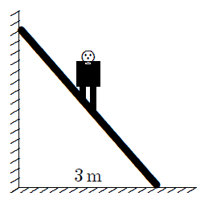

1. 150N B. 300N C. 400N D. 600N E. 800N
2. A 5.0-C charge is 10m from a −2.0-C charge. The electrostatic force on the positive charge is:

1. 9.0 × 108 N toward the negative charge
2. 9.0 × 108 N away from the negative charge
3. 9.0 × 109 N toward the negative charge
4. 9.0 × 109 N away from the negative charge
5. none of these
6. A magnifying glass has a focal length of 15 cm. If the near point of the eye is 25 cm from the eye the angular magnification of the glass is about:
7. 0.067 B. 0.33 C. 0.67 D. 1.7 E. 15
8. The diagram shows the electric field lines in a region of space containing two small charged spheres (Y and Z). Then:

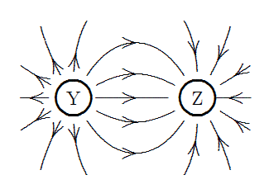

1. Y is negative and Z is positive
2. the magnitude of the electric field is the same everywhere
3. the electric field is strongest midway between Y and Z
4. Y is positive and Z is negative
5. Y and Z must have the same sign
6. At the end of communication system, the signal is converted from radio to
7. sound B. mechanical energy C. kinetic energy D. potential energy
8. Two independent events occur 100m apart with an intervening time interval of 0.42 μs. The proper time in μs between the events is:
9. 0 B. 0.16 C. 0.26 D. 0.42 E. 0.69
10. With two slits spaced 0.2mm apart, and a screen at a distance of l=1m, the third bright fringe is found to be displaced h=7.5mm from the central fringe. The wavelength, λ , of the light used is

1. 5.00 × 10–7m B. 5.00 × 107m C. 50.0 × 10-7m D. None of above
2. The following are examples of green gases except
3. Carbondioxide B. Nitrous oxide C. Methane D. Oxygen
4. Which layer is the coldest?
5. Troposphere B. stratosphere C. Mesosphere D. thermosphere
6. The place where an earthquake begins underground is called
7. The focus or hypocenter, C. Epicenter. D. All of them are correct
8. seismic activity
9. Two identical piano strings of length 0.750 m are each tuned exactly to 440 Hz. The tension in one of the strings is then increased by 1.0%. If they are now struck, what is the beat frequency between the fundamentals of the two strings?
10. 2 mHz B. 2 Hz C. 2 GHz D. 5 Hz
11. A certain radioactive element has a half-life of 20 d. The time it will take for 7/8 of the atoms originally present to disintegrate is
12. 20 d B. 40 d C. 80 d D. 100 d E. 60 d
13. If the mass of proton mp=1.00759 amu and mass of neutron mn=1.008898 amu. The mass of  is 7.01653 amu and 1 amu =931.5 MeV, then the nuclear binding energy for is

1. 38.966508 MeV B. 1.218402 MeV C. 5596.109208 MeV D. 5597.32761MeV
2. An AM broadcast station transmits modulating frequencies up to 6 kHz. If the AM station is transmitting on a frequency of 894 kHz, the values for maximum and minimum upper and lower sidebands and the total bandwidth occupied by the AM station are:
3. 900 KHz, 888 KHz, 12 KHz C. 894 KHz, 888 KHz, 6 KHz
4. 894 KHz, 884 KHz, 12 KHz 900 KHz, 888 KHz, 6 KHz
5. Theuncertaintyofthex-componentoftheelectron’spositionis0.05nm.Use the position momentum Uncertainty principle to find the uncertainty in the momentum.
6. 10-24 kg B. 10-24 kg.m/s C. 11-24 kg.m/s2  D. 15-24 kg /s
7. A student claims to have observed a decay of an electron into two neutrinos, travelling in opposite directions. The conservation laws violated by this decay are:
8. Conservation Charge and Conservation baryon
9. Conservation Charge and Conservation leptons
10. Conservation Charge and Conservation strangeness
11. Conservation baryon and Conservation strangeness
12. Which reaction obeys the conservation of baryon number:
13. 
14. 
15. 
16. 

**OPEN QUESTIONS, ATTEMPT ALL QUESTIONS / 35MARKS**

1. **a)** What is meant by Doppler Effect? **/2marks**

**b)** A police car sound a siren of 1000 Hz as it approaches a stationary observer at a speed of 33.5m/s. what is the apparent frequency of the siren as heard by the observer if the speed of sound in air is 340m/s. **/2marks**

**c)** Give one application of the Doppler effect. **/1mark**

22. a) Explain the following terms: **(i) path difference** and **(ii)** **fringe spacing** with reference to the interference of light.  **/3marks**

**b)** In a young’s double slit experiment, the distance between the slits and the screen is 1.6m, using light of wavelength 5.89x10-7m. the distance between the central of the interference pattern and the fourth bright fringe on either side is 16.0mm. what is the slit separation?

**/2marks**

1. How many 160 Ohms resistors in parallel are required to carry 5A on a 100 V line?/**3marks**
2. Distinguish between mass and weight/ **2marks**
3. **a)** What is a LASER? /**2marks**

**b)** Explain why the light pulse from a laser is ( i) monochromatic, (ii) coherent, (iii) intense/**3marks**

1. A car of mass 1000kg travelling at 72km/h on horizontal road is brought to rest in a distance of 40m by the action of the brakes and frictional forces. Find **(a)** the average stopping force, **(b)** the time taken to stop the car**. */5marks***
2. **a)** What is a fiber optic cable? Explain the principle of fiber optics**./3marks**

**b)** Give three advantages of a fiber optics cable over electrical wire**./3marks**

1. A simple pendulum has a period of 2.0s and an amplitude of swing 5.0cm. calculate the maximum magnitudes of **(a)** the velocity of the bob, **(b)** the acceleration of the bob**./4marks**

**SECTION B: ATTEMPT ALL QUESTIONS/35MARKS**

1. **a)** How the radiographer can increase the:

**i.** Intensity of x rays? **ii.** Energy of x rays produced by an x rays tube? / **2marks**

**b)** State the energy transformation that take place during x ray production in an x ray tube/**3marks**

**c)** Calculate the wavelength of x rays whose energy is 9.5 keV. /**2.5marks**

**d)** Comment on the quality of the x rays in **(c)** /**2marks**

**e)** Calculate the electrons produced per minute by the cathode of an x ray tube which has a current of 40 mA flow drought it. /**1.5marks**

**f)** Determine the maximum frequency of the x rays so produced if the tube voltage is 80 kV and the tube has the efficiency of energy of 2%. **/1.5marks**

1. **a)** Differentiate between Rutherford’s atomic model and Bohr’s atomic model/**6marks**

**b) i)** State Bohr’s postulates of a hydrogen atom**./3marks**

**ii)** Propose any three deficiencies of the Bohr model of a hydrogen atom**/ 3marks**

1. The frequency associated with an energy change of a hydrogen atom is 6.166x1014Hz and the final energy level is 4. Determine the initial energy level, take the **Rydberg constant RH=2.179x10-18J./2marks**
2. Hertzsprung-Russell Diagrams

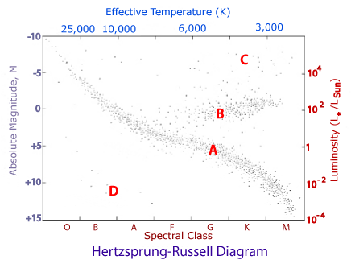

Answer the following questions using the Hertzsprung - Russell diagram provided above.

1. Indicate the regions of: **/3marks**
2. hottest stars
3. coolest stars
4. biggest stars
5. smallest stars
6. brightest stars
7. least bright stars
8. Using the HR diagram, which letters (A, B, C or D) represent the region of: **/2marks**
9. main sequence stars
10. white dwarfs
11. Giants
12. Supergiants
13. On the HR diagram, Label the evolutionary track (evolution path) for an average mass star (1 solar mass) using a pen of a different colour**. /1.5marks**
14. Describe the relationship between a star's temperature and its colour**./1.5marks**
15. What two factors affect a star’s luminosity (by looking at an HR diagram)? **/1.5marks**
16. Re-order these two lists from hottest to coolest stars:
17. Star colours: Yellow, Red, Orange, White, Blue/ **1.5marks**
18. Spectral classes: M, G, A, K, B, O, F **/1.5mark**

**SECTION C: choose only one question /15marks**

1. By using a glass prism of A=600; ng=1.50; fill this table by giving us your answer in: degrees, min. sec, tierce and all digits have to be written. Where: A: prism angle; D: deviation angle ( FILL CLEARLY ALL DIGITS).Where :i=incident angle on the first side (light comes from air to glass) and r=refracted angle; r’=incident angle on second side(that light now comes from glass to air) and i’=refracted angle. Don’t forget to show us all possible formula you have used and describe letters used.

|  |  |  |  |  |
| --- | --- | --- | --- | --- |
| i/0 | R | r’ | i’ | D |
| 0 | … | … | … | … |
| 30 | … | … | … | … |
| 45 | … | … | … | … |
| 60 | … | … | … | … |
| 90 | … | … | … | … |

1. In the following fig, calculate T1; T2; T3; T4; T5

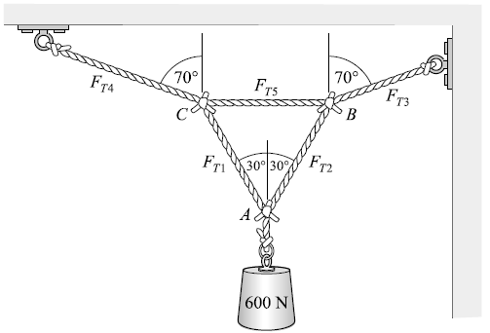

**The end!!!!!!**

**MINISTRY OF EDUCATION SCHOOL YEAR:2021**

**SOUTHERN PROVINCE TERM: III**

**RUHANGO DISTRICT DATE: …/…/2021**

**PROMOTION: S6 DURATION: 3HRS**

**PHYSICS EXAMINATION FOR: MPG, MPC, PCB, PCM**

**Total marks: 100**

**SECTION A: ATTEMPT ALL QUESTIONS (10 marks)**

|  |  |  |  |  |
| --- | --- | --- | --- | --- |
| 1. B | 2. D | 3. C | 4. B | 5. A |
| 6. D | 7. D | 8. A | 9. C | 10. A |
| 11. D | 12. C | 13. A | 14. B | 15. E |
| 16. A | 17. A | 18. B | 19. B | 20. D |

**OPEN QUESTIONS, ATTEMPT ALL QUESTIONS / 35MARKS**

**21.**

1. The Doppler effect is the change in frequency heard by an observer whenever there is relative motion between the source and observer**./2marks**
2. **./2marks**
3. The application of Doppler effect is a police camera speed checks. Etc. **./1mark**
4. a) i. The path difference is the distance travelled by two waves from their respective sources to a given point on the pattern. **./1.5marks**

ii) The fringe spacing is the distance between two adjacent bright or dark fringes. **./1.5marks**

b) **./2marks**

1. RT =160 Ohms, ,  thus **./3marks**

**24.** **./2marks**

|  |  |
| --- | --- |
| Mass | Weight |
| Quantity of material(inertia) | Force of gravity |
| Scalar quantity | Vector quantity |
| Invariable | Variable |
| Measured with a scalar | Measured with dynamometer |
| Unit: kg(kilogram) | Unit : N(newton) |

**25.**

1. LASER is Light Amplification by Stimulated Emission of Radiation **./2marks**
2. i) The light from laser is monochromatic because all photons have the same energy above the basic level and therefore the same frequency. **./1mark**

ii) coherent or consistence: because all photons are in phase. **./1mark**

iii) intense: because all the photons emitted are in phase or coherent. **./1mark**

**26.**

72km/h = 72000m/3600s =20m/s **./0.5marks**

1. Kinetic energy lost by the car =, if F is average stopping force and S the distance over which it acts, then work done by car against F=FS, but 

**./2marks**

1. Assuming the constant acceleration and substituting vf =0, vi=20m/s and S=40m  , (the negative sign indicates the acceleration is in opposite direction to the displacement.) **./2.5marks**

Using 

0 =20+(-5)t , 

**27.**

1. A fiber optic cable is a set of bundle of glass or of plastic, capable of transmitting messages modulate into light waves. Or a fiber optic cable is a light pipe which is used to transmit information from one point to another by using the principle of total internal reflection of light. **./3marks**
2. Fiber optic can carry much more information in a small cable. **./3marks**

Fiber optics are easy manufacture.

Fiber optics can transmit information in form of pictures.

Fiber optics offer greater security to the user.

**2 8.**

**a)** , therefore 

The velocity is maximum at the equilibrium position where x=0.

, where r= 5cm/s

=**./2marks**

**b)** The acceleration is maximum at the limits of the swing where 

**./2marks**

**ANSWERS FOR SECTION B**

**29. a)** **i)** The intensity of x rays can either be increased by:

Increasing the current on the filament cathode or Increasing the tube voltage **./1mark**

**ii)** Increase the tube voltage**./1mark**

**b)** Electrical energy is converted to heat energy in the filament cathode. The heat energy is then converted to kinetic energy of moving electrons. Upon reaching the anode, the kinetic energy is converted to x rays and heat energy. **./3marks**

**c)** **./2.5marks**

**(d)** The x rays are of high quality. Quality of x rays in the penetrating power of x rays. X rays of short wavelength like that in **(c)** above are of high quality since their penetrating power is high. **./2marks**

**e)** Total charge, Number of electrons **./1.5marks**

**f)** energy per electron , efficiency of tube 

hence **./1.5marks**

**30.**

1. The difference between atomic model of Rutherford and Bohr are summarized in the following table below. **./6marks**

|  |  |
| --- | --- |
| Rutherford model states that an atom is composed of a central core where nearly the whole mass of that atom is concentrated and light weight particles move around this central core. | Bohr model explains that the electrons always travel in specific shells or orbits  which are located around the nucleus and these shells have discrete energy levels. |
| Rutherford model was developed based on observations of gold foil experiment | Bohr model was developed based on observations of lines spectra of hydrogen atom. |
| Rutherford model does not describe the presence of discrete energy levels. | Bohr model describes the presence of discrete energy levels. |
| Rutherford model does not explain the relationship between orbital size and the energy of the orbital. | Bohr model explains the relationship between orbital size and the energy of the orbital; smallest orbital has the lowest energy. |

1. **i)** Bohr’s postulates of a hydrogen atom are: **./3marks**

* Each electron moves in circular orbit centred at the nucleus
* The centripetal force needed by the electron moving in circle is provided by electrostatic force of attraction between the nucleus and electrons.
* The angular momenta p of electrons are whole number multiple of  where 
* When electron moves in its allowed orbit, it doesn’t radiate energy. the atom is stable.
* When an electron jumps from one allowed orbit to another, it radiates energy. The energy of radiation equals energy difference between levels.

**ii)** Three deficiencies of the Bohr model of a hydrogen atom are: **./3marks**

* Bohr model can not be applied to multi- electron atoms
* Bohr model does not provide a method to calculate relative intensities of spectral lines
* Bohr model does not predict fine structure of atomic spectral lines.
* Bohr model predicts the wrong value of angular momentum for the electron in the atom.
* Bohr model violates the Heisenberg uncertainty principle (although Bohr’s model preceded this by more than a decade).

1. The energy change 







Solving the equation, ni=2 **./2marks**

**31.**

1. **./3marks**

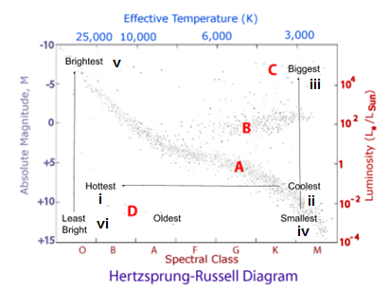

1. **./2marks**
2. A
3. D
4. B
5. C
6. **./1.5marks**

Typical evolution path of a 1 M☉ star:

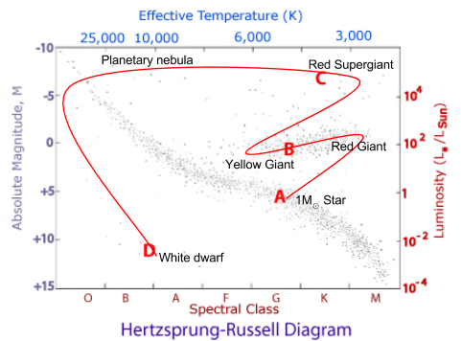

1. The hotter a star, the more blue in colour the light emitted from that star will be.Cooler stars are more red in colour. **./1.5marks**
2. The two factors that affect a star’s luminosity are the temperature and the radius (or size).

We can also see this in the Stefan–Boltzmann equation: L = 4πR2σT4 Where: L = luminosity; R = radius of the star; T = temperature of the star; σ = the Stefan–Boltzmann constant. **./1.5marks**

1. Blue, White, Yellow, Orange, Red **./1.5marks**
2. O B A F G K M **./1.5marks**

**SECTION C: CHOOSE ONLY ONE QUESTION /15marks**

1. By using a glass prism of A=600; ng=1.50; fill this table by giving us your answer in: degrees, min. sec, tierce and all digits have to be written. FORMULAS: ; ; ; ; ;;  **( all formulas: 0.5x7= 3.5 marks, table headings: 0.5x4= 2marks, table fillings: 0.5x20= 10marks)**

|  |  |  |  |  |
| --- | --- | --- | --- | --- |
| i/0 | r/0 | r’/0 | i’/0 | D/0 |
| 0 | 0 | 60 | 90 | 30 |
| 30 | 19.47122063 | 40.52877937 | 77.09581152 | 47.09581152 |
| 45 | 28.1255057 | 31.8744943 | 52.38130648 | 37.38130648 |
| 60 | 35.26438968 | 24.73561032 | 38.87676961 | 38.87676961 |
| 90 | 41.81031489 | 18.18968511 | 27.92049012 | 57.92049012 |

1. Let us select as our object at A because we know one force acting on it. The weight pulls down on it with a force of 600N, and so the free-body diagram for that object as shown here (b)

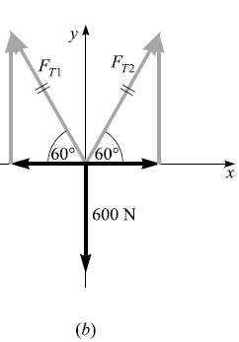

Applying the first condition for equilibrium to that diagram, we have:  and 

 and  ;we see that and after substitution we get :  let us isolete object B , its free-body diagram see the following fig (c)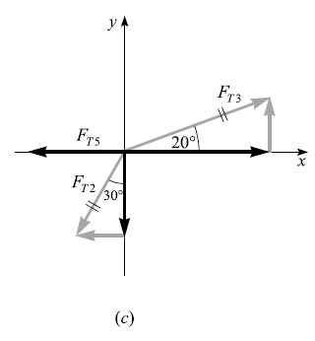

 and 

 and 

After solving we get:  and 

Again let us isolete object C , its free-body diagram see the following fig (d)

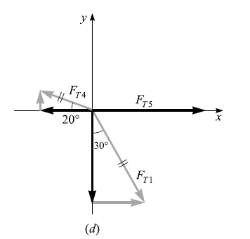

Similarly by projecting and by calculating we see that the last force is 

**Conclusion:** ; ; ; ; **(marks: drawing free diagrams:1.5*3=4.5; solving and get the answer :3*5=15 and 0.5 for underlining answers)**

**The end**