

**PHYSICS**

**02/07/2021**

**8:30 am – 11:30 am**

**SENIOR FIVE END OF YEAR EXAMINATIONS, 2021**

**SUBJECT: PHYSICS THEORY**

**COMBINATIONS:**

**PHYSICS-CHEMISTRY-MATHEMATICS (PCM)**

**MATHEMATICS- PHYSICS- COMPUTER SCIENCE (MPC)**

**PHYSICS –CHEMISTRY- BIOLOGY (PCB)**

**MATHEMATICS –PHYSICS- GEOGRAPHY (MPG)**

|  |
| --- |
| **/100**    **Marks:** |

**DURATION: 3 HOURS**

**INSTRUCTIONS:**

1. Do not open this question paper until you are told to do so.
2. Answer all questions: **100 marks**
3. Use only a **blue** or **black** pen.

**PART I: MULTIPLE CHOICE QUESTIONS (30 MARKS)**

Choose the letter that corresponds to the correct answer

1)Which of the following does Compton shift depend on?

a) Incident radiation b) Nature of scattering substance

c) Angle of scattering d) Compton wavelength of the electron

**(2 marks)**

**2)** Fill in the blank with appropriate acronym used in mobile phone or

radio communication.

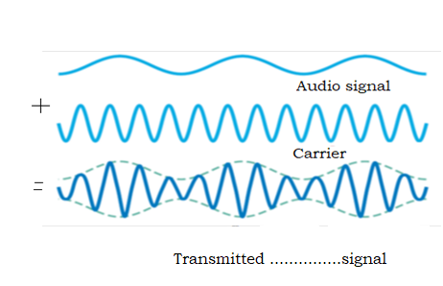

a)AM b)FM c)PTT d)PM **(2 marks)**

**3)** If the length of a simple pendulum is doubled, its period will:

a) Halve b)be greater by a factor of  c)be less by a factor of

d) double **(2 marks)**

**4)** Oscillations are damped due to

a)linear motion b)restoring force c)frictional force d)gravitational force

**(2 marks)**

**5)** When an outside driving force causes an object to oscillate at certain

frequency, the resulting oscillations are called.

a)Resonant oscillations b)natural oscillations c)damped oscillations

d) Forced oscillations. **(2 marks)**

**6)** What type of fossil fuel is mined from the ground?

a)Copper b)Geothermal energy c)coal d)biomass

**(2 marks)**

**7)** Which of the following produces greenhouse gases?

a) Burning fossil fuel b) nuclear fission c) Use of solar energy

d)Use of electricity. **(2marks)**

**8)** Two objects, one with a mass m and other with a mass 4 m are

attracted to each other by gravitational force.

If the gravitational force on 4 m is F, what is the force on mass m

in terms of F?

1. 16 F b)4 F c)F d) F/4 **(2 marks)**

**9)** The escape velocity of a projectile from the Earth can be calculated

using the formula ( where G: gravitational constant ,:radius of the

Earth , M mass of the Earth ,g acceleration due to gravity)

a) b)  c)  d)  **(2 marks)**

**10)** Which of the following characterizes an analog quantity?

a) Discrete levels represent changes in a quantity.

b)Its values follow a logarithmic response curve.

c) It can be described with a finite number of steps.

d)It has a continuous set of values over a given range. **(2 marks)**

**11)** Which of the following is **NOT** a component of communication system?

a)Transmitter b)Transmission channel c)Noise d)receiver **(2 marks)**

**12)** Half duplex system for communication has

a)communication in single direction

b) Communication in both directions but only one at a time

c) Communication in both directions at the same time

d)None of the above  **(2 marks)**

**13)** According to the theory of relativity, the speed of light in a vacuum

is …………………………………for all observers.

a) dependent on the motion of the source of light b)the same

c) dependent on the relative motion of the observers d)different

**(2 marks)**

**14)** Light years is the unit of

a) Distance b) Weight c) time d) Intensity of light

**(2 marks)**

**15)** -------------- is a measure of the amount of the brightness of a star

or other astronomical object observed from the Earth.

a)Absolute magnitude b) Fusion c)Apparent magnitude d) Parallax

**(2 marks)**

**PART II: ATTEMPT ALL QUESTIONS (70 MARKS)**

**16)**a)A particle executes a simple harmonic motion with amplitude A

(i) Write the expression of the potential energy of this particle in terms

of displacement x **(1 mark)**

(ii)Write out the formula of the kinetic energy of this particle in terms of

displacement x. **(1 mark)**

b)The figure below shows how the potential energy of the oscillator

performing simple harmonic motion varies with displacement x .

This varies between -0.2 m and +0.2 m.

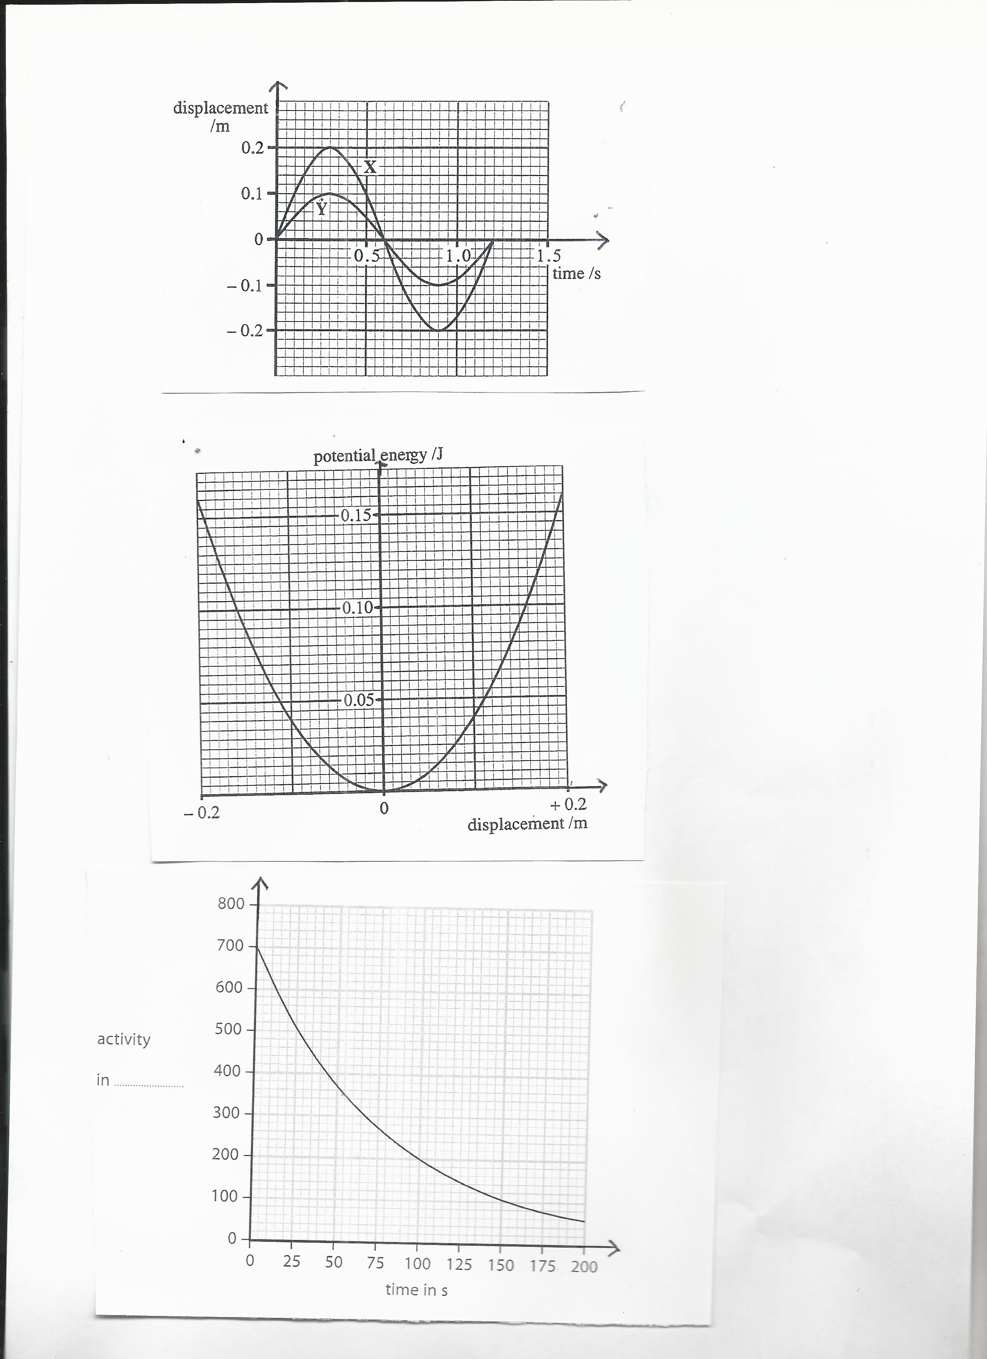

Find

(i)the amplitude of oscillations **(1 mark)**

(ii) the total energy of the mass of this oscillator  **(1mark)**

(iii) its kinetic energy if the potential energy is 0.10J **(1 mark)**

**17)**  a) Use true or false to answer the following sub questions

(i)Gravitational force is always attractive **(1 mark)**

(ii)Electrostatic force may be attractive or repulsive **(1mark)**

(iii)Gravitational potential has always positive values **(1mark)**

(iv)Cathode rays are composed of protons **(1 mark)**

b) Point charges Q1=3.5  and a point A are 0.0 5 m apart.



Find the electric potential due to Q1 at point A.

The coulomb’s constant k=9x109Nm2/C2 **(3 marks)**

c) Three 0.300 kg billiard balls are placed on a table at the corners

of a right triangle, as shown in figure below.

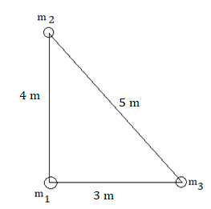

Copy the diagram and indicate the direction of the gravitational force on the cue ball (designated m1 ) resulting from the other two balls. Show how this gravitational force is obtained. **(3 marks)**

**18)** a)Enumerate any two factors on which the resistance of a conductor

depends **(2 marks)**

b) In the following electric circuit, 5 resistors are connected as

shown below

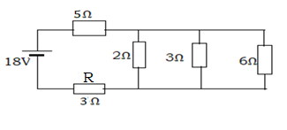

Find

(i)Equivalent resistance of the circuit **(3 marks)**

(ii)The electric current through the circuit **(2 marks)**

(iii) The electric power dissipated by the resistor R of3Ω**. (2 marks)**

c) Use Kirchhoff’s laws to find the currents *I*1, *I*2, and *I*3 in the

circuit shown below.

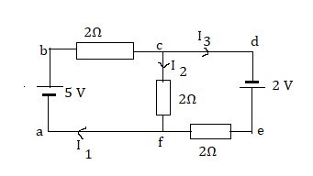

**(6 marks)**

**19)** a)Use true or false to answer these sub-questions.

(i) Stationary/standing wave is the combination of two progressive

waves moving in opposite directions ,each having the same amplitude

and frequency. **(1mark)**

(ii)When the particles of a medium are vibrating at right angles

to the direction of energy transport, then the wave is longitudinal

wave **(1mark)**

(iii)Transverse waves are waves in which the displacement of the

particles of medium is in the same direction as the direction of

propagation of the wave. **(1mark)**

(iv)Progressive wave is a wave where continuous energy transfer

takes place in elastic medium between the crest and

trough(transverse wave) or rarefactions and compressions

(longitudinal wave. **(1mark)**

b) One end of a long string is attached to an oscillator.

The string passes over a frictionless pulley and is kept taut by means

of a weight as shown below.

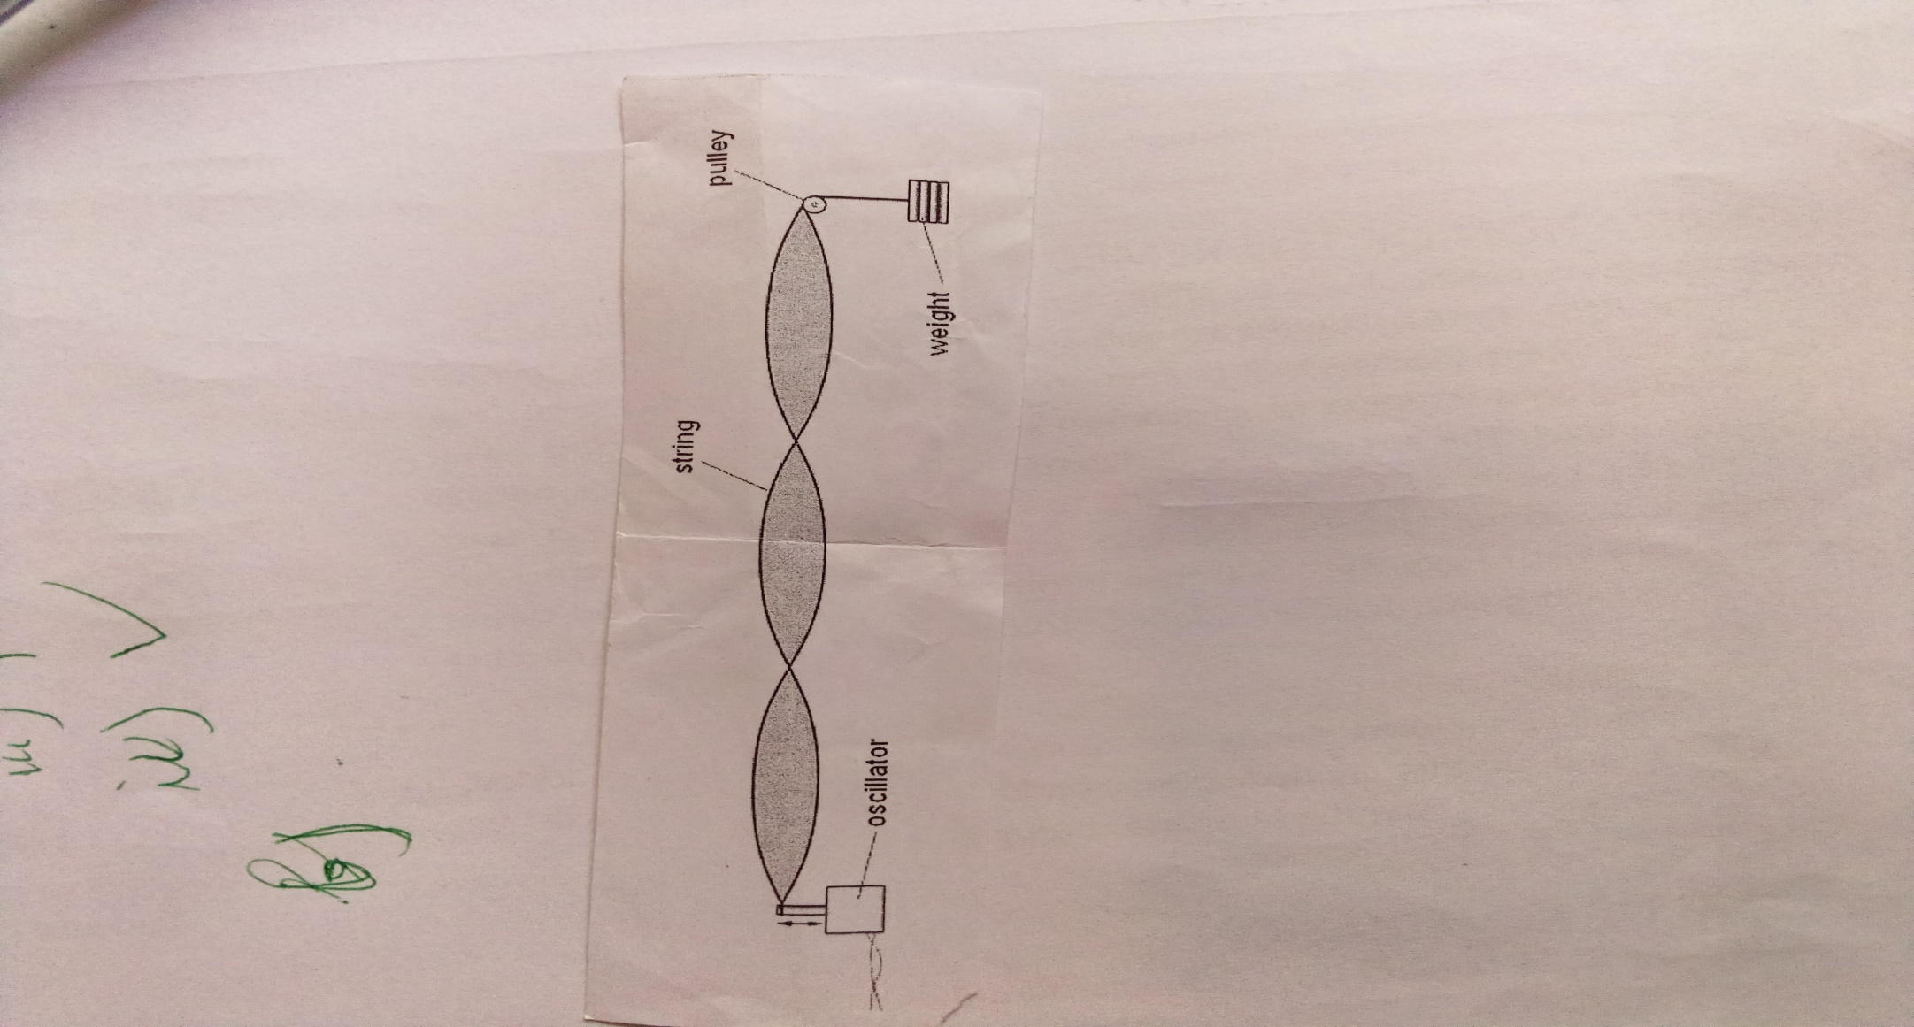

The frequency of oscillation is varied and at one value of frequency the

wave formed on the string is as shown

(i)State what is meant by the term antinode **(1 mark)**

(ii)State what is meant by the term node **(1 mark)**

(iii)Redraw the figure and label on it one node with the letter N and

one antinode with the letter A **(2 marks)**

c)A weight of 4 N is hung from the string( see figure in b) and the

frequency of oscillation is adjusted until a stationary wave is formed

on the string. The separation of the antinodes on the string is 17.8 cm

for a stationary wave of 125 Hz.

The speed v of the waves on a string is given by the expression 

where T is the tension in the string and µ is its mass per unit length

(i) Find the wavelength of the wave **(2 marks)**

(ii)Determine the length of the string between the oscillator and the

pulley. **(2 marks)**

(iii)Show that the speed v of the wave on the string is equal to

44.5 m/s  **(2 marks)**

(iv)Use the given formula to find the mass per unit length of the string.

The tension in the string is 4N as stated above. **(1mark)**

**20)** a)State

(i) Any one factor affecting photoelectric emission **(1 mark)**

(ii)Any one postulate of bohr model of hydrogen atom  **(1 mark)**

b)(i)Einstein equation for photoelectric effect is given by 

What do you understand by each of the terms hf , and EK? **(3 marks)**

(ii)The graph in the figure below shows how the energy Ek of

photoelectrons emitted from the surface of sodium metal varies

with frequency f of the incident radiation.

Planck constant h=6.62x10-34m2kg/s

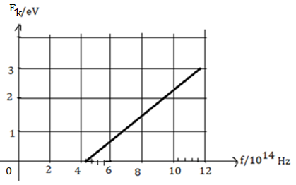

1. Find the threshold frequency **(2 marks)**
2. Calculate the work function of sodium in J or  **(2 marks)**

c)The lowest energy of a hydrogen atom are shown below

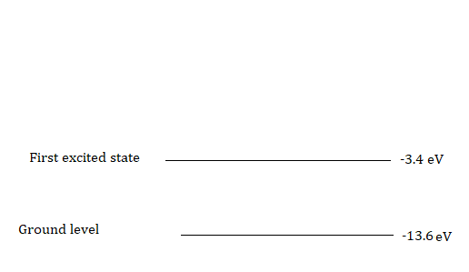

(i)Determine the energy of level n=3(second excited state) of the

hydrogen atom(**** ) **(2 marks)**

(ii)A free electron with kinetic energy collides with an atom of

hydrogen and causes it to be raised to its first excited state(n=2).

1) Determine the energy absorbed when electron jumps from

ground level n=1 to n=2 **(3 marks)**

2) Calculate the kinetic energy of the free electron in  after the

collision **(1 mark)**

**21)** a)Apparatus used to produce interference fringes is shown below.

The apparatus is not drawn to scale

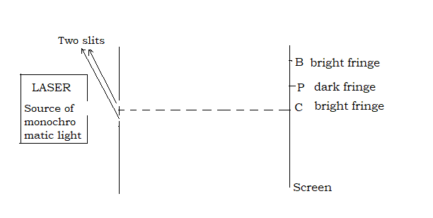

Laser light is incident on two slits. The Laser provides monochromatic light

The light from the two slits produces a fringe pattern on the screen.

A bright fringe is produced at C and the next bright fringe is at B.

A dark fringe is produced at P.

(i)Explain why one laser and two slits are used, instead of two different

lasers to produce visible fringe pattern on the screen. **(2 marks**

(ii)State the condition of interference related to the phase difference

Δθ between the waves that meet at

1) B **(1 mark)**

2) P **(1 mark)**

(iii)State the condition of interference related to the path difference δ

between the waves that meet at

1. B **(1 mark)**

2) P **(1 mark)**

b) In the given figure the distance D from the two slits to the screen is

1.8 m. The distance CB is 2.3 mm and the distance a between the slits

is 25x10-5m.

(i)Convert 2.3 mm into metres (m) **(2 marks)**

(ii)Calculate the wavelength of the light provided by the Laser.

**(2 marks)**

**COMPREHENSIVE ASSESSMENT 2021**

**S5 MARKING SCHEME OF PHYSICS**

**PART I: MULTIPLE CHOICE QUESTIONS (30 MARKS)**

**1)C (2 marks)**  h,m0 and c are constant

**2)a) (2 marks)**

**3)b)(2 marks) 4)c)(2 marks) 5)d(2 marks)**

**6) c)(2 marks) 7)a)(2 marks) 8) c)(2 marks)**

**9) b) (2 marks)**kinetic energy of the object is equal to the gravitational

potential energy



**10)d)(2 marks) 11)c(2 marks) 12)b)(2 marks)**

**13)b)(2 mark) 14)a)(2 marks) 15)c)(2 marks)**

**PART II (70 MARKS)**

**16)**a)(i) Potential energy **(1mark)**

(ii) Kinetic energy KE=ET-PE where ET is the total energy of the

system(principle of conservation of the mechanical energy)

**(1mark)**

Or 

b)(i)Amplitude A=0.2 m**(1 mark)**

(ii)The total energy is equal to maximum potential energy

ET=0.16 J (from the graph) **(1 mark)**

(iii)The kinetic energy KE= 0.16 J-0.1J=0.06 J**(1mark)**

**17)**a)(i)True **(1mark)**

(ii)True **(1mark)**

(iii)False **(1mark)**

(iv)False **(1mark)**

b)(i)The electric potential due to Q1

 **(1 mark)**



=630 V**(2 marks)**unit+value

c) **1mark** for each force x3= **3 marks**

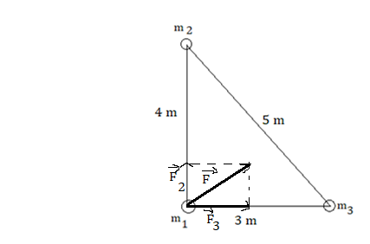

**18)**a) Length of the conductor **(1mark)**

Nature of the conductor **(1mark)** and

Cross sectional area of the conductor

b)(i)Equivalent resistance of resistors in parallel

**(1mark)**

 the R=1Ω**(1mark)**

All resistors are now in series

Total resistance Rt=1Ω+3Ω+5Ω

=9Ω**(1mark)**

(ii)The current **(1 mark)**

**=****(1mark)**

(iii)The power P=RI2**(1 mark)**

=9x22 W=36W**(1mark)**

1. Junction c or f :I1=I2+I3(eq1) **(1 mark)**

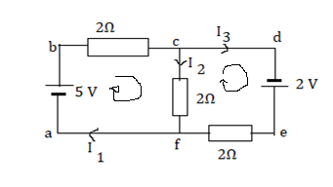

Loop abcfa 5-2I1-2I2 =0(eq 2) **(1 mark)**

Loop cdefc 2 -2I3+2I2 =0(eq 3)**(1 mark)**

Put eq 1 into equation 2

2(I2+I3)+ 2 I2 =5

4I2 +2I3 =5 (eq 4)

Eq 3 and eq 4 give I2=0.5 A **(1mark)**

Substitute I2 into eq 2 ,you obtain I1 =2 A **(1mark)**

Eq 1 gives I3 =1.5 A**(1mark)**

**19)** a)(i) True**(1mark)**

(ii)False **(1mark)**

(iii)False **(1mark)**

(iv)True **(1mark)**

b)(i) Antinode: position along the wave where amplitude of

vibration is a maximum**(1mark)**

(ii)Node: position along the wave where the amplitude is zero

**(1 mark )**

(iii)Any one node **(1 mark)** and one antinode **(1mark)**

see the diagram

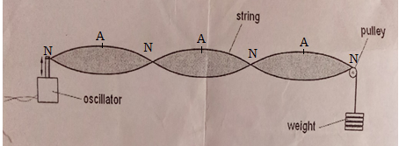

c)(i)The wavelength ** (1mark)**

λ=35.6 cm **(1mark)**

(ii)From the figure, the length of the string **(1 mark)**

 53.4cm **(1mark)**

(iii)The speed of the wave v = λf **(1 mark)**

= 35.6x10-2 x125 m/s=44.5m/s**(1mark)**

(iv)The mass per unit length 

µ = 2.0 x 10-3 kg/m**(1mark)**

**20)**a)(i)The intensity of the incident radiation**(1mark)**

The type of the metal surface

The frequency of the incident radiation

(ii)An electron moves around the nucleus in a circular motion

**(1mark)**

An electron’s angular momentum in the orbit is quantized

An electron can jump from one orbit to another higher

energy on the absorption of energy and one orbit to

another lower energy orbit with the emission of energy

b)(i) hf: energy of incident radiation **(1mark)**

 work function of the meatl **(1mark)**

EK **kinetic** energy of the emitted electrons **(1mark)**

(ii) 1) Threshold frequency f0=4.4 x1014Hz (**2marks)**

2)=hf0 **(1mark)**

=6.62x10-34x 4.4x1014J= 29.128x10-20 J **(1mark)**

Or 

c)(i)The energy of the level n=3

**(1mark)**





** (1mark)**

(ii)1)Energy used to raise the electron from n=1 to n=2

**(1 mark)**

**(2marks)**

2) Energy transferred to the hydrogen atom is

The kinetic energy of the electron after collision

**(1 mark)**

**21)** a(i)Laser provides monochromatic light of a single wavelength or

frequencyso the two slits are two monochromatic **(1 mark)** and

coherent **(1mark)**sources .Coherent sources are sources which have

a constant phase difference

These are the two conditions to produce interference of light.

(ii) 1) They must be always in phase Δθ=0**(1mark)**, 2π, 4π…..or

0°, 360°, 720°...

In general phase difference for constructive interference

Δθ=2nπ or nx360˚ where n=0, 1, 2, 3…

2) They must be out of phase: Δθ = π **(1mark),** or180˚

General condition Δθ = (2n+1) π or

(2n+1)180˚where n=0, 1, 2, 3…

(iii) 1)δ=nλ**(1mark)** where n=0,1,2,3,…..

2)δ=(2n+1) **(1mark)** where n=0,1,2,3,…..

b) (i) 2.3 mm =2.3 x10-3 m**(2 marks)**

(ii)The wavelength **(1 mark)**



=319.4x10-9 m **(1mark)**

**PHYSICS**

**23/06/2021**

**8:30 am – 11:30 am**



**SENIOR FIVE END OF YEAR EXAMINATIONS, 2021**

**SUBJECT: PHYSICS PRACTICAL**

**COMBINATIONS:**

**PHYSICS-CHEMISTRY-MATHEMATICS (PCM)**

**MATHEMATICS- PHYSICS- COMPUTER SCIENCE (MPC)**

**PHYSICS –CHEMISTRY- BIOLOGY (PCB)**

**MATHEMATICS –PHYSICS- GEOGRAPHY (MPG)**

|  |
| --- |
| **/100**    **Marks:** |

**DURATION: 1 HOUR 30 MINUTES**

**INSTRUCTIONS:**

1. Do not open this question paper until you are told to do so.
2. Answer all questions: **100 marks**
3. Use only a **blue** or **black** pen.

**ATTEMPT ALL QUESTIONS (40 MARKS)**

In this experiment you will determine the spring constant K of a spring

provided.

**Apparatus required**

1 spring with pointer or without pointer

1 metre rule

1 retort stand set

1 set of 20 g slotted masses comprising 9 slotted masses and 1 mass

hanger of 20 g

1 set of geometrical instruments

**Procedures**

a) From the following figure, measure the vertical distance D0 in mm,

between the bottom of the spring and the surface of the bench.

D0 must be greater than 30 mm on the figure.

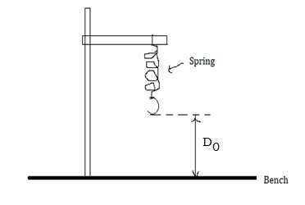

**(1mark)**

b) The diagram is drawn 1/10th actual size.

Calculate the actual distance D0 in mm, between the bottom of the

spring and the surface of the bench. **(2 marks)**

c) Set up the apparatus as shown above using actual distance D0

d) Hang a 20g load L on the spring .Measure and record the distance D

between the bottom of the spring and the surface of the bench.

The weight of the load L must be in N.

Acceleration due to gravity g = 10 m/s2.

e) Repeat the procedure d) using loads of 40g, 60g, 80g, 100g and 120 g.

f) Calculate the extension e= (D0-D) of the spring for each set of readings

g) Record your results in a suitable table as shown below

|  |  |  |  |
| --- | --- | --- | --- |
| Mass of the load /g | L/N | D/mm | e=(D0-D) /mm |
| 20 |  |  |  |
| 40 |  |  |  |
| 60 |  |  |  |
| 80 |  |  |  |
| 100 |  |  |  |
| 120 |  |  |  |

**(18 marks)**

**Questions**

(i)Plot a graph of e (vertical axis) against L (horizontal axis). **(11 marks)**

(ii)Determine the gradient/slope G of the graph. Show clearly on the

graph how you obtained the necessary information.**(3 marks)**

(iii)Interpret your result. **(3 marks)**

(iv)Suggest the precautions that should be taken when carrying out this

experiment. **(2 marks)**

**S5 PHYSICS PRACTICAL EXAM 2021**

**MARKING SCHEME /40MARKS**

**THE MARKING SCHEME TO BE USED WILL BE PREPARED BY THE S5 PHYSICS TEACHER**

The results will depend on the nature of the spring used and the distance D0

Follow the following guidelines during the marking of this exam

a)Value of D0 in mm**(1mark)**

b) Actual value of D=value obtained in a) X 10 in mm **(2marks)**

g) Allocate marks as follows

|  |  |  |  |
| --- | --- | --- | --- |
| Mass of the load /g | L/N | D/mm | e=(D0-D) /mm |
| 20 | **(1mark)** | **(1mark)** | **(1mark)** |
| 40 | **(1mark)** | **(1mark)** | **(1mark)** |
| 60 | **(1mark)** | **(1mark)** | **(1mark)** |
| 80 | **(1mark)** | **(1mark)** | **(1mark)** |
| 100 | **(1mark)** | **(1mark)** | **(1mark)** |
| 120 | **(1mark)** | **(1mark)** | **(1mark)** |

Questions

(i) 2Labelled axes with arrows **2x 1mark=2 marks**

2 Uniform scales **2x 1mark=2 marks**

6 plotted points 6x **1mark=6 marks**

Best fit straight line **1 mark**

(ii) Indication of the slope on the graph **1mark**

Formula for the slope **1mark**

Correct value of the slope **1mark**

(iii)Logic interpretation **(3 marks)**

(iv)Any two precautions **(2 marks)**

**I(exam setter) obtained the following results**

a) D0=33 mm

b) Actual value D0=33mmx10=330 mm

g)

|  |  |  |  |
| --- | --- | --- | --- |
| Mass of the load /g | L/N | D/mm | e=(D0-D) /mm |
| 20 | 0.2 | 314 | 16 |
| 40 | 0.4 | 287 | 43 |
| 60 | 0.6 | 254 | 76 |
| 80 | 0.8 | 220 | 110 |
| 100 | 1.0 | 184 | 145 |
| 120 | 1.2 | 148 | 182 |

Questions

(i)

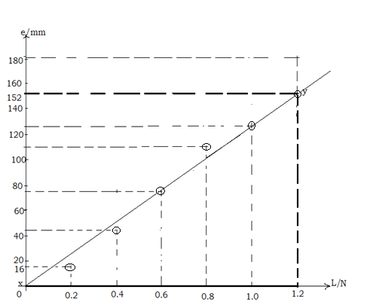

(ii)

(iii)The slope G is the inverse of the spring constant/force constant of

the provided spring.

(iv)Avoid parallax error,

Remove the mass when you are recording the

results because the spring may be permanently stretched .

Use of protective clothes (overall or lab coat, gloves),

Use of accurate measuring instruments, adhere to the safety rules etc.



**PHYSICS**

**23/06/2021**

**8:30 am – 11:30 am**

**SENIOR FIVE END OF YEAR EXAMINATIONS, 2021**

**SUBJECT: ALTERNATIVE TO PHYSICS PRACTICAL EXAM**

**COMBINATIONS:**

**PHYSICS-CHEMISTRY-MATHEMATICS (PCM)**

**MATHEMATICS- PHYSICS- COMPUTER SCIENCE (MPC)**

**PHYSICS –CHEMISTRY- BIOLOGY (PCB)**

**MATHEMATICS –PHYSICS- GEOGRAPHY (MPG)**

|  |
| --- |
| **/100**    **Marks:** |

**DURATION: 1 HOUR 30 MINUTES**

**INSTRUCTIONS:**

1. Do not open this question paper until you are told to do so.
2. Answer all questions: **100 marks**
3. Use only a **blue** or **black** pen.

**ATTEMPT ALL QUESTIONS (25 MARKS)**

A Learner studied the variation in volume with pressure for a sample of air at constant temperature using suitable apparatus. Air can be treated as ideal gas.



The results obtained were recorded in the table below

|  |  |  |
| --- | --- | --- |
| Pressure P /kPa | Volume V/10-5 m3 | 104m-3 |
| 250.0 | 1.37 |  |
| 155.0 | 1.85 |  |
| 100.0 | 2.27 |  |
| 63.0 | 2.70 |  |
| 27.0 | 3.22 |  |
| 9.8 | 3.70 |  |

a) For each value of the volume, calculate 1/V to one decimal place as

indicated in the table **(6 marks)**

b) Plot a graph of the pressure P (along vertical axis) against the inverse

of the volume (along horizontal axis).

Draw the best fit straight line **(11 marks)**

c)(i)Why the best fit straight line does not pass through the origin?

**(2 marks)**

(ii) From your graph, state the relation between pressure and volume

of a given mass of air. **(2 marks)**

d) Enumerate any two properties of the gas discovered by the student

during this experiment. **(2 marks)**

e) Propose two applications of this gas law in daily life **(2 marks)**

**S5 MARKING SCHEME OF ALTERNATIVE TO PHYSICS PRACTICAL EXAM 2021(25 MARKS)**

a)

|  |  |  |
| --- | --- | --- |
| Pressure P /kPa | Volume V/10-5 m3 | 104m-3 |
| 250.0 | 1.37 | 7.3**(1mark)** |
| 155.0 | 1.85 | 5.4**(1mark)** |
| 100.0 | 2.27 | 4.4**(1mark)** |
| 63.0 | 2.70 | 3.7**(1mark)** |
| 27.0 | 3.22 | 3.1**(1mark)** |
| 9.8 | 3.70 | 2.7**(1mark)** |

b)Graph

2Labelled axes with arrows **2x 1mark=2 marks**

2 Uniform scales **2x 1mark=2 marks**

6 plotted points 6x **1mark=6 marks**

Best fit straight line **1 mark**

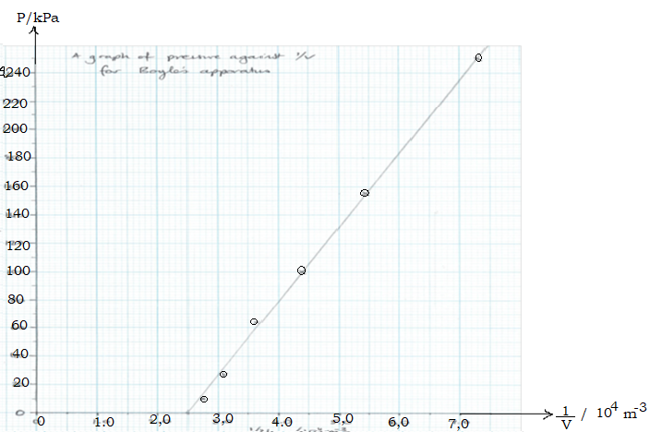

c) (i)This is due to possible systematic error **(2 marks)** because ifpressure

tenders towards 0 then volume tenders towards ∞ and thus 1/v tenders

towards 0 and vice versa.

(ii)The pressure is inversely proportional to the volume of a given mass of

gas. **(2 marks)** or the pressure is directly proportional to the inverse of

the volume of a given gas.

d) Gas is compressible **(1mark)** it doesn’t have definite volume **(1mark)**

e) Syringe **(1mark)** Drawing fluid into a syringe

Spray paint **(1mark)**

**Soda can or Bottle**. When we open a bottle of soda, we slowly turn the

cap to allow the air escape before we completely remove the lid.

**Process of inhalation and exhalation in Human lungs:**

As the lungs expand there is reduction in pressure, thus the pressure

inside the body is lower than the outside .Consequently ,the surrounding

air slips in the body . When the lungs relax, the volume of the lungs

decreases, which increases the pressure momentarily relative to outside

and the air is exhaled from the body. .

**Bicycle pump**

**Spacesuits for Astronauts:** In outer space there is no atmosphere,

no air and no pressure. Any pressurized gas in space will expand

infinitively as per Boyle’s law.

Astronauts in space protect themselves by wearing

their spacesuits which can withstand extreme pressures and

temperatures. In the case their spacesuits get damage their blood and

other fluids will start boiling on exposure to space and they are as

good as dead.