**PHYSICS**

**30/06/2021**

**8:30 am – 11:30 am**



**SENIOR ONE END OF YEAR EXAMINATIONS, 2021**

**SUBJECT: PHYSICS THEORY**

|  |
| --- |
| **/100**      **Marks:** |

**DURATION: 3 HOURS**

**INSTRUCTIONS:**

1. Do not open this question paper until you are told to do so.
2. Answer all questions: **100 marks**

3) Use only a **blue** or **black** pen.

**PART I: MULTIPLE CHOICE QUESTIONS (30 MARKS)**

Choose the letter that corresponds to the correct answer

**1)** Magnetic force is

a)contact force b) non-contact force c)friction force d)power  **(3 marks)**

**2)** Graph of velocity v of an object against time t is shown in the figure below. What is the best description for this graph?

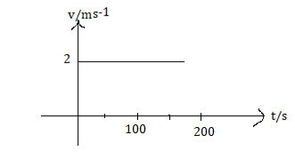

a) The object is moving with constant speed

b) The motion is not rectilinear

c) The object is at rest

d) The object is accelerating  **(3 marks)**

**3)** Determine the acceleration that results when a net force of 100 N is exerted on a 50 kg object.

a) 5 000 m/s2  b) 50 m/s2 c) 9.81 m/s2  d) 2 m/s2  **(3 marks)**

**4)** The point through which the whole weight of the body acts is called

a) inertial point b) centre of gravity c) centroid d)central point  **(3 marks)**

**5)** Energy that object possesses due to its position is called

a) kinetic energy b)nuclear energy c)potential energy

d)chemical energy **(3 marks)**

**6)** Trapped heat inside the Earth is known as

a) heat energy b)solar energy c) electrical energy d) geothermal energy **(3 marks)**

**7)** Which of the following is a simple machine?

a) Chair b) candle c) pulley d)horizontal table **(3 marks)**

**8)** Temperature of water in a beaker is 40˚C.Its value in Kelvin scale

is a)104K b) 313K c)-233K d) 104 ˚F **(3 marks)**

**9)** An example of magnetic material is

a) water b)plastic c)wooden chair d) iron **(3 marks)**

**10)** Two bar magnets are placed closer with their North poles facing each other (see diagram).

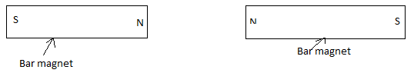

a) They repel each other b)they attract each other c) both a and b

d) none of these. **(3 marks)**

**ATTEMPT ALL QUESTIONS (70 MARKS)**

**11)** Copy and complete the following table

|  |  |  |  |
| --- | --- | --- | --- |
| Physical quantity | Fundamental physical quantity. Answer yes or no | Symbol of S I unit | Measuring instrument |
| Time |  |  |  |
|  | Yes |  |  |
| Density |  |  |  |
|  | Yes |  | Ammeter |
| Weight |  | N |  |

**(12 marks)**

**12)** a)(i) Why a passenger travelling in a bus found himself/herself kicking forward when the bus stopped abruptly? **(2 marks)**

(ii) State a Newton’s second law of motion. **(2 marks)**

b) A box of 50 kg is put on a horizontal table.

Acceleration due to gravity g=10 m/s2

(i)Determine the weight of this box. **(2 marks)**

(ii)Determine the magnitude and direction of the force exerted on the box by the table. **(2 marks)**

c)A body A of mass 0.16 kg exerts a gravitational force of 6.2x10-10 N on a body B when the distance between their centres is 0.37 m. What is the mass of body B?

The gravitational constant G=6.67x10-11 m3/kg s2 **(2 marks)**

**13)** a)Use arrow to match each of the following physical properties of liquid (first column) with its meaning(second column).

Example:



|  |  |
| --- | --- |
| Physical property of liquid | Meaning |
| 1)Viscosity | i)Temperature at which the vapour pressure of liquid equals the pressure surrounding the liquid and the liquid changes into a vapour. |
| 2)Melting point | ii)Temperature at which a liquid turns into solid when cooled. |
| 3)Boiling point | iii)Resistance of fluid to a change in shape or movement of neighbouring portions relative to one another. |
| 4)Freezing point | iv)Temperature at which a substance changes state from solid to liquid. |

**(4 marks)**

b) State any two properties of

(i) liquid state **(4 marks)**

(ii) solid state **(4 marks)**

**14)** a) A small charge is found in uniform electric field E= 3 N/C

(i)Is electric field a vector quantity? Explain **(3 marks)**

(ii)Determine the electrostatic force on the charge. **(3 marks)**

b) Two electric charges Q1 and Q2 carry positive charges of  and respectively.

Calculate the distance between the charges if the electrostatic force between them is 60N.

Take the Coulomb constant k=9x109 Nm2/C2  **(3 marks)**

c) A charge Q=1x10-11 C acts as a positive point charge to create an electric field at a distance of 0.05 m away.

(i) Draw the electric field line created by Q at a distance of 0.05 m away **(1mark)**

(ii) Determine the electric field strength created by Q at a distance of 0.05 m. Coulomb’s law constant k=9x109 Nm2/C2 **(2 marks)**

**15)** Below is a simple electric circuit.

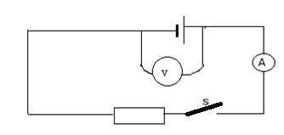

a) (i)Copy the electric circuit above and name any 3 symbols used to draw this electrical circuit. **(3 marks)**

(ii)Redraw the electric circuit above so that it is closed. Use arrows to show the direction of the electric current I and the direction of electrons e. **(2 marks)**

b) A current of 0.4 A passes through a resistor of 5 Ω in 2minutes when connected to a battery.

(i)Find the voltage /potential difference across the resistor of 5 Ω. **(3 marks)**

(ii) Convert 2 minutes in seconds. **(1 mark)**

(iii)Determine the electric energy dissipated by the 5 Ω resistor. **(3 marks)**

**16)** a)(i) Draw a

1.divergingbeamof light  **(1mark)**

2. converging light beam **(1mark)**

3. parallel light beam **(1mark)**

(ii) What is the type of light beams produced by car headlamps? **(1 mark)**

b) Analyze the diagram below showing the image formation in a pinhole camera.

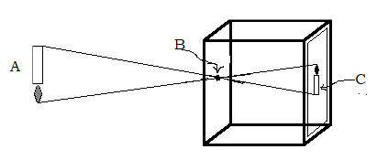

(i)What does the symbol B represent? **(1 mark)**

(ii)Suggest any three characteristics of the image formed by the pinhole

camera shown above. **(3 marks)**

(iii) What is the actual size of the object, if the magnification of the pinhole camera is 0.2 and the image size is 3.5 cm high? **(2 marks)**

c) (i)What happens when a ray of light is incident on a plane mirror? **(1 mark)**

(ii)Is a plane mirror opaque or transparent? **(1mark)**

**S1 MARKING SCHEME OF PHYSICS 2021**

**PART I:**

**1)b) 3marks 2)a) 3marks 3)d) 3marks 4)b) 3marks**

**5)c 3marks 6)d) 3marks 7)c) 3marks**

**8)b) 3marks 9)d) 3marks 10)a) 3marks**

**PART II**

**11)**

|  |  |  |  |
| --- | --- | --- | --- |
| Physical quantity | Fundamental physical quantity | Symbol of S I unit | Measuring instrument |
| Time | Yes**(1mark)** | s **(1mark)** | Stop clock**(1mark),**watch |
| Length **(1mark)** | Yes |  | Ruler **(1mark)** metre rule, micrometer screw gauge ,vernier caliper, tape metre |
| Density | No **(1mark)** | **(1mark)** | Densimeter **(1mark)** lactometer, hydrometer |
| Electric current **(1mark)** | Yes | A **(1mark)** | Ammeter |
| Weight | No **(1mark)** | Newton (N) | Force meter**(1mark)** or force gauge, spring balance, newton meter |

**12)** a)(i)The passenger kicks forward when the bus stops abruptly in trying

to resist stopping due to his/her inertia **(2marks).**

He/she wants to keep on moving

(ii)Newton’s second law states that the acceleration of an object as

produced by a net force is directly proportional to the magnitude of

the net force in the same direction as the net force and inversely

proportional to the mass of the object**(2marks)**

b)(i)Weight W=mg **(1mark)**

=50kg x 10 m/s2=500 N**(1mark)**

(ii)The reaction of the table is equal in magnitude to the weight of

the box but opposite in direction

R=500 N**(1mark) .**It is oriented inupward direction **(1mark)**

c) The gravitational force between two masses **(1mark)**

The mass of body B is **(1mark)**

**13)a)** 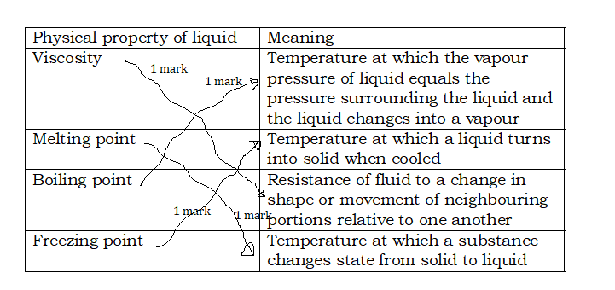

b)(i)Liquid is viscous **(2marks)**It has fixed volume **(2marks)**

It does not have fixed shape etc.

(ii)Solid is rigid (**2marks)** It has definite volume **(2marks)** definite shape

etc.

**14)** a)(i)It is a vector quantity**(1mark)**

It has both magnitude **(1mark)** and direction **(1mark)**

(ii) **(1 mark)**

**(1mark)** F=6x10-3 x3 N= 18x10-3 N **(1mark)** or 0.018 N

b) The Coulomb force **(1mark)**

 **(1mark)**

d = 3x10-2 m**(1mark)**

c) (i)

 **(1mark)**

(ii)The electric field strength  **(1mark)**

(**1 mark)**

**15)**a)(i)Any three elements **1 marksx3 =3 marks**

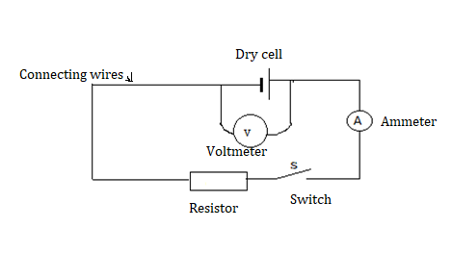

(ii)

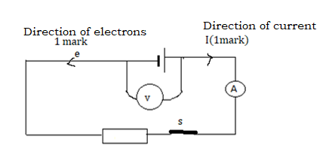

b)(i) The potential difference V=RI **(1mark)**

=5Ωx0.4A **(1mark)** =2 V **(1mark)**

(ii) t =2 min =60x2 s =120 s **(1mark)**

(iii)Energy dissipated E=VIt **(1mark)** or RI2t

=2x0.4 x120 J **(1 mark)** =96 J**(1mark)**

**16)**a)(i)

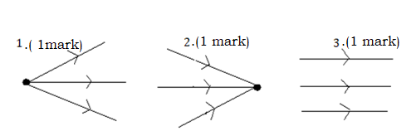

(ii) Parallel beam  **(1mark**

b)(i)B is a pinhole **(1mark)**

(ii)Image is real **(1mark)** inverted **(1mark)** smaller than the object

**(1mark)**

NB: Inverted image means image that is upside-down compared to

the orientation of the object or image that has a vertical orientation

opposite to that of the object.

(iii) m=0.2 and  **(1mark)  ,**actual size of the object

is **1mark)**

c)(i)Light reflects **(1mark)** (ii)Opaque **(1mark)**



**PHYSICS**

**23/06/2021**

**8:30 am -11:30am**

**SENIOR ONE END OF YEAR EXAMINATIONS, 2021**

**SUBJECT: ALTERNATIVE TO PHYSICS PRACTICAL EXAM**

|  |
| --- |
| **/100**      **Marks:** |

**DURATION: 1HOUR 30 MINUTES**

**INSTRUCTIONS:**

1. Do not open this question paper until you are told to do so.
2. Answer all questions: **100 marks**

3) Use only a **blue** or **black** pen and pencil.

**ATTEMPT ALL QUESTIONS (20 MARKS)**

In experiment to study the motion of a cyclist, the following data were collected.

|  |  |
| --- | --- |
| Time t /s | Velocity v/ms-1 |
| 0 | 0 |
| 2 | 3 |
| 4 | 6 |
| 6 | 6 |
| 8 | 6 |
| 10 | 6 |

a) Plot a graph of velocity v (vertical axis) against time t (horizontal axis)

**(12 marks)**

b) Use your graph to state and explain

(i)the motion of the Cyclist in the first four seconds. **(2 marks)**

(ii)the motion of the Cyclist in the last six seconds. **(2 marks)**

c)(i)From your graph, determine the slope of the graph in the first

four minutes. **(2 marks)**

(ii)Interpret the obtained result in c) (i). **(2 marks)**

**S1 MARKING SCHEME OF ALTERNATIVE TO PHYSICS PRACTICAL EXAM 2021**

a) Graph

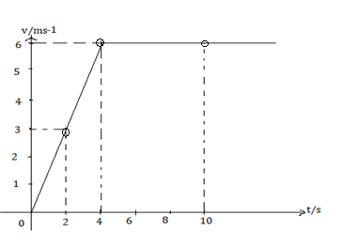

Uniform scale on each axis 1 mark x 2 =**2 marks**

Labelled axis with arrows 1markx 2 =**2 marks**

Plotted points 1markx6 =**6 *marks***

Graph **2 marks**

b)(i)Uniformly accelerated rectilinear motion **(1mark)** or the motion is

rectilinearwith constant acceleration

Reason: the graph is an oblique straight line **(1mark)** or the speed

increases linearlywith time.

(ii)Uniform rectilinear motion**(1mark)** the speed does not change with time

**(1mark**).

c) (i)The slope  **(1mark)**

=1.5 m/s2 **(1mark)**

(ii)The unit of slope shows that the calculated physical quantity is

acceleration **(2 marks)**.

**PHYSICS**

**30/06/2021**

**8:30 am -11:30am**



**SENIOR ONE END OF YEAR EXAMINATIONS, 2021**

**SUBJECT: PHYSICS THEORY FOR VISUALLY IMPAIRED LEARNERS**

|  |
| --- |
| **/100**      **Marks:** |

**DURATION: 3 HOURS**

**INSTRUCTIONS:**

1. Do not open this question paper until you are told to do so.
2. Answer all questions: **100 marks**

3) Use only a **blue** or **black** pen.

**PART I: MULTIPLE CHOICE QUESTIONS (45 MARKS)**

Choose the letter that corresponds to the correct answer

**1)** Magnetic force is

a) contact force

b) Non-contact force

c) both a and b

d) none of these

**(3 marks)**

**2)** Which of the following statements is correct regarding velocity and

speed of a moving body?

a) Velocity of a moving body is always high than its speed

b) Speed of a moving body is always high than its velocity

c) Speed of a moving body is its velocity in a given direction

d) Velocity of a moving body is its speed in a given direction

**(3 marks)**

**3)** A body of mass 50 kg runs with a force of 100 N, its acceleration would

be

a) 2 m/s2

b) 50 m/s2

c) 9.81 m/s2

d) 5 000 m/s2

**(3 marks)**

**4)** Force acting on an object may change its

a) direction

b) shape

c)speed

d) all of above

**(3 marks)**

**5)** The point through which the whole weight of the body acts is called

a) inertial point

b) centre of gravity

c)centroid

d)central point

**(3 marks)**

**6)** Where is the centre of gravity of a uniform rod located?

a) At its end

b) at its middle point

c)at the centre of its cross-sectional area

d) depends upon its material

**(3 marks)**

**7)** Energy that object possesses due to its position is called

a) kinetic energy

b) mechanical energy

c) potential energy

d)chemical energy

**(3 marks)**

**8)** If energy loss is zero, when gravitational potential energy decreases, the

a) kinetic energy decreases

b) kinetic energy increases

c)kinetic energy remains constant

d)kinetic energy becomes zero

**(3 marks)**

**9)** Trapped heat inside the Earth is known as

a) heat energy

b) solar energy

c)geothermal energy

d)Electrical energy

**(3 marks)**

**10)** Which of the following is a simple machine?

a) Chair

b) candle

c) pulley

d)table

**(3marks)**

**11)** Which of these is an example of a wedge?

a) broom

b) butter knife

c)stairs

d) ladder

**(3 marks)**

**12)** The liquid metal used in thermometer is

a) Mercury

b) silver

c) gold

d) copper

**(3 marks)**

**13)** Temperature of water in a beaker is 40˚C.Its value in Fahrenheit scale

is a)110˚F

b)104˚F

c)130˚F

d)116 ˚F

**(3 marks)**

**14)** An example of magnetic material is

a) iron

b) plastic

c)wooden chair

d) copper

**(3 marks)**

**15)** Two bar magnets are placed closer with their North poles facing each

other

a) they repel each other

b) they attract each other

c) both a and b

d) none of above

**(3 marks)**

**PART II: ATTEMPT ALL QUESTIONS (55 MARKS)**

**16)** You are provided with a list of some physical quantities namely

time, density, weight, acceleration, speed, mass and intensity of

current.

a) From the given list,

(i)Select any two fundamental physical quantities.  **(2 marks)**

(ii) Identify any two derived physical quantities **(2 marks)**

b) How can you measure intensity of current? **(2 marks)**

c) (i)What is the SI unit of weight? **(1mark)**

(ii)Give the base units of the SI unit of weight **(3 marks)**

**17)**a) (i) Why a passenger travelling in a bus found himself kicking forward

when the bus stopped abruptly? **(2 marks)**

(ii) State the Newton’s second law of motion **(2 marks)**

b) A box of 50 kg is put on top of a horizontal table.

Acceleration due to gravity g=10 m/s2

(i)Determine the weight of this box. **(2 marks)**

(ii)Determine the magnitude and direction of the force exerted on

the box by the table. **(2 marks)**

c)A body A of mass 0.16 kg exerts a gravitational force of 6.2x10-10 N

on a body B when the distance between their centres is 0.37 m.

What is the mass of body B?

The gravitational constant G=6.67x10-11 m3/kg s2 **(2 marks)**

**18)** a) Use arrow to match each of the following physical properties of liquid

(first column) with its meaning (second column)

|  |  |
| --- | --- |
| Physical property of liquid | Meaning |
| Viscosity | Temperature at which the vapour pressure of liquid equals the pressure surrounding the liquid and the liquid changes into a vapour |
| Melting point | Temperature at which a liquid turns into solid when cooled |
| Boiling point | Resistance of fluid to a change in shape or movement of neighbouring portions relative to one another |
| Freezing point | Temperature at which a substance changes state from solid to liquid |

**(4 marks)**

b) State any two properties for each of the following states of matter

(i) liquid state. **(4 marks)**

(ii) solid state. **(4 marks)**

**19)** a) A small charge is found in uniform electric field E= 3 N/C

(i)Is electric field a vector quantity? Explain. **(3 marks)**

(ii)Determine the electrostatic force on the charge. **(3 marks)**

b) Two electric charges Q1 and Q2 carry positive charges of  and

respectively.

Calculate the distance between the charges if the electrostatic force

between them is 60N.

Take the Coulomb constant k=9x109 Nm2/C2  **(3 marks)**

c) A charge Q=1x10-11 C acts as a positive point charge to create an

electric field at a distance of 0.05 m away.

Determine the electric field strength created by Q at a distance

of 0.05 m. Coulomb’s law constant k=9x109 Nm2/C2 **(2 marks)**

**20)** A current of 0.4 A passes through a resistor of 5 Ω in 2minutes when

connected to a battery.

a) Find the voltage (potential difference) across the resistor of 5 Ω.

**(3 marks)**

b) Convert 2 minutes in seconds. **(2 marks)**

c) Determine the electric energy dissipated by the resistor of 5 Ω

**(2 marks)**

**21)** a) Suggest any two characteristics of the image formed by a pinhole

camera. **(2 marks)**

b) (i)What happens when a ray of light is incident on a plane mirror?

**(1 mark)**

(ii)Is a plane mirror opaque or transparent? **(1mark)**

(iii)Propose the importance of plane mirrors as used in our daily life.

**(1 mark)**

**S1 MARKING SCHEME OF PHYSICS 2021 FOR BLIND LEARNERS**

**PART I: MULTIPLE CHOICE QUESTIONS**

**1)b) 3marks 2)d) 3marks 3)a) 3marks 4)d) 3marks 5)b) 3marks**

**6)b) 3marks 7)c) 3marks 8)b) 3marks 9)c) 3marks 10)c) 3marks**

**11)b) 3marks 12) a) 3marks 13) b)3marks 14) a) 3marks 15) a) 3marks**

**PART II**

**16)**a) Any two physical quantities

(i)Time **(1mark)**, intensity of current **(1mark),** mass

(ii)Density **(1mark)** weight **(1mark)** acceleration, speed

b) Use of ammeter **(1mark)** connected in series with the circuit**(1mark)**

c)(i)Newton**(1mark)** or N or kgm/s2

(ii) kg**(1mark),** m**(1mark)** and s **(1mark)** or kilogram, metre, second.

**17)** a) (i)The passenger kicks forward when the bus stops abruptly in trying

to resist stopping due to his/her inertia **(2marks)** because

he/she wants to keep on moving.

(ii)Newton’s second law states that the acceleration of an object as

produced by a net force is directly proportional to the magnitude of

the net force in the same direction as the net force and inversely

proportional to the mass of the object. **(2marks)**

b) (i)Weight W=mg **(1mark)**

=50kg x 10 m/s2=500 N**(1mark)**

(ii)The reaction of the table is equal in magnitude to the weight of

the box but opposite in direction. Therefore

R=500 N**(1mark).** It is oriented inupward direction **(1mark)**

c) The gravitational force between two masses **(1mark)**

The mass of body B is **(1mark)**

**18)**a) 

b) (i)Liquid is viscous **(2marks)** It has fixed volume **(2marks)**

It does not have fixed shape etc.

(ii)Solid is rigid (**2marks)** It has definite volume **(2marks)** definite shape

etc.

**19)** a)(i)It is a vector quantity**(1mark)**

It has both magnitude **(1mark)** and direction **(1mark)**

(ii) **(1 mark)**

**(1mark)** F=6x10-3 x3 N= 18x10-3 N **(1mark)** or 0.018 N

b) The Coulomb force**(1mark)**

 **(1mark)**

d = 3x10-2 m**(1mark)**

c) The electric field strength  **(1mark)**

**(1 mark)**

**20)**a) The potential difference V=RI **(1mark)**

=5Ωx0.4A **(1mark)** =2 V**(1mark)**

b) t =2 min =60x2 s =120 s **(2marks)**

c) Energy dissipated E=VIt **(1mark)** or RI2t

=2x0.4 x120 J =96 J **(1mark)**

**21)**a) (i)Image is real **(1mark)** inverted **(1mark)** smaller than the object

b) (i)It reflects **(1mark)**

(ii)Opaque **(1mark)**

(iii)They are used in periscope **(1mark)**, they are used for signaling, in

microscopes, in camera, mirrors tiles, bathroom mirrors etc.