SOUTHERN PROVINCE
RUHANGO DISTRICT

RUHANGO DISTRICT MOCK EXAMINATION, SEPTEMBER 2021.
S.E.T FOR P6
Duration: Two hours
Marks:
/100 /100
INSTRUCTIONS
1) Don’t open this question paper until you are told to do so.
2) All questions are compulsory.
3) Read each question carefully before answering it.
4) Answer the questions in the space provided on this question paper.
5) Use only a blue or black pen.
1.what is a simple machine?/2marks
………………………………………………………………………………
2.Name any two:/4marks
a.carpentry tool:……………………………
b.agricultural tool:………………………..
3.Mention one danger of stagnant water/2marks
………………………………………………………………………………………………………………
4.Name any two sources of electricity to operate radios in our district/2marks
a)…………………………………………b)……………………………………………………….
5.Give two ways of storing sound/2marks
a)………………………………………………….b)…………………………………………………
6.By which method does heat from the sun reach the earth/2marks
…………………………………………………………………………………………………….
7.Name the glands that produce the following juices /3marks
a.Gastricjuice:………………………
b.Saliva :……………………………..
c.bile:…………………………….
8.State four stages of digestion / 4marks
a)……………………………………………………………………………………
b)…………………………………………………………………………………
C)…………………………………………………………………………………
D)……………………………………………………………………………………
9.Name the male reproductive cells and female reproductive cells/2marks
a.Inflower:…………………………………………………………………..
b.In people:…………………………………………………………………..
10.Give two types of reproduction in plant /2marks
……………………………………………………………………………………………………………………………………………………………………………………………………………………….
11.Name any two non- infections diseases of the lung/2marks
i)…………………………………………………………………………………………
ii)…………………………………………………………………………………………
SECTION :B
12.Bar magnets have two poles . /2marks
What are they?
………………………………………………………………………………………………………………………………………………………………………………………………………………………………
13.Like poles………………..each other while unlike poles………….. each other./2marks
14.When water vapour gets cold it turns to a…………………./ 2marks
(liquid ,solid, rain drop, ice)
15.What are the three stages of water cycle?/ 2marks
i.Evaporation ,condensation ,precipitation
ii.Solid ,liquid ,gas
iii.evaporation,precipitation,sleet
iv.clauds,water, precipitation
16.When you heat water it turns into :(liquid, gas,water, solid)/1mark
…………………………………………………………………………………………………..
17.calculate the density and relative density of a body whose mass is 420 kg and the volume 42dm³./ 4marks
(show working steps)
………………………………………………………………………………………………………………………………………………………………………………………………………………………………………………………………………………………………………………………………………………………………………………………………………………………………………………………………………………
18.Match the items in list A with their function in the list B/4marks
a. Red blood cells 1.stops bleeding the skin is cut
b. Arteries 2.carry oxygen around the body
c. Valves 3.carry blood away from the body
d. Platelets 4.prevent back flow of blood in veins
19.a)Define air pollution/ 2marks
…………………………………………………………………………………………………………………………………………………………………………………………………………………………………………………………………..
b)write down three dangers of air pollution/ 3marks
…………………………………………………………………………………………………………………………………………………………………………………………………………………………………………………………………………………………………………………………………………………………………………………………………….
20.List at least three importance of fertilizer/3marks
………………………………………………………………………………………………………………………………………………………………………………………………………………………………………………………………………………………………………………………………………………………………………………………………..
21.State any three importance of magnet / 3marks
……………………………………………………………………………………………………………………………………………………………………………………………………………………………………………………………………………………………………………………………………..
22.What is the functions of a flower in plant?/ 2marks
………………………………………………………………………………………………………….
23.Which parts make up:/ 4marks
a)Pistil:……………………………………………………………………………………………………
b)Stamen:………………………………………………………………………………………………
24.What is pollination? /2marks
…………………………………………………………………………………………………………………………………………………………………………………………………………………………
25.Name the types of pollination in flowers./ 4marks
………………………………………………………………………………………………………………………………………………………………………………………………………………………..
26.Which type of blood vessels:/ 4marks
a)Return blood to the heart…………………………………………………..
b)Supply blood from heart to the body…………………………………..
27.State two types of breeds of chicken./ 2marks
…………………………………………………………………………………………………………………………………………………………………………………………………………………………
28.Write the three methods the people use in the family planning.3mks
…………………………………………………………………………………………………………………………………………………………………………………………………………………………………………………………………………………………………………………………………………………………………………………………………………………………………………………………………………….

29.Fill gaps in the flow chart below/ 4marks
Liquid
Gas
Solid

- From solid to liquid is ……………………………
- From liquid to gas is ……………………………
- From gas to Liquid is ……………………………
- From liquid to solid…….……………………………
30. State whether the following statements are true or false:5marks.
a) sensory organs are connected to brain through nerves………………..
b) Tongue enables us to balance our body…………………………..
c) The inner ear has three tiny bones…………………………………
d) Retina is the outer layer of the eye…………….
e) Short-sightedness can be corrected using a convex lens……………….
31.below are diagrams of watches /2marks
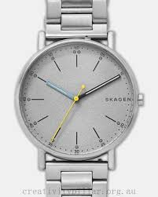
Diagram A Diagram B
- which one is digital: ……………………………………………..
- which one is analogue: ………………………………………….
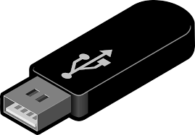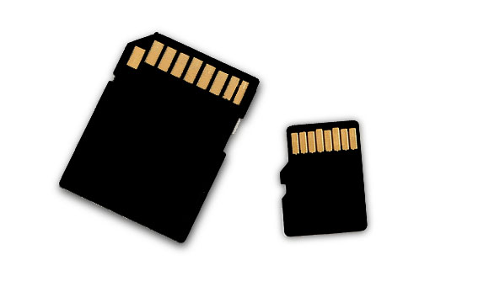32.a)Above are the diagrams represents the external memory of a computer3marks

b).Name the external memory above in full words
A…………………………………………. B……………………………………….C………………………………
33.Name the external input device here below /1 mark…………………………………………………..
34.Write in full 4marks
a) I.C.T: ……………………………………………………………………………………………..
b)R.O.M:………………………………………………………………………………………
c) O.L.P.C : ………………………………………………………………………………………
e) W.W.W: ……………………………………………………………………………………..
35. Give the function of the following parts of XO computers;/ 4marks
i) Monitor: ……………………………………………………………………………………
ii) Keyboard: …………………………………………………………………………….…
iii) Power button:………………………………….……………………………’’……
iv) Speaker: ……………………………………………………………………………..
Good Luck!!!!!!!!!!!!!!!!!!!

SET MARKING SCHEME P6 2020-2021
1.Simple machine is a device which makes work easy
2.a.saw,hammer, work bench,
b.ahoe, slasher ,
3.cause diseases like diarrhoea;dysentery
4.dry cells ,electricity
5.mobile phones ,music tapes, memory cards ,flash
6.By radiation
7.a) stomach. b)salivary gland c)liver
8) Ingestion
Digestion
Absorption
Elimination
9) a.Stamen and pistil
b.Sperms and ovule
10.sexual reproduction and asexual reproduction
11.Asthma , lung cancer

SECTION B
12.north pole and south pole
13.repel –attract
14.ice
15.i.evaporation,condensation, precipitation
16.gas
17.D=M/V =420kg/42dm³ =10kg/dm³
R.D=density of body/density of water=10kg/dm³:1kg/1dm³=10
18. a--------2
b…………3
c…………4
d………..1

19. Air pollution is the adding of dangerous substances into the atmosphere
20 . It improves the growth of plants ,it improves soil fertility ,it increases productivity
21.carrying heavy lood ;separation mixtures involving magnetic and nom magnetic materials
In magnetic compass to showing directions
22.Is the reproductive organ
23.a. pistile=style ,ovary,ovule ,stigma
b.stamen=filament,pollen grains ,anther
24.Pollination is transfer of pollen grains from anther to stigma
25.Self- pollination ,cross-pollination
26. a.vena cava b.Aorta
27.Egg-laying chicken , meat type of chicken
28.Use pills tables ,use condom ,use spermicides
29.a.Melting
b.Evaporation
c.Condensation
d.Freezing
30. a) true b)false c)false d) false d) false

31 . a) A b) B
32. a) memory card
b) flash disk
c)compact disk
33. mouse
33. a) Information Communication Technology
b) Read Only Memory
c) One Laptop Per Child
d) World Wide Web
35. monitor: displays data
Keyboard: enters data in a computer
Power button: turns on or off the computer
Speaker: passes out the sound

