RUHANGO DISTRICTNAMES: ......................................................
ACADEMIC YEAR: 2020-2021 CLASS: ………………………………
SET SECOND TERM EXAMINATION FOR P3 / 50x2= 100 marks
1. Write the mains party of Xo Laptop (8Marks)
- …………………………………………………………………………………..
- ……………………………………………………………………,……………
- …………………………………………………………………………………..
- ………………………………………………………………………………….
2. Arrange the following steps of cleaning water in their correct order ( 12 Marks )
- Cover drinking water …………………………………………………………………….
- Drink clean water …………………………………………………………………………
- Wash your hands ……………………………………………………………………….
- Pour”sur”Eau”into the water …………………………………………………………
- Prepare the materials …………………………………………………………………..
- Shake the water …………………………………………………………………………
3. List down any two diseases caused by drinking dirty water ( 4 Marks )
- ……………………………………………………………………………………..
- ……………………………………………………………………………………..
- ……………………………………………………………………………………..
- ……………………………………………………………………………………..
4. Name the different types of soil ( 3 Marks)
- …………………………………………………………………………………….
- …………………………………………………………………………………….
- ……………………………………………………………………………………..
5. Answer Yes or No ( 5 Marks )
- Terracing can prevent erosion …………………………………….
- It is not good to plant trees can maintain ……………………….
- Keeping animals in a shed causes erosion ……………………….
- Planting trees which can grow with …………………………………
- Light drops of rain water can cause erosion………………………
6. Circlethe animals which have no backbones ( 5 Marks)
- Wasp
- Caterpillar
- Smelling ant
- Fish
- Black ant
- Sheep
- Male
- Cow
- Ant
7.Look at the diagram below ( 10 Marks )
Complete with -Bones: Ribs, Fubula, Humerus, Tibia
-Frontal bone
Muscles:Thigh muscles, abdominal muscles,hand muscles,Trunk muscles

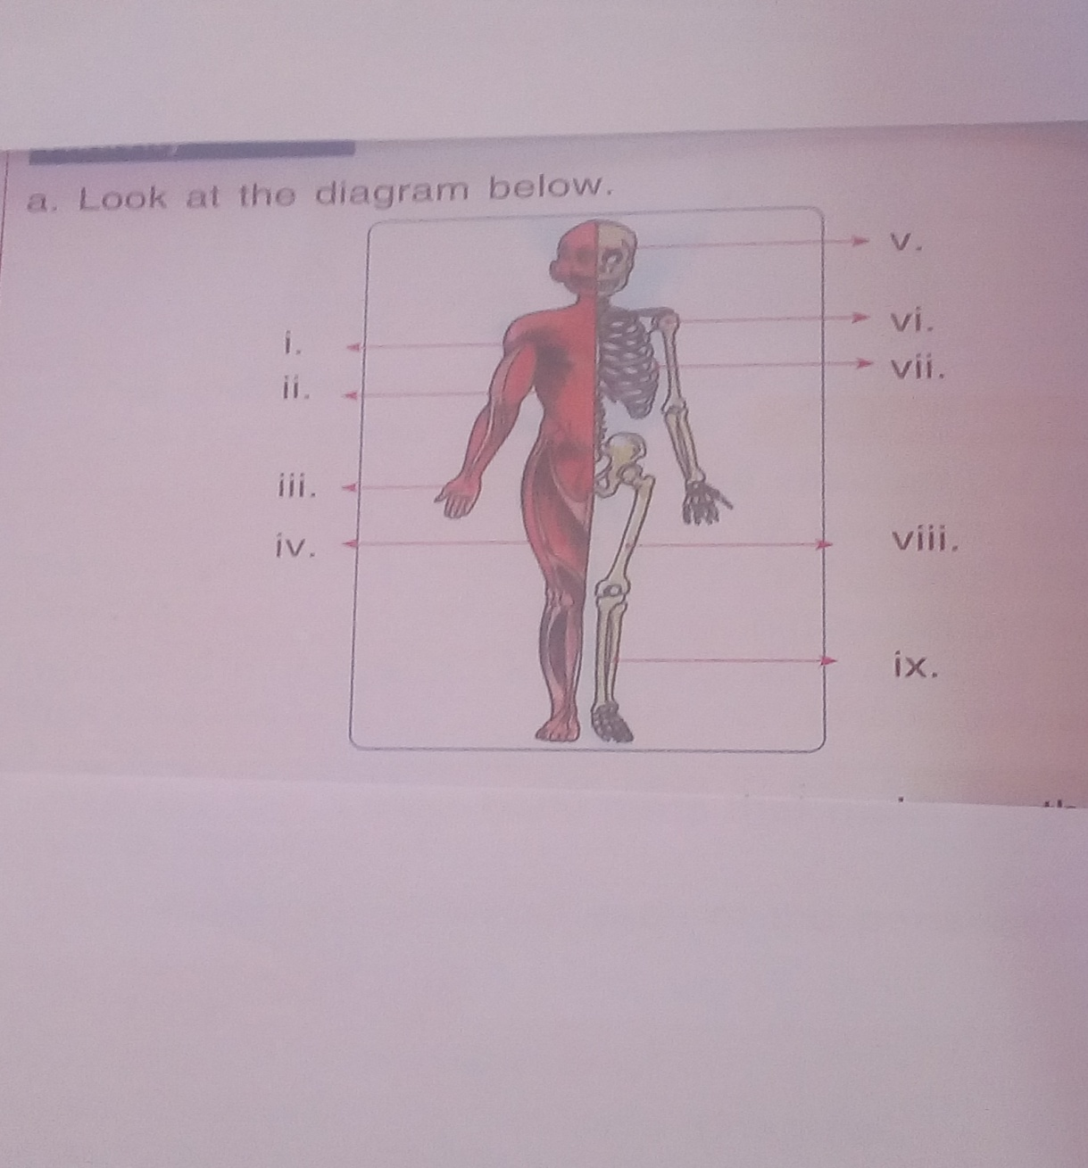

- …………………………………………………….
- …………………………………………………….
- …………………………………………………….
- …………………………………………………….
- …………………………………………………….
- …………………………………………………….
- ……………………………………………………..
- …………………………………………………….
- …………………………………………………….
- …………………………………………………….

8. What makes an umbrella to fly? (1 Mark)
……………………………………………………………………………………………..
9. What makes wet clothes to dry?(0.5 Mark)
……………………………………………………………………………………………..
10. What is the meaning of energy? (0.5Mark)
……………………………………………………………………………………………..
11. List any two materials you see at school that provide energy. (1 Mark)
…………………………………………………………………………………………………….
………………………………………………………………………………………………………

Good Luck!!!!!!!!!!!!!!!

MARKING GUIDE FOR SET EXAMINATION FOR SECOND Term p3
Q1-Screen
-Keyboard
-Tachpard
Q2.Arrange the following steps of cleaning water in their correct order
4a)
6b)
2c)
3d)
1e)
5f)
Q3Worms,diarrhea,dysentery,cholera
Q4.-Clay soil
-Sandy soil
-zoam soil
Q5.a)Yes
b)no
c)No
d)Yes
e)No
Q6.a )wasp
b)Caterpillar
c)Smelling ant
e)Black ant
i)Ant
Q7
- Trunk muscles
- Abdominal muscles
- Hand muscles
- Thigh muscles
- Flontal bone
- Humerus
- Ribs
- Femur
- Tibia
- Fibula

Q8.Wind
Q9.Sun
Q10.Energy is ability to do work
Q11.-Laptop
-Telephone
-Microphone

