SOUTHERN PROVINCE Date25/06 /2021
RUHANGO DISTRICT Term 2
Names: ________________________________________________________ Class: _______
SET EXAMINATIONFOR P2 / 50marks X 2 = 100marks
- Give 5 materials used at school. 5 marks
_____________________________________ _______________________________________
____________________________________ ______________________________________
____________________________________

- Give 2 materials used at home. 2 marks
__________________________________ , __________________________________

- Match the following tools according to their use: 5 marks
Materials | Use
Pencil 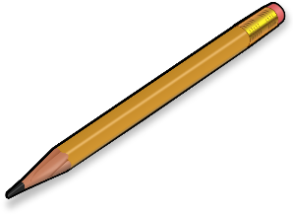 | Eating
Plate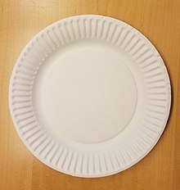 | Writing
Chair 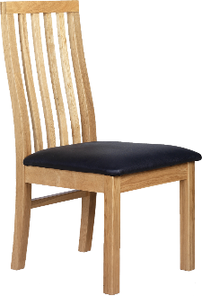 | Pounding cassava leaves
Mortar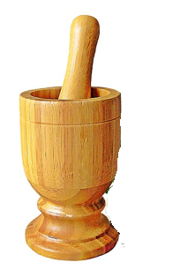 | Sitting

- Write the two importance of air. 2 marks
_____________________________________________________________________

_____________________________________________________________________

- Mention two types of wind. 2 marks
_______________________________________________________
_______________________________________________________
- Write the following in full word. 2 marks
ICT: __________________________________________________________________________
SET: _________________________________________________________________________

- What is this? 2 marks
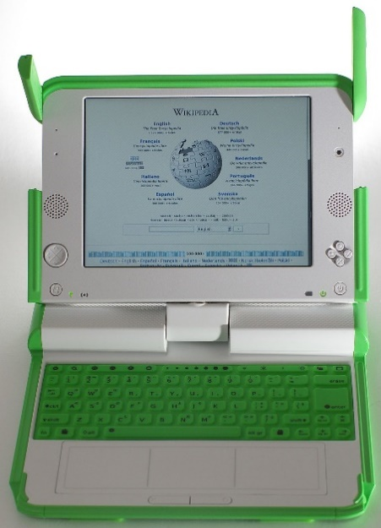

It is _________________________
- Give the name of the following parts: 4 marks
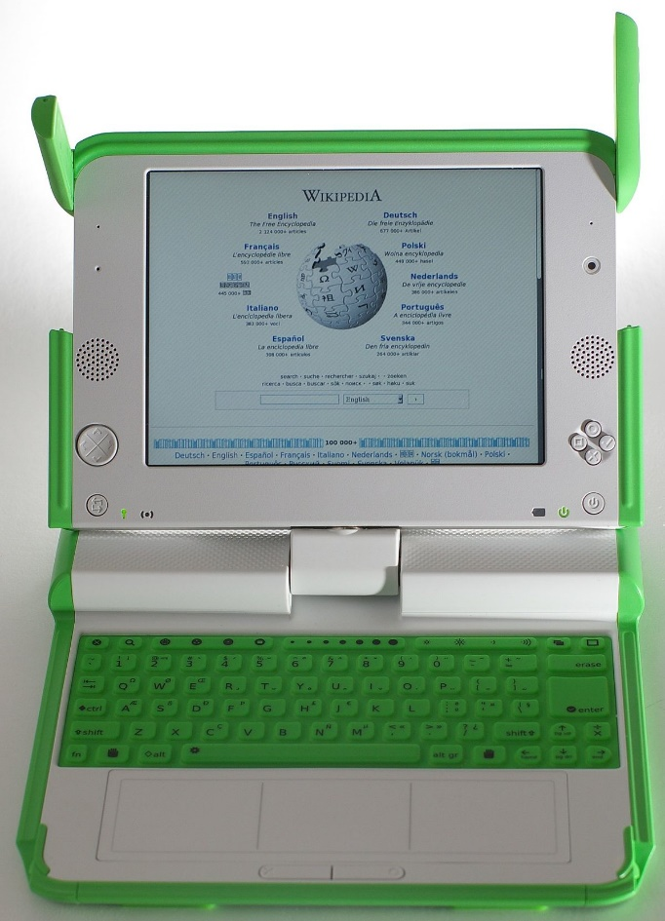

- it is ____________________

- it is ___________________

- it is _____________________

- it is ___________________
- Mention the role of a computer. 1 mark
____________________________________________________________________

- Complete the table by the following: “At home” or “At school”. 5 marks
Materials | Where they are used
An axe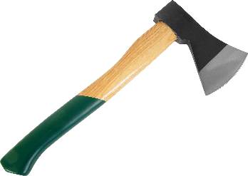 | ---------------------------------------------
Books 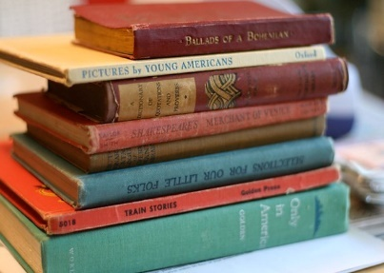 | ---------------------------------------------
Hoe 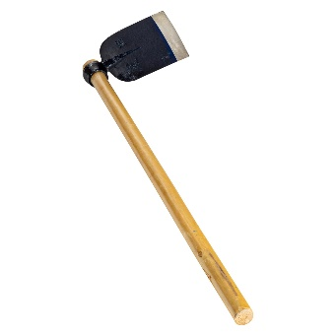 | ---------------------------------------
A panga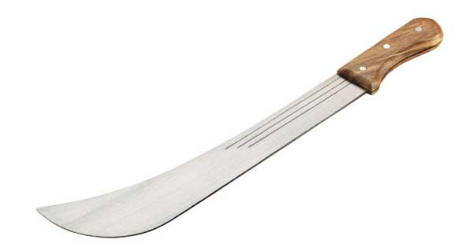 | ----------------------------------------
Pens 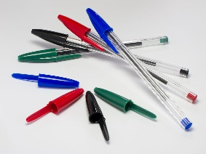 | ------------------------------------------

- What are the roles of the following tools? 6 marks
- a cup: ____________________________________________________________________
- a broom: __________________________________________________________________
- a soap: ____________________________________________________________________
- a desk: ____________________________________________________________________
- a chair: ____________________________________________________________________
- a blackboard: ______________________________________________________________

- Answer by “Yes” or “No” 2 marks
- When writing in a computer; sit on the chair upright. ___________
- When writing in a computer; sitting while right or left. ___________

- (a) Name three toys made in the paper. 3 marks
__________________________________ _____________________________________ ___________________________________

(b) Name three toys made in clay. 3 marks
_____________________________________ __________________________________ ________________________________

- Why can maintain properly the class or the home? 2 marks
______________________________________ _______________________________________

- Give the importance of soil. 2 marks
______________________________________ _____________________________________

- Complete the sentences by: soil erosion, to wash. 2 marks

- Water help ____________________________
- Water causes _____________________________

GOOD LUCK!!!!

SOUTHERN PROVINCE Date25/ 06 /2021
RUHANGO DISTRICT Term 2
MARKING GUIDE of SET EXAMINATION FOR P2 / 50 marks X 2= 100 marks
- Give 5 materials used at school. 5 marks

- Books
- Desks
- Pens
- Blackboard
- Notebook
- Rulers

- Give 2 materials used at home. 2 marks

- Cup
- Plate
- Spoon
- Bucket
- Hoe

- Match the following tools according to their use: 5 marks
Materials | Use
Pencil | Eating
Plate | Writing
Chair | Pounding cassava leaves
Mortar | Sitting

- Write the two importance of air. 2 marks
- Breathing
- Helps for burning the fire

- Mention two types of wind. 2 marks
- Light wind
- Strong wind

- Write the following in full word. 2 marks
ICT: Information and Communication Technology.
SET: Science and Elementary Technology.

- What is this? 2 marks
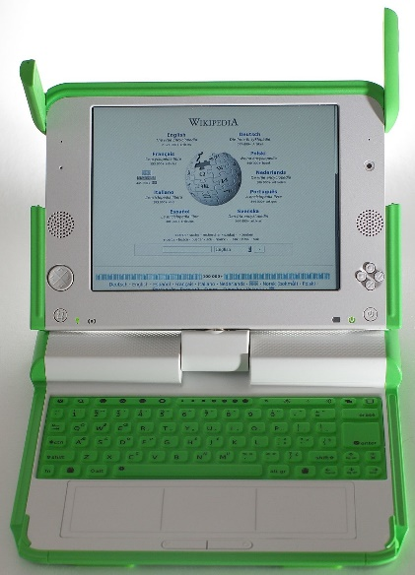 it is a computer

- Give the name of the following parts: 4 marks
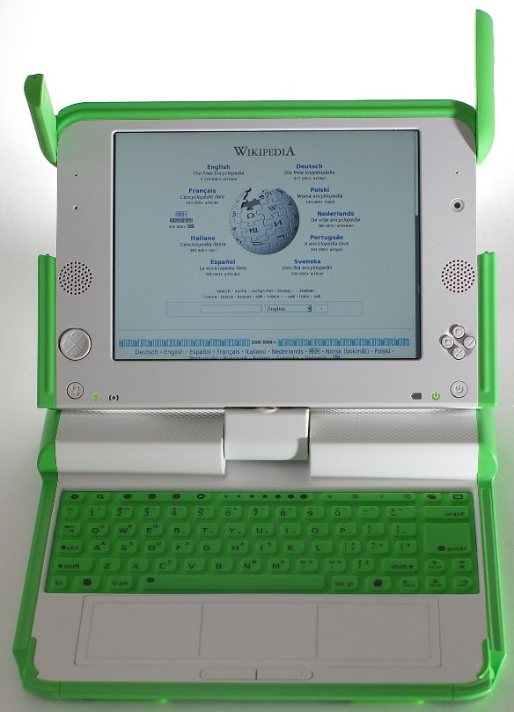

- it is Antenna

- it is Screen or Monitor

- it is Keyboard

- it is Touchpad

- Mention the role of a computer. 1 mark
- To write
- To play music
- To communicate

- Complete the table by the following: “At home” or “At school”. 5 marks
Materials | Where they are used
An axe | At home
Books 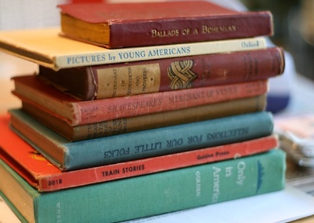 | At school
Hoe | At home
A panga | At home
Pens | At school

- What are the roles of the following tools? 6 marks
- a cup: To drink
- a broom: To sweep
- a soap: To wash / to clean
- a desk: To sit
- a chair: to sit
- a blackboard: To write

- Answer by “Yes” or “No” 2 marks
- When writing in a computer, sit on the chair upright. Yes
- When writing in a computer, sitting while right or left. No

- (a) Name three toys made in the paper. 3 marks
- Square
- Rectangle
- Bird

(b) Name three toys made in clay. 3 marks
- A bottle
- A car
- A human
- A pot

- Why can maintain properly the class or the home? 2 marks
- To avoid diseases
- To arrange materials in order
- (Look the ideas of child accordingly)

- Give the importance of soil. 2 marks
- To cultivate
- To construct houses
- (Look the ideas of child accordingly)

- Complete the sentences by: soil erosion, to wash. 2 marks

- Water helps to wash.
- Water causes soil erosion.

GOOD LUCK!!!!

