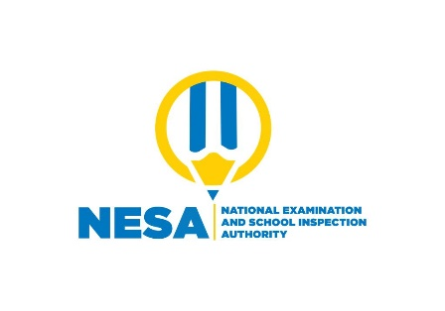
Science and Elementary Technology
25/06/2021
1:30 am -3:30 am

P5 END OF YEAR EXAMINATIONS, 2020/2021
SCIENCE AND ELEMENTARY TECHNOLGY

DURATION: 2 HOURS

/70
MARKS:

Instructions:
- Don’t open this question paper until you are told to do so`.
- All questions are compulsory.
- Read each question carefully before answering it.
- Use only a blue or black pen.

ANSWER ALL QUESTIONS /50 MARKS

1) Use true if the following statement is correct and false if it is wrong
a) Light travels in a straight line in homogeneous and transparent
medium
..………………………………………………………………………..(1mark)
b) Transparent material allows some light to pass through it
………………………………………………………………………….. (1mark)
2) Use arrows to match each of the following tools with its use
Tool | Use
1.Claw hammer | a. Cutting a block of wood into small pieces
2.Table saw | b. Driving nails into wood and removing a nail from wood

(2 marks)
3) a)What is electricity?
……………………………………………………………………………..
……………………………………………………………………………(1mark)
b) State one use of electricity in our daily life.
………………………………………………………………………………
………………………………………………………………………… (1mark)
4) Give any one way of maintaining utility or learning objects
that you have made at school
…………………………………………………………………………….
………………………………………………………………………………
…………………………………………………………………………….(1mark)
5) What happens to a ray of visible light when it is incident obliquely on a
surface of pure water?
………………………………………………………………………………….(1mark)
6) A student made a toy house.
a) Identify one tool she/he used
…………………………………………………………………………….(1mark)
b) State any one local material she/he used
………………………………………………………………………. (1mark)
7) Explain the following terms
a)Masonry
………………………………………………………………………………
………………………………………………………………………………….(1mark)
b)Wheel barrow
……………………………………………………………………………….
………………………………………………………………………………..(1mark)
8) a) Give one property of metal
……………………………………………………………………………(1mark)
b) Why do people paint material made of metal?
…………………………………………………………………………
………………………………………………………………………..
……………………………………………………………………………….(1mark)

9) Why are nails made of metal?
…………………………………………………………………….
…………………………………………………………………………….(1mark)
10) a) Electricity can be dangerous.
(i)Why do people continue to use it?
…………………………………………………………………..............
..…………………………………………………………………………(1mark)
(ii)Show that electricity can be dangerous.
………………………………………………………………………… (1mark)
11) The density of gold is 19.3 g/cm³ .What does this mean?
……………………………………………………………………………(1mark)

12) What is the meaning of Play sound? (1 mark)

13) Fill in the blanks with the correct options: (2 marks)
(i) Regular shapes have straight sides and equal interior ______________
a. Vertex b. Angles c. Sides d. None of these
(ii) Hat blocks are used to start every ___________________________
a. Code b. Script c. Sound d. None of these.
14) Explain 2 importance of using e- mail in real life (2 mark)

15) Answer by True or False. (2 marks)
a. If you select a text and press ctrl + B key on the keyboard, it will
become bold. _____
b. Collaboration means sharing an activity on Xo laptop with a
friend.________
16) Write any 2 examples for each storage. (2 marks)
a. Internal storage.
b. External storage.

17) Write the following abbreviations in full words (2 marks)
a. USB
b. WWW
18) Mention 2 examples of information you can download. (2 marks)
19) The personal security code used as a key to login on e-mail account is
called …………………………………………………….. (1 mark)

20) The Government of Rwanda advises people to wear masks. Why? (1 mark)

21) Name the tool farmers use to transplant seedlings. (1 mark)

22) The Government of Rwanda encourages people to dig ditches across hills.
How is this practice good to farmers? (1 mark)

23) Name the organ Frogs use to breath when they are
(i) on land (1 mark)
(ii) in water (1 mark)

24) State any three characteristics all birds have. (3 marks)

25) ……………. are parts of our body that help us to get information from the
environment. (1 mark)

28) What is a balanced diet? (1 mark)

29) Write down any one class of food. (1 mark)

30) Define adolescence (1 mark)

31) List any Four sexually transmitted diseases that misbehaving boys and
girls suffer from. (4 marks)

32) State Two methods of making soil fertile. (2 marks)

COMPREHENSIVE ASSESSMENT 2020-2021
P5 SET MARKING SCHEME
1) a) True(1mark)
b)False(1mark)
2)
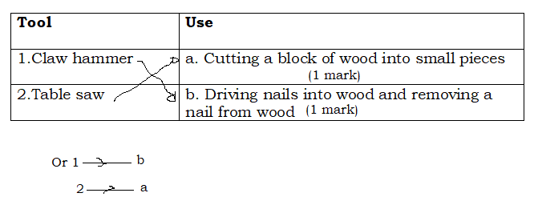
3) a)A simple definition which is at the level of P5 learner
Electricity is a form of energy (1mark) or electricity is electrical energy
b) Electricity is used for
Lighting (1mark) Cooking, charging telephones, cooling/refrigeration,
operating appliances, public transportation etc.
4) Keeping them in a dry, cool and clean place (1mark)
Use them for the purpose they are designed for
Use them carefully
Wooden objects should be hung on a rack
Learning objects should be mounted on a soft board and displayed in
school
Learning objects can be put in shelves, box
5) It refracts (1mark)
Accept also It reflects because a very small amount of the incident light is
reflected off water.
6) a)Knife (1mark) razor blade saw ,hammer, nails or any example of wedge
b) Sorghum straws (1mark) Small flexible tree sticks with a sharpened
end, string/thread, wires
Learner can also make toy house from clay, he can use hoe, plastic
, sorghum sticks, clay, water etc.
7) a)Masonry is the art of building house (1 mark) bridge or any structure
from individual units such as stones, bricks which are laid together by
mortar, clay etc. Or the art or occupation of mason
b) Wheel barrow is agricultural tool or masonry tool used for transport
(1mark)
8) a)Good conductor of heat(1mark) shiny, good conductor of
electricity, hard, sonorous
b)Protect metal against rust (1mark)or corrosion
9) Metal is very hard (1mark) malleable, ductile
10) a)We don’t have alternative energy sources that can replace electricity
to operate for example a television (1mark)
b) Electricity can cause fire (1mark) electric shocks, burns, explosion
and death
11) The density of gold 19.3 g/cm³ means that a volume of 1cm³ of gold
has a mass of 19.3 g (1mark) or a mass of 19.3 g of gold occupies
a volume of 1cm³
Comprehensive Assessment P5

12) Play sound helps to play sound (1 mark)

13) i. b angles
iii. b script
- marks)
14) Uses of e – mail in real life (any two: 2 marks)
- It is easy to use
- It is the fastet and cheapest mean of communication
- E- mail is delivered across the world within seconds.
- Single message can be sent to several people across the world.
- We can send e- mail at any time.
15) c. True
d. True
(2 marks)
16) a. Internal storage: ROM, RAM, hard disk, hard drive, journal, RTF( Rich
text format), HTML ( Hyper text format), TXT ( Plain Text format).
b. External storage: Memory card, Flash disk, CDs, DVDs, External hard
disk, Floppy disk.
(2 marks)
17) USB: Universal Serial Bus.
WWW: World Wide Web.
(2 marks)

18) Examples of information you can download (any two: 2 marks)
- Images
- Videos
- Audios
- Text documents

19) Password (1 mark)

20) -To avoid the spread of COVD-19 (any one: 1 mark)
- To avoid inhaling dangerous gases

21) –Trowel (1 mark)

22) It stops soil erosion (1 mark)

23) (i) Lungs (1 mark)
(ii) Skin (1 mark)

24) - Have feathers (3 marks)
- Have two legs
-Are warm-blooded

25) Sensory organs (1 mark)

26) A balanced diet is a diet that contains all food values in the right amounts. (1 mark)

27) - Energy giving food (any one: 1 mark)
- Body building food
- Body protecting food

28) Adolescence is the change from childhood to adulthood. (1 mark)

29) –Syphillis ( any four: 4 marks)
- Herps
- Gonorrhoe
- Candidias
-HIV/AIDS

30) –Manuring (any two: 2 marks)
- Mulching
- Practice crop rotation
- Avoid soil erosion

